Contents
Foreword 1
Glossary of terms 2
01. Encouraging and Widening Public Engagement 4
02. Supporting our Workforce: The Assembly Commission as an employer of choice 12
03. Supporting Assembly Members, their Staff and Assembly Business 19
04. Embedding Equality into our work 22
Annex A: Progress on Achieving Equality Objectives 24
Annex B: Monitoring Workforce and Recruitment Data 42
Annex C: Equal Pay Audit 2016 60

Foreword
This is the fourth and final annual report relating to our Equality Plan 2012-2016 and it highlights the work we have undertaken to engage with the people of Wales, to support the diverse needs of our staff, to support Assembly Members and Assembly Business, and to embed equality in our organisation.
This report covers the period 1 April 2015-31 March 2016. Included in this document is an update on the Action plan from our previous Equality Plan as well as reports on workforce equality data, recruitment equality data and an equal pay audit.
We believe that the work we have undertaken to widen access to the Assembly and to further develop as an inclusive employer sets a firm foundation for the Fifth Assembly in taking this work further forward. We will take account of what we have learned in the Fourth Assembly when developing the new Assembly Commission’s strategy for Diversity and Inclusion. We would like to thank staff for their work in delivering the vision set out in the Fourth Assembly’s Equality Scheme and Action Plan and also the previous Assembly Commission, for its vision and direction in relation to creating and nurturing an accessible, inclusive organisation.
We welcome any feedback that you may have on the report, on our approach to equality, diversity and inclusion or the accessibility of the Assembly.
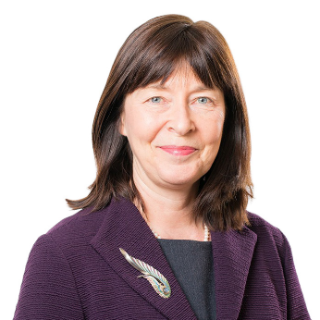
Claire Clancy  Chief Executive and Clerk to the Assembly | Joyce Watson AM  Commissioner for Employees and Equalities

Glossary of terms
Assembly Business – the work undertaken by Assembly Members in the National Assembly for Wales, including plenary debates, committees and constituency work.
Assembly Commissioners – the four Assembly Members who, alongside the Presiding Officers, are responsible for the work of the staff in the Assembly Commission.
Assembly Committees - a group of Assembly Members who meet to scrutinise the policies of the Welsh Government, holding Ministers to account, and examining proposed laws.
Assembly Estate – the buildings that make up the National Assembly for Wales. The Senedd, Tŷ Hywel and the Pierhead are based in Cardiff Bay, and the Public Information Office is based in Colwyn Bay. The Senedd is the main building where the political work of the Assembly takes place. Tŷ Hywel is the administrative office supporting the running of the Assembly. The Pierhead is a public exhibition and events space.
Assembly Members – elected politicians that make up the National Assembly for Wales. The 60 Members represent the different areas of Wales.
Cardiff Travel To Work Area - identified by the Office of National Statistics as Cardiff and the surrounding area where people who work in Cardiff may live. In addition to Cardiff, it covers parts of the following areas; Newport, Caerphilly, Merthyr Tydfil, Rhondda Cynon Taf and Vale of Glamorgan.
Constituencies – the areas of Wales represented by 40 Assembly Members. The remaining 20 Assembly represent the different regions of Wales – North Wales, Mid and West Wales, South Wales West, South Wales Central and South Wales East.
Consultation – the work that we do to find out what people in Wales think about the issues that the Assembly Members are considering.
Equality Impact Assessments (EQIAs) - a process designed to ensure that a policy, project or scheme does not discriminate against any disadvantaged or vulnerable people.
First Minister’s Questions (FMQs) – The First Minister is the leader of the Welsh Government. First Minister's Questions is the name given to the weekly questioning of the First Minister during a dedicated plenary session.
Management Board – the group of senior staff who take forward the management, operational and policy matters on behalf of the Assembly Commission. The Management Board comprises the Chief Executive, Directors and each Head of Service.
National Assembly for Wales (Assembly) – made up of 60 Assembly Members from across Wales. They are elected by the people of Wales to represent them and their communities, make laws for Wales and to ensure the Welsh Government is doing its job properly.

National Assembly for Wales Commission (Assembly Commission) – the body which provides property, staff and services to support the Assembly Members. The Commission is chaired by the Presiding Officer and four other Members nominated by the main political parties. The Commission has responsibilities as an employer and as an organisation that supports Assembly Members and interacts with the public. The services the Commission offer to the public include welcoming visitors to the Assembly estate, providing information to people and visiting schools and community groups across Wales.
Plenary – a meeting of all 60 Assembly Members to discuss Assembly Business.
Presiding Officers – the Assembly Members nominated by the main political parties to chair plenary debates and to represent the National Assembly for Wales.
Welsh Government – is responsible for developing and implementing policies. The National Assembly for Wales scrutinises the work of the Welsh Government and makes sure it’s doing its job properly.

- Encouraging and Widening Public Engagement
A key priority for both the Fourth Assembly’s Presiding Officer and Assembly Commission was to enable more people to connect with the Assembly and to engage with our work. Over the last year, we have interacted with a diverse range of people across Wales and welcomed thousands of people from across the world.
We continued to engage with a broad range of groups and individuals through:
- the Presiding Officer’s Women in Public Life scheme;
- the development of our education and youth engagement work;
- reaching out to a broad range of people to participate in Assembly Business;
- encouraging people to register to vote, via the Vote 2016 campaign prior to the Assembly elections in May 2016;
- Participating in community events such as Black History Month and Cardiff Pride;
- Taking the Assembly out of Cardiff to other parts of Wales as part of the Senedd@ initiative, e.g. Senedd@Swansea which involved a week’s programme of events
- increasing our use of social media and other digital platforms to reach people across Wales and across the world; and
- welcoming people to our estate for tours, events and to watch and participate in Assembly Business.

Senedd@Swansea
The second Senedd@... initiative took place in Swansea in October 2015, building on the success of the Assembly’s visit to Wrexham. Swansea was chosen as the location for the second of these initiatives owing to the area’s low voter turnout in the 2011 Assembly election, to help create momentum for the 2016 election. The week’s activities were delivered in partnership with the South Wales Evening Post and we also worked closely with Swansea University and the National Waterfront Museum. The Public Accounts Committee, Enterprise and Business Committee and Committee for Scrutiny of the First Minister held formal meetings in the Waterfront Museum.
To complement the formal Assembly business, Commission staff delivered 33 workshops, as well as five other events and seminars, around the city. We engaged directly with over 1,500 individuals and established links with numerous schools, youth groups and other organisations.

Understanding and Engaging Sessions
Our Outreach Team held 49 “Understanding and Engaging” sessions for 1,243 delegates over this year, involving a range of groups, including RNIB Cymru, several regional sections of the Association of Voluntary Organisations, People First, Chwarae Teg and Popeth Cymraeg. These session introduced attendees to the Assembly, outlining the election of Assembly Members, how they can engage with Members and the work of the Assembly.

Vote 2016 campaign
The Vote 2016 election awareness raising campaign has seen us engage with people from a Black or minority ethnic (BME) background, women and young people to increase levels of awareness and understanding around the 2016 Assembly election. This has been done using digital and face to face engagement techniques, including:
- creating an election website;
- testing our content with a sample of the audiences mentioned above to make sure the messaging is accessible and relevant to those groups;
- producing easy read content and materials translated into seven different languages; and
- distributing materials to various representative groups, directly to households in areas with high levels of BME residents, and in places of community interest across Wales.

Education and Youth Engagement
- Our Education and Youth Engagement Team welcomes children and young people to our education suite and visits schools, colleges and youth groups across Wales. From April 2015 to March 2016, it has engaged with 571 groups and worked with 20,967 children and young people. During this year, we continued to enhance our offer to other ‘new’ groups outside the school setting, working with 178 youth groups.
- The Education Service uses an interactive approach to introduce children and young people to the Assembly. Their sessions look at what the Assembly is, explain the role of an Assembly Member, and describe how children and young people can become involved in the work of the Assembly.
- Our Youth Engagement Officer has delivered activities outside of the classroom setting including youth organisations, youth fora and voluntary sector and engaged with hard-to-reach young people in particular to help raise awareness about the Assembly and how to participate in its work. We have developing new ways of promoting information about how young people are involved in Assembly Business and the impact of their contributions.
- Other notable youth engagement activities:
- Following the 2014 publication of the Assembly’s Children and Young People Engagement Charter, we extended our programme of youth engagement. This included establishing a Young Assembly Ambassador Scheme designed to enable youth organisations to train their young people to engage others in the work of the Assembly. We also improved our dedicated Your Assembly online youth channels.
- The new 2015 Welsh Baccalaureate Qualification presented a new opportunity to further engage young people in Assembly business. We therefore developed new Community and Global Citizenship challenges and delivered new skills based workshops at Aberystwyth University.
- We also continued to engage young people as an employer. We offered a range of work experience opportunities in different parts of the Commission, successfully completed our second apprenticeship scheme and launched the third.

CASE STUDY
Assemble the Youth Conference
At the ‘Assemble the Youth Conference’ on 15 July 2015, 27 groups of young people came together to debate the outcomes of the Presiding Officer’s ‘Vote@16?’ consultation. This followed a six-month consultation, during which 10,375 young people gave their opinions on lowering the voting age - the biggest ever response to an Assembly consultation. The young delegates discussed issues relating to voter registration and education, and encouraging more young people to vote in future elections. The Children, Young People and Education Committee used this event, as well as the summer shows, to canvass young people’s views on issues that should appear in the Committee’s future work programme.
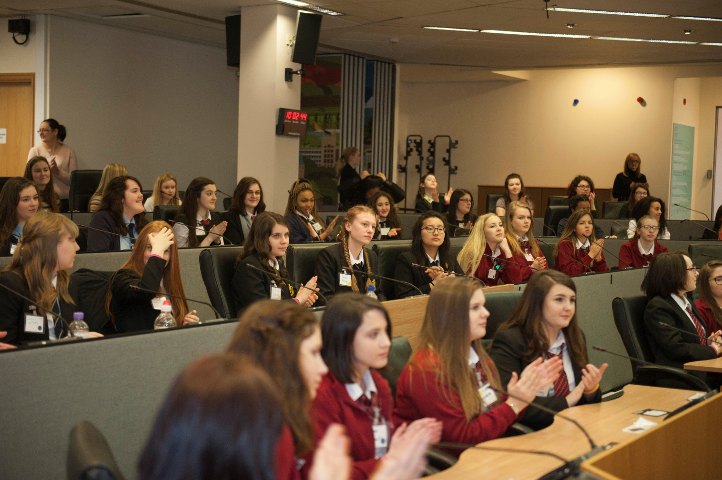
Attendees at an International Women’s Day event as part of the Presiding Officer’s Women in Public Life campaign.

Presiding Officer’s Women in Public Life (POWiPL) Campaign
The Presiding Officer continued her focus on breaking down barriers to more women entering public life through her POWiPL campaign. In July, the former Prime Minister of Australia, Wales-born Julia Gillard, was the guest speaker at the final POWiPL lecture in the Senedd.
A Women in Public Life Networking Fair took place at the National Eisteddfod in August. Organisations were able to promote vacancies on their boards and women looking for board positions gained a better understanding of the roles available and how to apply.
In September, the Assembly’s cross-party Women in Democracy Caucus discussed the implementation of some of the recommendations included in its earlier 2015 report. Representatives from S4C and ITV were invited to the meeting to discuss how they intended to address the lack of women being used as expert contributors to their news and current affairs programming.
The Presiding Officer also hosted a reception at the Senedd in December to mark the end of the POWiPL mentoring scheme and to celebrate its many achievements. During a period of 18 months from September 2014 to January 2016, the scheme included personal development and skills training, one to one mentoring support, and role shadowing opportunities at the highest levels in public bodies. The scheme was very successful, with 11 out of the 14 mentees applying for positions in public life.
The POWiPL campaign attracted attention from other European legislatures. Sixteen women representing the Belfast Interface Project’s Women in Society programme came to the Senedd to learn more about the campaign. The Presiding Officer visited the Georgian Parliament to share her experiences of leading this initiative.

Promoting Equality
We have undertaken a variety of outreach and engagement activities that enable the Assembly to promote equality to the people of Wales and beyond. Through increasing the use of social media we have been able to reach a wider audience. We have used social media to promote a diverse range of campaigns and key dates in the diversity and inclusion calendar, including Stonewall’s No Bystanders anti-bullying campaign during Anti-bullying week; LGBT History Month; International Day Against Homophobia; Transphobia and Biphobia; Black History Month; Disability Access Day; World Autism Awareness Day; celebrating external recognition that we have received; International Women’s Day; Bi-Visibility Day; a campaign to end violence against women; Pride Cymru; youth engagement; the Presiding Officer’s Women in Public Life scheme; and Swansea Sparkle.

CASE STUDY
Case Study – Sparkle
Swansea Sparkle was held in November and was an event organised by Tawe Butterflies and South Wales Police, which aimed to break down barriers between the public and the transgender community by bringing organisations from across Wales and the UK together to showcase the support, information and advice available to the community. The event was an opportunity for the Assembly to network, share best practice and resources with the trans community and public organisations. Attended by Director, Craig Stephenson and Youth Engagement Officer, Kelly Harris, it allowed our organisation talk about how we include the trans community in all of our work, and provide further information about our equality work.
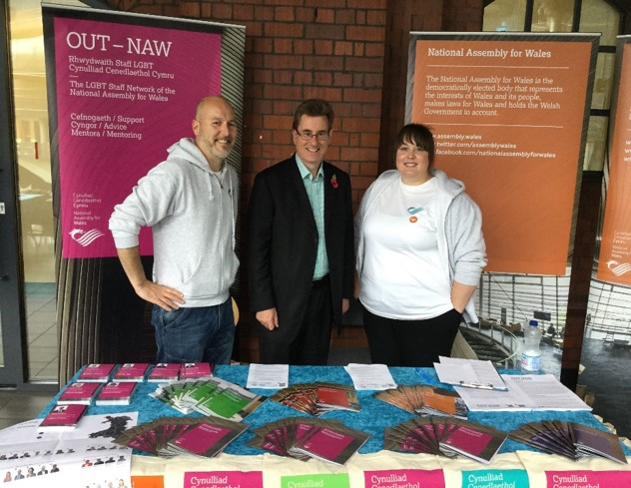
Assembly staff and Peter Black AM at Swansea Sparkle
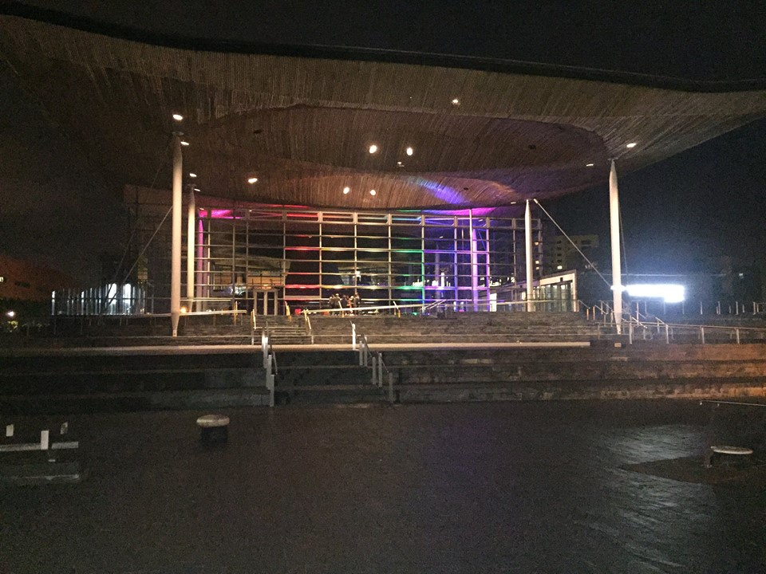
The Senedd lit in the colours of the rainbow flag for Pride Cymru

Welcoming People
The Assembly estate continues to be a popular visitor attraction for people from Wales and across the world, with both the Pierhead and Senedd welcoming thousands of people every month. People may come to attend an event, to watch Assembly Business, to visit the shop or cafe or look at an exhibition.
We promote the Assembly as a visitor attraction through connections with the local Cardiff Bay Waterfront Partners Group, through social media, through our outreach work and through Euan’s Guide, a listings and review website that helps disabled people and their families know which venues are accessible.
We continue to welcome a diverse range of groups to the Assembly for visits, events and exhibitions. From April 2015 - March 2016 we welcomed over 160,000 people to our estate.
In the past year we have welcomed:
- Exhibitions and events covering a range of equality and diversity issues;
- Visitors from across the world; and
- A range of visitors that reflects the diversity of Wales including tours for people with Attention Deficit Disorder.
We always make reasonable adjustments upon request for visitors. This year, adjustments have included adjustments to tours for visitors with mobility impairments.
Visitors join our tour manager to pose for a Senedd selfie

Accessible Estate
We continually review the accessibility of our estate, undertaking monthly maintenance audits and act upon feedback and adopt best practice. Further investment has been made to improve the physical accessibility of our estate. During this reporting period, the Assembly Commission has:
- refurbished the milling area toilet in Tŷ Hywel to improve accessibility. Signage has been installed to promote gender neutral and accessible toilets across the estate;
- continued with the programme of installing LED lighting to improve visibility in the Senedd and other areas across the estate including Siambr Hywel;
- installed space saving office furniture in Assembly Member offices to allow better access;
- installed larger archway security scanners in both Tŷ Hywel and the Senedd allowing access for wheelchair users through the arches:
- installed flashing fire warning beacons in the Pierhead; and
- refreshed the conferencing, voting and audio technology systems in the Senedd Siambr. The project included opportunities to enhance the ergonomics and accessibility of the Siambr.

British Sign Language interpretation of First Minister’s Questions
We continue to provide British Sign Language (BSL) interpretation for First Minister’s Questions (FMQs). Archived recordings of the interpretation of First Minister’s Questions are available on Senedd.tv as well as archived videos of all BSL interpreted meetings can also be found on the site. We have also continued to provide subtitled versions of First Minister’s Questions on our dedicated YouTube channel.

Assembly’s Website Refresh
A refreshed website was developed by teams across the Commission. Many aspects of the site were revised and refreshed making it easier for visitors to engage with the Assembly and access relevant information.

Going forward
- We will continue to reach out to the people of Wales in innovative ways to raise the profile of the Assembly and to encourage participation in our work.
- We will consider ways in which to integrate the Fourth Assembly’s Youth Engagement and Women in Public Life initiatives into the work of the Fifth Assembly.
- We will continue to celebrate, promote and share best practice in relation to equality and diversity.
- We will continue to ensure that visitors to our estate have the welcome that they deserve by providing the facilities and staff training necessary to make their visit comfortable and accessible.
- Supporting our Workforce: The Assembly Commission as an employer of choice
We strive to be an inclusive employer that supports the diverse needs of our workforce. We have a number of teams, policies and procedures in place to ensure that staff are supported, can be themselves and fulfil their potential.
Our workforce and recruitment equality data and equal pay audit report are published alongside this report attached as Annexes B and C respectively.

Arrangements to support Commission staff
We have a number of policies and initiatives in place to support our staff and to help us promote equality, foster good relations and remove discrimination. These include:
- dedicated teams and workplace equality networks that provide a range of advice and support;
- using our workplace equality networks to impact assess our policies to ensure they are fair and inclusive;
- an Employee Assistance Programme that offers a counselling and advice service to staff;
- a variety of flexible working arrangements which to allow staff to find a working pattern that suits their needs;
- annual Display Screen Equipment (DSE) assessments and reasonable adjustments;
- an annual Equality and Diversity week to raise awareness of different equality issues and promote the support available to staff. In June 2015, we had a programme of events which included: delivering training on: Transgender Awareness, Bisexuality Awareness, Disability Confidence, Dementia Friends, and Supporting LGBT staff. We also promoted equality internally and externally, with awareness raising blog articles on: Carer’s Week, the Assembly as an Inclusive Employer, Gender Stereotypes, Cultural Diversity, our BME Action Plan, Equality Impact Assessments, Supporting Disabled Staff, Unconscious Bias, and the Assembly as a Dementia Friendly organisation.
- regular awareness-raising initiatives on equality–related themes to inform staff and Assembly Members, including factsheets, training, and a monthly Equality Bulletin that lists relevant news, publications and consultations.

External Recognition
The Assembly has received the following external recognition for its work on equality and diversity:
- Ranked third in the UK in Stonewall’s Top Employers for LGBT people and named Top Public Sector Employer in Wales for LGBT people for the third year running.
- Listed as a Working Families Top 30 Employer during 2015 and was a finalist for the first time at the Top Employers for Working Families Special Awards 2015 for embedding flexible working and featured in the Equal Opportunities Review journal;
- Retained our commitment to the Positive About Disabled People and Age Champion campaigns;
- Retained Action on Hearing Loss Louder than Words charter mark and was awarded the Excellence Wales Silver Award;
- Retained the National Autism Society Access Award; and
- Retained our Investors in People Gold Standard.
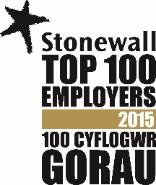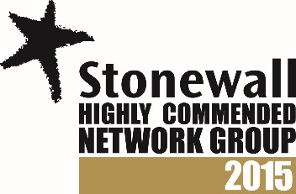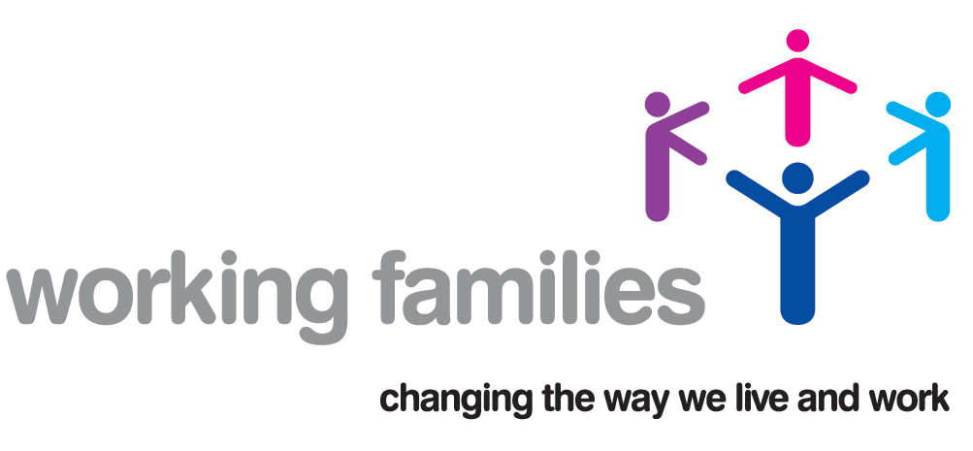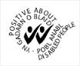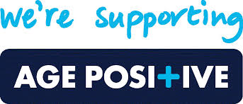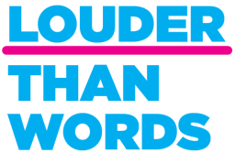

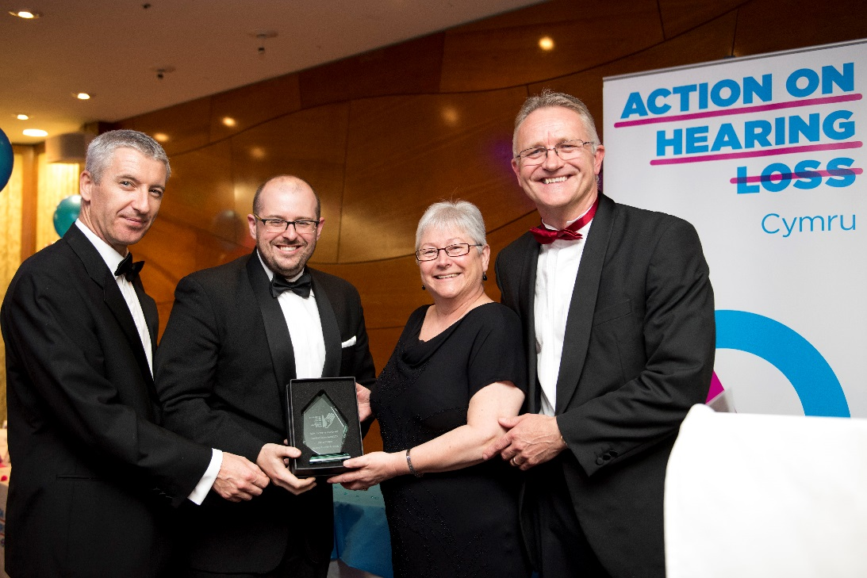
Sandy Mewies AM and our Diversity and Inclusion Manager receiving our Action on Hearing Loss award

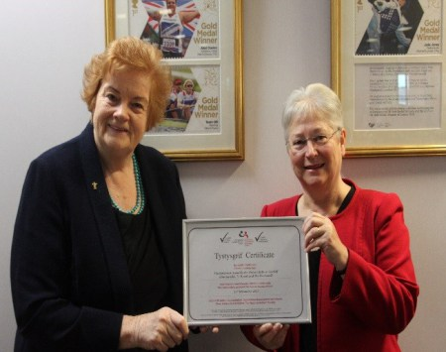
Dame Rosemary Butler with Sandy Mewies AM receiving National Autistic Society Autism Accreditation

Assembly Apprenticeship Scheme
The Apprenticeship Scheme is intended to encourage young people to consider the Assembly as an employer of choice. Our second apprenticeship scheme concluded in May 2015 and our third scheme is being prepared for the Fifth Assembly.
Assembly apprentice Stephanie Wetton, centre, with fellow nominees at the Apprenticeship Awards.

Workplace Equality Networks
Our workplace equality networks (formerly named staff networks) help us to promote equality, foster good relations and remove discrimination in a number of ways, including offering advice on equality, diversity and inclusion matters and impact assessing policies to ensure they are fair and inclusive. They have evolved over the duration of the Fourth Assembly and the number of network members and allies has increased. Our current networks are:
- REACH (Race, Ethnicity and Cultural Heritage);
- Embrace (Disability)
- Teulu (Working Parents and Carers)
- OUT-NAW (Lesbian, Gay, Bisexual and Transgender)
- Inspire (Gender)

During the year, a workplace network co-ordinator role has been developed within existing resources to support the networks on a strategic level which includes liaising with chairs, managing the budget and providing guidance and support. Workplace network activities over this reporting period have included:
- All networks being invited to feedback as part of equality impact assessments;
- Our BME staff network hosted the inaugural meeting of the Welsh Public Sector BME Staff Networks;
- Our Working Parent and Carer staff network undertook a member survey to identify where improvements could be made to the processes of supporting working parents and carers;
- Our Inspire network collaborating with other networks to raise awareness on learning and development needs identified by and specific to network members;
- Embrace members provided guidance on access issues in relation to refurbishment projects on our estate; and
- OUT-NAW marked International Day Against Homophobia, Biphobia and transphobia in May.

BME Action Plan: addressing underrepresentation issues in our workforce
The legacy of the work initiated by our BME Action Plan Co-ordinator has been incorporated into the work streams of colleagues in HR, Diversity and Inclusion and Communications. We will consider how to address underrepresentation in our workforce, particularly at senior level, as part of our planning for the Fifth Assembly’s Diversity Strategy. Our senior champion for BME staff works closely with REACH to take forward actions and promote race equality.
We will continue to focus on two main themes: supporting and developing existing BME colleagues and raising the profile of the Assembly Commission as an employer of choice for the widest pool of talent.
We continue to look at how we share information on job opportunities with their service users and contacts. To help increase engagement with BME people and improve the visibility of the Assembly as an employer of choice, the REACH network participated in a number of external events including launching the inaugural meeting of the Public Sector BME Network Wales.
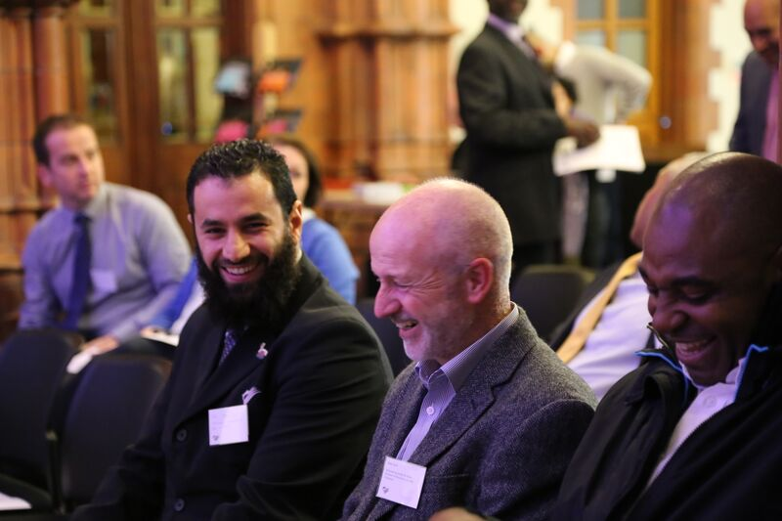
Assembly staff at a Black History Month celebration

Learning and Development
We have continued to provide staff with opportunities to learn more about equality, diversity and inclusion. In addition to continuing induction training and online training for all staff, we have delivered in-house workshops on Disability Confidence, Autism Champions, Supporting LGBT staff, Dementia Awareness and online training for understanding autism. This year, we also provided additional training for staff related to equality and diversity, including:
- identified and provided training to Mental Health First Aiders across the organisation;
- Trans Awareness and gender diversity training; and
- provided an introduction to British Sign Language (BSL) training for staff who have expressed an interest. The session acted as a taster for people who would like to proceed to learn level one.
We have also developed awareness factsheets on a range of topics including Cultural Diversity, Supporting an LGBT person when they are coming out, supporting disabled staff, and supporting Muslim staff during Ramadan.

Going forward
- We will continue to participate in benchmarking and accreditation exercises to ensure that we remain an inclusive employer and service provider.
- We will continue to implement our BME Action Plan and consider how this work is mainstreamed in our procedures and practices as part of a wider strategy to address under representation in our workforce.
- We will look for opportunities to promote the Assembly as an employer of choice for the widest pool of talent.
- We will continue to formalise and support our staff networks, refreshing them as ‘workplace equality networks’ to be inclusive of AMs, their staff and onsite contractors.
- We will continue to promote diversity and inclusion to our staff to further their understanding of the different needs and experiences of colleagues, visitors and the people of Wales.
- We will encourage staff to update their personal equality data on our HR / Payroll system and we will be exploring ways in which we can reduce the number of ‘No replies’ on the equality monitoring section of our recruitment application forms.

- Supporting Assembly Members, their Staff and Assembly Business
The Assembly Commission provides a range of support for Assembly Members to assist them in building equality considerations into their work within the Assembly, when employing staff and when engaging with the public.

Online Equality Training
The training includes information on each of the protected characteristics and includes sections on supporting staff, recruitment and providing services to members of the public. The training is supplemented by our Equality Act 2010 Factsheets aimed at Assembly Members and their staff.

Equality Information, Advice and Guidance
Our teams across the Assembly provide specialist advice and guidance to all Assembly Members, by:
- Providing employment, management and recruitment advice to Members;
- Building in equality considerations where relevant into briefings and research provided to Assembly Members and their staff from Research Service;
- Providing equality-related training to Members and their staff on a range of topics. Members and their staff are invited to other training such as Disability Confidence and Supporting LGBT Staff, and awareness events such as Equality and Diversity Week and No Bystanders anti-bullying campaign awareness;
- Ensuring that our workplace equality networks are open to Members and their staff either as allies or members; and
- Making Health and Safety assessments and Personal Emergency Evacuation Plans available to Members and their staff.

Equality and Access Fund
The Equality and Access Fund was established to ensure that Members have the necessary support to engage with constituents with a diverse range of needs, and provide additional support to disabled Members and disabled support staff. During this year the Fund has been reviewed to ensure it correlates with current equality law and it has been used to: provide a disabled access ramp for a Member’s office; translation of English documents into other languages for non-English speaking constituents; provide British Sign Language communication at meetings; telephone interpreting services; and provision of reasonable adjustments for staff, such as specialist software.

Assembly Committees
Assembly Committees continued to pursue the Commission’s aim of widening engagement with, and improving understanding of, the work of the Assembly. They did this by holding meetings and events outside Cardiff, as well as by finding new ways of capturing the views of people whose voices might not previously have been heard.
Some examples of how Committees have taken different approaches to widening engagement and/or have taken equality issues into account in the process of their work include:
- Enterprise and Business Committee engaged a sign language interpreter to enable a deaf stakeholder to take a full part in formal committee business, and for informal stakeholder engagement sessions during the year. The Committee’s Inquiry into Employment Opportunities for People over 50, looked at issues of age discrimination, and recommended research into the scale of the problem and campaigns to challenge age discrimination;
- The Health and Social Care Committee adopted a number of innovative methods to engage with the people of Wales during its inquiry into alcohol and substance misuse. It established a reference group, in partnership with NewLink Wales, to enable Members to draw on the experiences of service users and front-line service providers. In an Assembly Committee first, an online forum was set up to allow reference group members to share their views with Members between meetings using Loomio, decision-making software to assist groups with collaborative decision-making processes. They later attended an event to raise points made on Loomio with Members of the Committee ahead of an evidence session with the Deputy Minister. Members of the public and service providers were also invited to respond to an anonymous online survey so that those who may not usually respond to a Committee consultation could express their views. The Committee also developed a dynamic summary of its report using the ‘Slate’ publishing platform to communicate its findings clearly and succinctly.
- For an inquiry on supply teaching, the Children, Young People and Education Committee created two surveys: for children and young people of school age, and for their parents and carers. The survey asked participants about the use of supply teachers and its impact on pupils, including how lessons taught by supply teachers differ from those led by permanent teachers. The Committee received 1,486 survey responses: 929 from children and young people, and 557 from parents and carers. The survey results became a news item in their own right, as they were picked up by the media before the inquiry had been completed; and
- In addition to the more traditional production of hard copy reports, a number of committees have produced engaging summary reports designed to be read on mobile devices. Committees published these summaries on their webpages, shared them on social media accounts and embedded them within blog posts. The Communities, Equality and Local Government Committee saw the benefit of this approach for a report on poverty and inequality in Wales. The summary was viewed over 3,000 times.

CASE STUDY
Deffo
In March 2015 Deffo, a Swansea based forum for young deaf people, handed in a petition calling for improved access to education and services for deaf people in Wales. The Petitions Committee facilitated an interpreter for the event to ensure that all present could fully participate and has continued to provide support to the group in a number of ways to allow them to monitor the progress of their petition.
CASE STUDY
Renting Homes Wales Bill
The Communities, Equality and Local Government Committee considered the impact of the proposals in the Bill on 16 and 17 year olds – they were concerned that changes to contractual arrangements would mean that 16 and 17 year olds would have difficulties entering into contracts for utilities. They were also keen for a statutory requirement on landlords to provide guidance and support to 16 and 17 year olds entering into tenancies. The Minister subsequently amended the Bill so that it would not apply to 16 and17 year olds.
Committee Witness Training Programme for Women
Policy and Legislation Committee staff worked in partnership with Chwarae Teg on a second training programme to encourage women to give evidence to committee inquiries. This second training programme focused on women from minority communities. The first session on ‘what makes good evidence’ involved presentations from the Deputy Presiding Officer, staff from Policy and Legislation Committee Service, Research Service, Translation and Outreach. The Deputy CEO of Techniquest also talked about her experience as a previous participant in the programme and as a witness to the Enterprise and Business Committee. Members of staff role-played Assembly Members in a ‘mock’ committee meeting, which helped demystify the experience of giving evidence and build the women’s confidence in speaking in front of a committee, as well as giving staff a better understanding of what it is like to be a committee Member. The feedback from participants was very positive. A photo-blog of the event is available.
Some of the women who participated in the first scheme gave evidence formally to committees during this reporting period, utilising the training they had previously received.

Going forward
- We will ensure that Assembly Members have the necessary support, information and advice in place to build equality considerations into their roles as employers, elected representatives and service providers.
- We will continue to promote equality-related training to Members and their staff, including Disability Confidence, Dementia Friends, and Supporting LGBT staff.
- We will continue to promote workplace equality networks to Assembly Members and their staff and ensure that they are invited to network events.

- Embedding Equality into our work

Monitoring and Reporting
Progress on achieving the objectives set out in the Equality Action Plan is monitored on an on-going basis (Annex A). Our Annual Equality Reports are scrutinised by the Commission’s Management Board and the Assembly Commission to ensure compliance with our legal and corporate responsibilities and to monitor progress on our Action Plan.
We have undertaken an analysis of workforce and recruitment equality data and carried out an equal pay audit. These reports are available at Annexes B and C.
Going forward, the key actions resulting from the analysis are: building on our BME Action Plan, enhancing our recruitment webpages and recruitment outreach activity, reducing the number of ‘No replies’ on our equality monitoring form and reviewing how our HR/IT payroll system can be best utilised to gather and review data.
Findings from the equal pay audit revealed a limited number of pay differentials for which we were able to provide justifiable explanations. Overall, the analysis indicated that there was an equal pay risk on the grounds of race/ethnicity and we have detailed our approach to addressing this in Annex C.

Building Equality Considerations into Our Work
During the last year, we have introduced a more formalised system of Equality Impact Assessments (EQIAs) to ensure that we have a consistent approach across the organisation. Staff who were nominated as EQIA Leads across the service areas received formal training in Autumn 2015 on how to carry out EQIAs. Since that time, colleagues have worked, with the Diversity and Inclusion Team in a supporting role, to undertake EQIAs and share their experiences with others.
Over the last year, equality has been considered on an ongoing basis as part of a range of projects and policies, including:
- My Senedd programme;
- Our outreach and engagement work;
- Written brand narratives;
- Staff policies; and
- Building work and refurbishments.

Procurement
We take every opportunity to champion equality throughout our procurement process and on-going contract management.
Equality is included as part of our sustainability risk assessments at the very start of a procurement process and as part of the pre-qualification process. Suppliers who fail to demonstrate their commitment to equality are not invited to tender.
Through our work on social responsibility, we look at the supply chain for our goods and we ensure that the living wage is paid to contractors working in our buildings.
To further raise awareness of equality we include a specific question on Corporate Social Responsibility in our contract review meetings with our suppliers and our terms and conditions of contract include a clause on “Equality Considerations” ensuring that equality is a contractual obligation.

Going forward
- We will ensure that staff have the confidence to implement our new approach to EQIAs.
- We will publish all completed EQIAs on our website.
- We will ensure that contract managers have the support necessary to build equality into their review meetings.

Annex A: Progress on Achieving Equality Objectives

Priority Objective One: Encouraging and Widening Public Engagement

Actions for 2015-2016
Actions | Lead Responsibility | Update - March 2016
Review written outputs to ensure people understand the role of the Assembly and Assembly Members | Head of Communications | The team has been running the Managing Assembly Content project to review and refine the Assembly’s written messaging. The project is nearing completion and its first outputs were launched in February. These outputs included publications and videos to explain the role and powers of the Assembly and how Members are elected.
Consider how we provide hard copy information in a range of community locations | Head of Communications | The Outreach team provides hard copy information to community groups as part of their everyday work. They also regularly visit Members in their offices in the constituencies and regions and share hard copy information with them.
Develop a new introductory publication in a range of accessible formats and languages | Head of Communications | The first outputs of the Managing Assembly Content project, which were launched in February 2016, included videos in BSL and publications in easy read, large print and a range of languages. These materials covered the role and powers of the Assembly, the importance of voting and how the voting system works. Before the second set of project outputs are launched, they will also need to be translated into a range of formats in order to provide up to date information to all of our audiences.
Provide plain language training to staff | Head of HR training, Head of Communications | In light of the introduction of the new written output materials, the need for plain language training has reduced as the purpose of the managing Assembly Content Project is to create clarity and consistency in our written outputs across the service areas. We have a Writing Style guide to ensure readability and consistency.  A number of different writing skills courses are available as part of the internal Learning and Development course offering. We have run an introductory Effective Writing course for staff and a more in-depth Writing Skills course.
Review and update database of equality groups for consultations | Head of Policy and Legislation Committee Service, Head of Chamber and Committee Service and Head of Research Service | Our Committee, Research and Outreach teams continue to build relationships with a range of equality groups. They are constantly reviewing and developing their contact lists in order to engage more grass roots and community groups in Assembly Business.

On-going Commitments
Actions | Lead Responsibility | Update - March 2016
Focus on engaging grass roots and diverse groups in our engagement and consultation strategies  Develop outreach work to increase committee engagement | Head of Communications, Head of Policy and Legislation Committee Service, Head of Chamber and Committee Service and Head of Strategic Transformation | Over the past 12 months the Assembly Outreach team has engaged these groups directly in Assembly committee business. Examples include:  - Digital engagement with a more diverse range of grass roots bloggers and hyperlocal websites to promote committee work on local and subject based levels. For example, engaging with popular Welsh food bloggers to promote the Scrutiny of First Minister committee meeting on promoting Welsh produce.  - Holding sessions on effective consultation working with Ceredigion Association of Voluntary Organisations.  - Holding sessions with local and regional Bus and Community Transport Forums to gather evidence for the Enterprise and Business Committee Inquiry into Bus and Community Transport Services.
Develop our use of social media to reach a diverse range of groups | Head of Communications | The Digital Media team has developed a more effective engagement strategy on social media with more accessible content and better use of visuals.  - As a result of this, Instagram followers increased by 600% since May 2015, a platform that has also seen the biggest growth in young users in the last year.  - The Senedd Facebook page had several high impact ‘viral’ posts and broke 1,000 Likes.  - Young people, women and BME groups have been identified as key audiences for the Wales2016 election awareness raising campaign, both in terms of the content produced, and the channels they have been distributed on. These groups have been specifically targeted through Facebook advertising, using content specifically tailored for those audiences, with one video aimed specifically at women becoming one of our top videos ever posted on Facebook with a reach of close to 100,000.  Surveys promoted as part of committee consultations are promoted both online and offline with a diverse range of groups include:  - The Health and Social Care Committee Consultation on the Public Health (Wales) Bill (766 responses). The survey was promoted on all social media channels, with targeted promotion with stakeholders such as Family Information Services, Local Authorities, Youth Offending Teams, Local Health Boards and Community Councils)  Enterprise and Business Committee Inquiry into Bus and Community Transport (1,011 responses). The survey was promoted through visiting school groups, through general visits to the Senedd, and with representative organisations such as Traveller Partnerships and Rail Users Associations). We also conducted survey specific focus groups with Disability Rights Campaigners (People’s First and various Disability Transport Forums) to discuss the survey in greater depth.
Promote Outreach work through social media, local media and local contacts | Head of Communications | The Outreach team actively promotes the work that it undertakes through the use of social media and through third party media sources.  - It has its own twitter accounts, both in English (@SeneddOutreach) and Welsh (@SeneddAllgym) The team uses twitter to actively promote understanding and engaging sessions that are available and those that are taking place around Wales. The twitter accounts are also used in order to promote any large scale projects for example the #Wales2016 campaign for the National Assembly for Wales’ election.  - The Communications team liaises with media and social media contacts to raise awareness of Outreach work, which has seen political bloggers and BBC Wales publish information on the work of the team such as survey data compiled for the Inquiry into Supply Teaching.  As part of BBC Wales’ coverage of the Assembly election the Outreach team were featured in their news items and video content, demonstrating the work undertaken by the team in raising awareness of the election across Wales with a variety of diverse groups.
Work more closely with Members and the Presiding Officer to promote public engagement | Head of Communications | Assembly Members are invited to attend Outreach sessions as a matter of course. Assembly Members are also a focal point for the vast majority of engagement activity with Assembly committees, shaping the types of audiences we engage with and then participating in engagement with these audiences. Recent examples include:  - The Constitutional and Legislative Affairs Committee consultation on the draft Wales Bill. Here, Members first met with a range of organisations (RSPCA, WAO, CLA as examples) to discuss the practical implications of the additional powers held within the Bill.  - The Finance Committee’s consultation on the Tax and Management (Wales) Bill. Here, Members met with a range of organisations to discuss the implications of new tax raising powers. Stakeholders included: The Bevan Foundation; Wales Audit Office; Federation of Small Businesses and Geldards LLP.  A suite of resources are being produced in preparation for the Fifth Assembly which will help Assembly Members explain their role, the difference between the National Assembly for Wales and the Welsh Government, and how the voting system works. A specific set of materials are also being developed to explain the role of the Presiding Officer.
Develop and promote a cross-Wales programme of events related to promoting equality | Head of Communications | We meet with a range of diverse groups and ensure that equality events are always considered as part of the summer events programme. We attend Pride Cymru in Cardiff, Swansea Pride and Cardiff Multicultural Mela to reach audiences that may not otherwise have engaged with the Assembly. Each year we review the range of events that we attend across Wales to ensure that all events are considered as part of the summer event programme.
Undertake monthly maintenance checks of accessible services | Head of Estates and Facilities | Monthly maintenance checks are still on-going and any actions taken forward as necessary.
Use a checklist to ensure accessibility of venues booked across Wales | Head of Policy and Legislation Committee Service, Head of Chamber and Committee Service, Head of Communications | Accessibility remains a priority when booking external venues and a checklist is used to ensure all considerations are taken into account before booking a venue. Outreach and Events Teams consult with the Equality Team for advice when necessary and use a local access group to provide additional advice when necessary.
Promote relevant debates to representative groups | Head of Communications | The Outreach team regularly emails their contacts with information on upcoming debates on topics of interest, some of which will have taken part in committee consultations.  Examples include:  - Sharing a consultation exercise on the Environment (Wales) Bill with those who contributed to the Environment and Sustainability Committee Inquiry into Recycling in Wales;  - Sharing a consultation exercise on the Inquiry into Alcohol and Substance Misuse with those who contributed to the Health and Social Care Committee Inquiry into New Psychoactive Substances;  - Sharing a consultation exercise on the Inquiry into Bus and Community Transport Services in Wales with signatories and petitioners who contributed to a number of petitions handled by the Petitions Committee during the Fourth Assembly involving transport and bus services.  Relevant debates are also promoted across the Assembly’s social media channels.
Promote petitions to diverse groups through outreach and communications | Head of Communications | The petitions process is promoted during presentations and workshops with community groups.
Review processes to identify and remove barriers to engagement and involvement | Head of Assembly Committees, Head of Chamber and Legislation Service, Head of Communications | The Wales 2016 election awareness raising campaign has seen us engage with BME, women and youth audiences to increase levels of awareness and understanding around the upcoming election.  This has been done using digital and face to face engagement techniques, including:  creating an election website testing our content with a sample of the audiences mentioned above to make sure the messaging is accessible and relevant to those groups producing easy read content and materials translated into seven different languages distributing materials to various representative groups, directly to households in areas with high levels of BME residents, and in places of community interest across Wales.  Training is provided for web content publishers to promote good practice for publishing content in an accessible way on the Assembly’s website.  A new style inquiry page has been trialled with the Enterprise and Business Committee for their inquiry into Welsh Rail Infrastructure, which focused on providing information about the inquiry in a more accessible writing style, providing simpler context and less jargon for less expert audiences. Improvements have also been made to the website, with a new home page, business landing page and news page to provide more current, relevant and contextual information to people visiting the website.  Opportunities to take part in less formal means of submitting evidence to committee inquiries is regularly available as part of the support the Outreach team offers, examples include:  Contributions through surveys (examples include the Public Health (Wales) Bill and Inquiry into Bus and Community Transport in Wales.  Roundtable discussions (examples include security of the draft Wales Bill and consultation on the Tax Management (Wales) Bill;  Focus groups (example includes the Inquiry into Bus and Community Transport in Wales, which catered to those service users and individuals who were unable to contribute through the survey); and  Video interviews (example includes scrutiny of the Environment (Wales) Bill and specific provisions relating to shellfisheries.
Audit the use of the Assembly estate as an event venue by a diverse range of groups | Head of Front of House | We collect monthly data on the range of events and exhibitions held on site. We analyse the data to identify any gaps.
Ensure access issues are considered for events through equality impact assessments | Head of Front of House Events, Head of Corporate Events | Access issues are considered as part of every site visit prior to an event.  When delivering Assembly led events access issues are routinely considered. Where appropriate we will ask an external access group to come and assess potential event venues, we will take and act upon their advice when finalising the event venue.  We are constantly looking to improve our services and actively seek feedback to ensure that we are meeting the needs of our diverse customers.
Promote the availability of tours and visits to a diverse range of groups | Head of Front of House | The availability of tours and visits is promoted to all groups by the Outreach team, the website and by the booking team. We regularly promote tours and visits via social media to reach communities across Wales. We offer adjustments on a case by case basis.  We promote the Senedd and Pierhead as accessible visitor attractions on the Euan’s Guide website. The site also enables us to capture feedback on visits. The link to Euan’s Guide is at the bottom of the feedback email we send to each group after their visit. We also promoted BSL tours of the Senedd for Disability Access Day in March.
Facilitate tours in British Sign Language (BSL) upon request | Head of Front of House | We have not had any requests for tours in BSL during this reporting period. All requests for reasonable adjustments however are met.
Review information and signage directing people to the Assembly | Head of Estates and Facilities | Discussions with Cardiff Council and the Cardiff Harbour Authority about the provision of additional signage for the Assembly around Cardiff Bay are still ongoing.
Front of House staff undergo training on welcoming diverse visitors. | Equality Manager, Head of HR training, Head of Front of House | All new staff undertake equality training related to an inclusive workplace and providing accessible services. We have delivered Disability Confidence training to all Front of House and Security staff. We have a procedure in place to welcome BSL-users to our estate.  We have trained Autism Champions across the organisation, including our Front of House and Security teams, to ensure that they can confidently welcome and support visitors with autism.

Completed and Closed Priority Objective One Actions
Undertake an access audit of our website and prioritise actions
Produce a toolkit of ways of conducting inclusive consultations
Review current event guidance to include information on accessibility to third parties holding events here by sharing our accessible publications guidance
Provide visitor information prior to security check in the Senedd
Undertake an access audit of the Assembly Estate and prioritise actions
Assess the feasibility of undertaking a further Step Up Cymru mentoring scheme
Create signage outside the Senedd to welcome visitors and to promote services and facilities
Review our publications brand /style guide to identify and prioritise actions to address any barriers to access

Priority Objective Two: Assembly Commission as an Equality of Opportunity Employer

Actions for 2015-2016
Actions | Lead responsibility | Update - March 2016
Produce data to demonstrate gender split by service area for next reporting period. | Head of HR | This now routinely occurs as part of capacity planning rounds.
Consider how new HR / Payroll system could be used to capture equal pay data on internal promotions and how many new starters start on minimum pay point. | Head of HR and Equality Team | Work is still ongoing to identify how best to approach this using our system.
Increase the completion rate of equalities data form within the recruitment application process in order to develop greater insight into recruitment activity. | Head of HR | From the Fifth Assembly, both internal and external candidates applying for our jobs will be required as part of the application process to submit a completed equality monitoring form. Applications will not be considered without submission of this form. Candidates will be given the option ‘prefer not to say’ and anticipate higher rates of disclosure of equality data as a result.
Explore how new HR / IT Payroll system could be used to report separately on internal and external recruitment, alongside other useful data sets. | Head of HR | New databases have been designed to report separately on this and will be operational later in 2016.
Re-brand our recruitment webpages and publicise the support available to staff (e.g. staff networks, workplace policies) to encourage applications. | Head of HR with support from Equality Team | New web copy has been prepared in preparation for the Fifth Assembly which includes information about our staff networks, staff testimonials, benefits of working and the Assembly and our inclusive workplace policies.
Liaise with representative bodies to promote jobs | Head of HR | This area of work has been subsumed into the workstream of HR Recruitment Team (see update below on BME Action Plan).
Encourage more staff, including new starters, to self-identify on enhanced HR / Payroll system. | Head of HR  Internal Communications | Staff are able to amend their personal data via our HR self-service system. As part of induction for new staff, the Equality Team explains why it is important for staff to update their details and what we do with the information provided. Staff are periodically reminded to update their details via newspage alerts.
Implement BME Action Plan via the BME Action Plan Co-ordinator. | Head of HR with support from Equality Team | The BME Action Plan Co-ordinator’s fixed-term contract expired in summer 2014 and the work streams initiated by the Co-ordinator have been subsumed into the work of the HR Recruitment Team and Equality Team. The two main themes of this work are: supporting our existing BME colleagues to fulfil their potential and encouraging applications from the broadest range of talent.
Continue to support staff networks and invite them to encourage applications for employment utilising their contacts. | Equality Team and Head of HR | Our Staff Network Co-ordinator (based in the Equality Team) is developing their role to support the networks. Networks have been encouraged to share job vacancy adverts with their contacts.
Continue to promote equality and recruitment training, including unconscious bias training. | Head of HR | All new recruiting managers receive unconscious bias training as part of their recruitment training. Unconscious bias training in e-learning format is available for staff to use and we will further explore how to widen unconscious bias training out among staff.
Continue to participate in benchmarking exercises i.e. Stonewall WEI, Working Families and Action on Hearing Loss Charter Mark. | Equality Team and HR | The Assembly has received and/or continues to receive recognition from the following benchmark and accreditation initiatives:  - Ranked third in the UK in Stonewall’s Top Employers for LGB people and named Top Public Sector Employer in Wales for the third year running;  - Investors in People Gold Standard;  - Action on Hearing Loss Charter Mark;  - National Autistic Society’s Access Award;  - Working Families Top 30 Employer
Develop mental health and wellbeing policy | Head of HR Operations, Head of Health and Safety | A volunteer staff focus group has convened to develop a draft mental health policy for staff. A draft policy has been developed in readiness for further consultation with a view to launching a finalised policy in summer 2016.
Equality Impact Assess recruitment practices | Head of HR Training, Head of HR Recruitment | This is happening on an ongoing basis; we will feed this work into the development of the Fifth Assembly’s Diversity and Inclusion Strategy.
Develop guidance outlining the support available for staff networks | Head of HR Operations,  Equality Manager | Guidance document is nearing finalisation and one member of the Equality Team’s role now includes the function of co-ordinating and supporting the staff networks. Main responsibilities of this role include managing the networks’ budget, offering ongoing guidance and support to both network members and chairs and facilitating joint working between the networks.

On-going Commitments
Actions | Lead Responsibility | Update – March 2016
Run annual Equality and Diversity Week to raise staff awareness of equality issues | Equality Manager | In June 2015, we had a programme of events which included: delivering training on: Transgender Awareness, Bisexuality Awareness, Disability Confidence, Dementia Friends, and Supporting LGBT staff. We also promoted equality internally and externally, with awareness raising articles on: Carer’s Week, the Assembly as an Inclusive Employer, Gender Stereotypes, Cultural Diversity, our BME Action Plan, Equality Impact Assessments, Supporting Disabled Staff, Unconscious Bias, and the Assembly as a Dementia Friendly organisation.
Promote support mechanisms to staff – networks, Equality Team, employee helpline, HR, Unions | Equality Manager | We promote support mechanisms in a number of ways, including to all new starters as part of our induction process. We regularly promote our staff networks though internal articles. Our employee helpline is promoted to staff via our intranet site and across the organisation through a poster campaign. All of our HR policies are reviewed and promoted to staff and our Unions have a dedicated noticeboard to promote their services to staff.
Undertake Display Screen Equipment Assessments for all Assembly staff | Head of HR Health and Safety | All new members of staff have a DSE assessment within their first three months. Staff can contact colleagues who act as our DSE assessors should they begin to experience any issues.
Promote equality-related policies to staff | Head of HR Operations | Equality-related documents are promoted to staff on the Intranet Newspage. New and updated policies are promoted via drop-in and awareness sessions which are advertised on the Newspage to encourage attendance. All policies are also promoted to members of our staff networks and TUS.
Undertake a rolling programme of Equality Impact Assessments of staff policies  Involve staff networks in the Equality Impact Assessments of corporate, where appropriate | Head of HR Operations, Equality Manager | We maintain a rolling programme of staff policy reviews and proposed policy reviews that are impact assessed with the assistance of our staff networks, Equality Team and TUS.
Ensure all recruitment panels undergo equality awareness training | Head of HR Training, Head of HR Recruitment | Panel members undergo recruitment training including a section on equality, access, and reasonable adjustments. Our mandatory online training also covers recruitment best practice and dealing with unconscious bias. All Recruiting Managers to undergo refresher training every three years.
Undertake annual equal pay reviews | Head of HR Operations | We undertake annual equal pay reviews. Our review as at 31 March 2016 is attached at Annex C.
Undertake regular staff surveys | Survey lead, Head of HR Operations, Equality Manager | The Assembly Staff survey was undertaken in May 2015 and the vision for this survey was to move away from an annual stand-alone ‘audit’, aiming instead to use the survey as a barometer used to measure levels of employee engagement, and to highlight and complement on-going engagement activities throughout the year in preparation for the Fifth Assembly. Follow-up sessions were arranged for staff.
Offer one work placement a year to people from under-represented groups | Head of HR Recruitment | We encourage a number of representative placements through positive action. For example, in partnership with Stonewall, a short-term work placement was taken-up by one of Stonewall’s supporters which allowed the person to experience the breadth of work undertaken by staff at the Assembly.
Develop communications to address barriers to applications from a diverse range of people | Head of HR Recruitment | We continue to develop tailored literature for community events and for community groups to develop a better understanding of the Assembly application process. We have outreach sessions to engage with communities at the grassroots level and also work with partners to help deliver our message.  We have increased engagement with the Assembly external outreach teams so that information on recruitment can be shared with diverse communities.  We have updated our web copy for the recruitment pages of our website in readiness for the Fifth Assembly to better reflect the diversity of our workforce by use of staff testimonials and information on our inclusive workplace policies etc.  Over the reporting period, we have utilised social media and our range of contacts with a view to sharing job vacancies as widely as possible.

Completed and Closed Priority Objective Two Actions
Develop and implement training strategy for all staff
Develop glossary of equality language and promote to staff
Build equality considerations into Management Development Programme
Establish BME staff network
Establish staff maternity network
Recruit a BME Action Plan Co-ordinator
Reinstate disability data for next reporting period.

Priority Objective Three: Supporting Assembly Members and their Staff

Actions for 2015-2016
Actions | Lead Responsibility | Update – March 2016
Develop training and awareness raising strategy for Members and their staff on equality issues | Head of Commission and Members’ Support Team,  Equality Manager | Assembly Members and their staff have access to online equality training, in addition to a suite of other continuing professional development opportunities. Members and their staff are also invited to participate in awareness-raising events such as Equality and Diversity Week.  The Equality Team holds workshops on supporting LGB staff, disability confidence and dementia friends training to which Members and their staff are invited. The Team has also produced equality factsheets for Members which outline their responsibilities under the Equality Act 2010 as employers and service providers.  A new equality module for new Assembly Member Support Staff (AMSS) induction for the Fifth Assembly is in development with an aim for roll-out after the May 2016 election.

On-going commitments
Actions | Lead Responsibility | Update – March 2016
Annually review, update and promote equality guidance for Assembly members | Equality Manager, Head of Commission and Members’ Support Team | The equality factsheets relating to the Equality Act 2010 are being checked and updated by our Legal Services Team in readiness for the Fifth Assembly.
Promote workplace networks to Members and their staff through internal communications | Network Chairs, Equality Manager | Our networks are promoted to Members and their staff through our internal website, leaflets and posters. They are invited to join the networks as members or to support them as allies.  Promotion of networks will be included in the new induction programme for support staff and information will be included in the Assembly Members’ Handbook for the Fifth Assembly.
Ensure that equality is considered in all areas of research work | Head of Research Service | Equality continues to be mainstreamed into the Assembly’s research work, through:  - Support for committee inquiries: the Communities, Equality and Local Government Committee inquiry into poverty looked specifically at the differential impact of low income on different groups of people. The Enterprise and Business Committee specifically considered disability issues during the inquiry into bus and community transport services. The Health and Social Care committee explored issues relating to older people in the alcohol and substance misuse inquiry. The new Children, Young People and Education Committee has recently initiated an inquiry into access to youth work.  - Financial scrutiny - during the draft budget scrutiny process, researchers were provided with a toolkit for analysing budgets from an equality perspective. The majority of briefings contained questions on equality.  - Disaggregated statistics – the Research Service team routinely published labour market statistics, broken down by gender and age. The team also plans to produce an analysis of the Assembly election results and women’s political representation.  - Proactive publications on specific equality issues include: children’s rights (multiple blog posts), international women’s day, special educational needs, mental health, obesity, an update on the Equality and Human Rights Commission’s research in Wales, and the Violence Against Women Act.  New Assembly Members’ induction - to assist new Assembly Members in getting up to speed on areas of interest, the Research Service will produce reading lists, including one specifically on equality and human rights. In addition to this, the Key Issues for the Fifth Assembly publication included an article on the current state of equality and human rights in Wales, which received good feedback from Members and external stakeholders. The equality researcher also plans to meet with new party spokespeople on equality to discuss topical issues and suggest areas of research.
Promote the work of Outreach and Events Teams to Members to include them in our work to promote equality | Head of Communications | Members take part in Outreach and Events work for Committee scrutiny, taking part in site visits and events, which include equality groups.

Completed and Closed Priority Objective Three Actions
Provide Members with a checklist for hiring / using accessible venues
Develop a glossary of equality language
Introduce and promote Access Fund to support disabled Members and to support Members to effectively communicate with diverse constituents

Priority Objective Four: Embedding Equality into Organisational Management

Actions for 2015-2016
Actions | Lead Responsibility | Update – March 2016
Introduce new system of undertaking Equality Impact Assessments (EQIAs) of our decisions, policies and practices. | Equality Manager, Policy leads | EQIA leads received training in November 2015 and the toolkit and guidance was re-circulated to all leads. Over the reporting period, the Equality Team has supported leads in developing EQIAs and we are gradually building up a bank of best practice EQIA examples.
Build Equality Impact Assessing into strategic developments and Project Initiation Documents. | Equality Manager, Policy leads | Our Projects, Business Analysis and Strategic Transformation teams have built EQIAs into their processes. All business cases for Investment and Resourcing Board include an EQIA process.

On-going commitments
Actions | Lead Responsibility | Update – March 2016
Ensure Equality is built into the entire procurement process | Head of Procurement | Equality forms part of our sustainability risk assessment at the very start of a procurement process. Equality is also part of our Pre-Qualification Questionnaire. Suppliers who fall short of our expectations on equality are not invited to tender. Our work on social responsibility has seen us look at the supply chain for our goods and we ensure that the living wage is paid to our contractors’ staff working in our buildings.
Ensure equality is considered in all areas of legal advice and drafting. | Director of Legal Services | Our Legal Services Directorate provide advice and guidance to Assembly Members, Committees and Assembly Commission staff. Over the last year, equality-related advice has included: ensuring revised terms and conditions of contracts contain equality clauses and are up to date in respect of all current protected characteristics; a review of the equality aspects of the Equality and Access Fund and advice on Members’ responsibilities as employers for the Assembly Members’ Handbook for the Fifth Assembly.
Monitor equality –related issues and complaints | Equality Manager | Colleagues from across the Assembly share feedback with the Equality Team. The Front of House Team prepare monthly complaints and feedback updates for the Equality Team to take any action as necessary.
Promote the equality agenda by working with the Presiding Officer, Assembly Commissioners and Chief Executive via internal communications and sponsoring and speaking at events | Equality Manager | The Equality Team works closely with the Presiding Officer, Assembly Commissioners, Chief Executive and colleagues across the organisation to promote the equality agenda.  The Presiding Officer, Dame Rosemary Butler AM, received a special recognition reward from Stonewall Cymru in January for championing LGBT equality.  We ensure that all events hosted by third party organisations that relate to our equalities agenda are brought to the attention of our Commissioners and Presiding Officer
Share our corporate values with suppliers and the public | Head of Procurement, Head of Communications | Our corporate values are built into our procurement processes and form part of contract discussions with suppliers. Our expectation is that suppliers who do business with us share our values. The Procurement pages on our website provide a link to the Assembly’s equality plan.

Completed Priority Objective Four Actions
Produce Annual Equality Reports which identify performance on achieving objectives

Annex B: Monitoring Workforce and Recruitment Data
Our workforce exists to support the efficient running of the National Assembly for Wales by providing services to Assembly Members, their staff and the public. Each year, we collect, analyse and publish equality data on our workforce and recruitment campaigns.
From this information, we are able to identify the diversity profile of our workforce, the people we attract to apply for jobs and to whom we offer employment. We use the analyses of these monitoring exercises to help us ensure the diverse needs of staff and members of the public are met through improving policies, services and working practices. An equal pay audit report is also available.
All data presented is as at 31 March 2016. As 98% of our workforce is based in Cardiff Bay, we are using the Cardiff Travel to Work Area (TTWA) to compare the characteristics of our workforce to the wider Cardiff population.

Workforce Data
Our workforce data is collated via our HR / Payroll system. We collect the information to enable us to create monitoring reports. Where there are small numbers of staff we have merged certain categories within the tables in the report to ensure that individuals’ privacy is protected. Raw data is only seen by a small number of key staff in the HR/Payroll Team and is held securely on a confidential basis in line with data protection requirements.
One of our identified on-going actions is to further increase the number of staff who self-identify their equality characteristics and update them on the HR / Payroll system.
Our staff structure is organised as:

Grade | Number as at 31 March 2016 | % at 31 March 2016
Senior Staff, including Chief Executive and Directors | 5 | 1.1
Executive Band 1 | 14 | 13.1
Executive Band 2 | 47 | 10.5
Management Band 1 | 66 | 14.8
Management Band 2 | 121 | 27.1
Management Band 3 | 65 | 14.6
Team Support | 128 | 29.0
Total | 446

Recruitment Data
The Assembly Commission’s recruitment policy commits to advertising all posts above Team Support internally in the first instance, where possible. If no suitable appointees are found, the job then goes to external recruitment. Occasionally and only with a supporting business case will we go direct to external recruitment.
The recruitment data presented below is related to external recruitment schemes that closed during the reporting period of April 2015-March 2016. As such, this includes schemes which were advertised in the 2014-15 reporting period but were not completed until after 1 April 2015. Assembly Commission staff who apply for posts advertised externally are also included in the data for external recruitment schemes.
Some of our temporary vacancies did not require applicants to complete an application form but to submit a CV instead. Although our equal opportunities monitoring form was available on the website for applicants to complete, very few submitted these details when applying by CV.
Going forward we will utilise our HR / Payroll systems to capture data on internal progression/internal recruitment data. We will also require that equal opportunities monitoring forms are mandatorily submitted to enable the application to be processed.
To ensure equality during recruitment schemes we have:
- Gender balanced panels;
- Recruitment training for panel members; and
- Mandatory equality training including recruitment and unconscious bias.

Age
Table 1: Age Profile of Workforce. Disclosure rate: 100%
Age range | Number | % of total workforce | % total 2014-15 | % Change
Under 21 | 3 | 0.7 | 1.6 | -0.9
21-25 | 36 | 8.1 | 7.0 | 1.1
26-30 | 50 | 11.2 | 14.4 | -3.2
31-35 | 94 | 21.1 | 21.9 | -0.8
36-40 | 83 | 18.6 | 16.3 | 2.3
41-45 | 48 | 10.8 | 10.5 | 0.3
46-50 | 45 | 10.1 | 8.6 | 1.5
51-55 | 39 | 8.7 | 9.5 | -0.8
56-60 | 31 | 7.0 | 6.7 | 0.3
61-65 | 13 | 2.9 | 2.6 | 0.3
65+ | 4 | 0.9 | 0.9 | 0.0
Total | 446 | 100.0 | 100.0

According to data from the 2011 Census, 14.3% of people in the Cardiff Travel to Work Area (TTWA) who are economically active and employed are aged under 24.This compares to 8.8% of our workforce who are aged under 25. At the time of writing, we are making preparations to launch our third Apprenticeship Scheme with which hope to see an influx of new starters under the age of 25.
The 2011 Census states that 23.9% of people who are economically active and employed in the Cardiff TTWA are aged 50 to 64. This compares to our workforce where 18.6% are aged between 51 and 65.

Table 2: External Recruitment (including internal applicants) by Age
Age |  | Applications received |  |  | Successful at sift |  | Offer of employment |  |  | Overall success rate | Overall success rate 2014-15
 |  | number | % of total applications |  | number | % of applications successful at sift | number | % of those successful at sift offered employment |  | % | %
<20 |  | 10 | 1.2 |  | 1 | 10.0 | 1 | 100.0 |  | 10.0 | 0.0
20-29 |  | 467 | 53.8 |  | 72 | 15.4 | 20 | 27.8 |  | 4.3 | 5.8
30-39 |  | 194 | 22.4 |  | 50 | 25.8 | 11 | 22.0 |  | 5.7 | 7.6
40-49 |  | 101 | 11.6 |  | 29 | 28.7 | 3 | 10.3 |  | 3.0 | 3.9
50-59 |  | 42 | 4.8 |  | 12 | 28.6 | 3 | 25.0 |  | 7.1 | 0.0
60> |  | 5 | 0.6 |  | 0 | 0.0 | 0 | 0.0 |  | 0.0 | 0.0
No reply |  | 49 | 5.6 |  | 12 | 24.5 | 4 | 33.3 |  | 8.2 | 7.8
Total |  | 868 | 100.0 |  | 176 | 20.3 | 42 | 23.9 |  | 4.8 | 5.7

Younger people
The low number of people under the age of twenty applying for jobs at the Assembly is partly due to the fact that we did not recruit for our apprenticeship scheme during this reporting period as we continue to support the current intake. We anticipate that the number of applicants and success rate of applicants under 20 will improve when our next apprentice scheme commences in summer 2016.
There was a decrease in the percentage of ‘No replies’ from 10.2% in 2014-2015 to 5.6% during this reporting period.

Older people
During 2014-15, we did not offer employment to anyone aged over 50, (who made up 7.2% of total applications). However, in this reporting period, we offered employment to three people aged over 50 (who made up 5.4% of total applications) but did not offer employment to people aged over 60 (who made up 0.6% of total applications).The overall success rate of 7.1% for people aged 50-59 is higher than the average success rate of 4.8%.

Disability
Table 3: Disability Profile of Workforce. Disclosure rate: 100% (includes no replies)
Grade | Total staff | Disabled staff |  | Non-disabled staff |  | % Split 2015-16 | % Split 2014-15
 | number | number | % | number | % | disabled / non-disabled | disabled / non-disabled
TS | 128 | 6 | 4.7 | 122 | 95.3 | 4.7 / 95.3 | 3.0 / 97.0
M3 | 65 | 3 | 4.6 | 62 | 95.4 | 4.6 / 95.4 | 5.0 / 95.0
M2 | 121 | 9 | 7.4 | 112 | 92.6 | 7.4 / 92.6 | 6.8 / 93.2
M1 | 66 | 1 | 1.5 | 65 | 98.5 | 1.5 / 98.5 | 0.0 / 100.0
E2 | 47 | 4 | 8.5 | 43 | 91.5 | 8.5 / 91.5 | 9.3 / 90.7
E1 | 14 | 1 | 7.1 | 13 | 92.9 | 7.1 / 92.9 | 7.7 / 92.3
Senior | 5 | 0 | 0.0 | 5 | 100.0 | 0.0 / 100 | 0.0 / 100.0
Total | 446 | 24 | 5.4 | 422 | 94.6 | 5.4/ 94.6 | 4.7/ 95.3

Due to the configuration of our HR monitoring system, the default setting for all staff is ‘Non-disabled’. As such the ‘Non-disabled’ figure includes staff who have not replied to the question or updated their status. The actual figure for disabled staff may therefore be higher than reported.
The percentage of staff who declared a disability in 2015-16 was 5.4% of our total workforce. This has increased from 4.7% in 2014-15. We believe that the increase in the number of staff, from 20 to 24, who have declared a disability could be attributed to awareness raising activities of Embrace, our workplace equality network for disabled staff and/or that people feel confident and comfortable to self-identify as disabled. As an employer, we make reasonable adjustments for staff in relation to disability and staff can also access occupational health support. The Embrace network offers peer support for staff and provides a mechanism for disabled staff to give feedback to our senior team.
The 2011 Census states that 8.3% of people who are economically active and employed in the Cardiff TTWA have a long-term health problem or disability that limits their day to day activities. As 5.4% of our workforce currently identifies as disabled, we would like this figure to accord more with the Cardiff TTWA figure of 8.3%. We realise that this potentially involves encouraging staff to self-identify as disabled staff but also we need to be sure that we are attracting disabled people to apply for work with us. We will therefore take account of this as part of a wider strategy to address underrepresentation in our workforce.
Table 4: External Recruitment (including internal applicants) by Disability
Disability |  | Applications received |  |  | Successful at sift |  | Offer of employment |  |  | Overall success rate | Overall success rate 2014-15
 |  | number | % of total applications |  | number | % of applications successful at sift | number | % of those successful at sift offered employment |  | % | %
Disabled |  | 49 | 5.6 |  | 8 | 16.3 | 1 | 12.5 |  | 2.0 | 0.0
Non-disabled |  | 763 | 87.9 |  | 154 | 20.2 | 36 | 23.4 |  | 4.7 | 5.8
Prefer not to say |  | 12 | 1.4 |  | 2 | 16.7 | 1 | 50.0 |  | 8.3 | 0.0
No reply |  | 44 | 5.1 |  | 12 | 27.3 | 4 | 33.3 |  | 9.1 | 8.1
Total |  | 868 | 100.0 |  | 176 | 20.3 | 42 | 23.9 |  | 4.8 | 5.7
Although the numbers remain relatively small, the overall percentage of people who declared a disability has increased from 4% in 2014-15 to 5.6% in this reporting period which compares to the Cardiff TTWA figure of 8.3%.The success rate at sift from last year has remained roughly the same, increasing slightly from 16% to 16.3%.
The percentage of people who did not reply has fallen from 9.8 in 2014-15 to 5.1 in 2015-16%. This could be linked to the increase in people identifying as disabled as part of the application process.
One person who identified as disabled was offered employment during this reporting period, compared with no disabled people in the previous reporting period. The success rate of disabled people remains behind that of non-disabled people. As an organisation, we take part in the Two Ticks Positive About Disability initiative for recruitment and promote our organisation as a disability-friendly employer in specialist media; we also undertake awareness-raising activities such as publishing blogs on the Assembly’s website on topics such as raising awareness on hidden disabilities and we run an in-house Disability Confident training workshop for staff. We work closely with external partners to ascertain best practice to enable us to be an inclusive, disability-friendly employer.

Gender Reassignment
No member of staff has self-identified as transgender.
Table 5: External Recruitment (including internal applicants) by Gender Reassignment
Gender Reassignment |  | Applications received |  |  | Successful at sift |  | Offer of employment |  |  | Overall success rate | Overall success rate 2014-15
 |  | number | % of total applications |  | number | % of applications successful at sift | number | % of those successful at sift offered employment |  | % | %
Identify as transgender |  | 4 | 0.5 |  | 1 | 25.0 | 0 | 0.0 |  | 0.0 | 0.0
Not identified as transgender |  | 779 | 89.7 |  | 157 | 20.2 | 36 | 22.9 |  | 4.6 | 5.7
No reply |  | 82 | 9.4 |  | 17 | 20.7 | 5 | 29.4 |  | 6.1 | 6.0
Prefer not to say |  | 3 | 0.3 |  | 1 | 33.3 | 1 | 100.0 |  | 33.3 | 0.0
Total |  | 868 | 100.0 |  | 176 | 20.3 | 42 | 23.9 |  | 4.8 | 5.7

The percentage of total applicants who identified as transgender has risen slightly from 0.3% in 2014-15 to 0.5% in 2015-16.
The percentage of ‘No replies’ has dropped from 15.9% to 9.4%.
We did not offer employment to anyone who identified as transgender.
While there are no comparative statistics for the Cardiff TTWA, Stonewall estimate that approximately 1% of the population identify as transgender. Because of the small numbers involved, it is difficult to draw conclusions on transgender applicants.
We actively promote the Assembly as an LGBT-inclusive employer by attending Pride events, promoting our support for International Day Against Homophobia and Transphobia, and celebrating LGBT History Month. We have a close working relationship with Stonewall Cymru who also represent transgender people and we work closely with them and other partners to further promote transgender equality.

Race / Ethnicity
Table 6: Race Profile of Workforce. Disclosure rate 96.5%
Grade | Total staff | BME*staff |  | Non-BME staff |  | No Reply/Prefer not to Say |  | Comparison of BME staff by grade
 | number | number | % | number | % | number | % | 2015-16 / 2015-14
TS | 128 | 16 | 12.5 | 107 | 83.6 | 5 | 3.9 | 12.5 / 10.9
M3 | 65 | 5 | 7.7 | 59 | 90.8 | 1 | 1.5 | 7.7 / 8.3
M2 | 121 | 0 | 0.0 | 115 | 95.0 | 6 | 5.0 | 0.0 / 1.7
M1 | 66 | 0 | 0.0 | 66 | 100.0 | 0 | 0.0 | 0.0 / 0.0
E2**  E1  Senior | 66 | 2 | 3.0 | 60 | 90.9 | 4 | 6.1 | 3.0 / 3.3
Total | 446 | 23 | 5.2 | 407 | 91.3 | 16 | 3.6 | 5.2 / 5.6
*Black Minority Ethnic (BME)
**merged for privacy
The number of BME staff has slightly decreased from 24 in 2014-15 to 23 in 2015-16, therefore the percentage of BME people in the total workforce has decreased from 5.6% in 2014-15 to 5.2% in 2015-16 as the overall number of staff has increased from 430 in 2014-15 to 446 in this reporting period.
69.6% of our BME staff are employed at entry level (TS grade).This has risen from 62.5% from 2014-15. The number of BME staff is relatively small compared to our non-BME staff and the rise in staff employed at entry level could be explained by the fact that one BME member of staff’s fixed-term contract expired. The drop in the number of BME staff at M2 from the previous reporting year can be explained by a member of staff’s temporary promotion (maternity cover) ending with a return to their substantive grade.
We have developed a BME Action Plan as part of a wider approach to addressing underrepresentation in the Assembly’s workforce which involves supporting our existing BME colleagues to fulfil their potential and also ensuring we take appropriate steps to attract the widest range of talent to apply for jobs with us. This includes all recruitment panel members undertaking unconscious bias training, ensuring our job adverts use inclusive language and using social media to reach a wider audience for our job vacancies. Our senior champion for BME colleagues and REACH, our Race Ethnicity and Cultural Heritage workplace equality network are raising the profile of the network and members of the network have been advising on improvements in the workplace for BME staff, including identifying their learning and development needs.
Table 7: External Recruitment (including internal applicants) by Race
Race/ Ethnicity |  | Applications received |  |  | Successful at sift |  | Offer of employment |  |  | Overall success rate | Overall success rate 2014-15
 |  | number | % of total applications |  | number | % of applications successful at sift | number | % of those successful at sift offered employment |  | % | %
BME |  | 74 | 8.5 |  | 10 | 13.5 | 0 | 0.0 |  | 0.0 | 2.1
Non-BME |  | 746 | 85.9 |  | 152 | 20.4 | 36 | 23.7 |  | 4.8 | 6
Prefer not to say |  | 0 | 0.0 |  | 0 | 0.0 | 0 | 0.0 |  | 0.0 | 0
No reply |  | 48 | 5.5 |  | 14 | 29.2 | 6 | 42.9 |  | 12.5 | 6.5
Total |  | 868 | 100.0 |  | 176 | 20.3 | 42 | 23.9 |  | 4.8 | 5.7

The percentage of total applicants who identified as BME has increased from 7.5% in 2014-15 to 8.5% in 2015-16. The 2011 Census states that 6.8% of people who are economically active and employed in the Cardiff TTWA identify as BME. As such, the number of applicants is higher than the BME population in the Cardiff TTWA.
The percentage of ‘No replies’ has decreased from 9.8% in 2014-15 to 5.5.% in 2015-16. We will continue to work to reduce this further as we are making the completion of our equality monitoring form mandatory in order to accept applications. We will continue to ensure that people have the choice of a ‘prefer not to say’ option whilst explaining why we collect and use the data provided by applicants.
13.5% of applicants who identified as BME were successful at sift compared with 20.4% of applicants who identified as non-BME and we would like to see that gap reduced. No applicants who identified as BME were successful in gaining an offer of employment during 2015-16. As outlined in the information under table six, we are taking steps to address underrepresentation in our workforce e.g. encouraging applications from the widest pool of talent and outreach work to promote the work of the Assembly, including as a prospective employer. This will form part of our new Diversity and Inclusion Strategy for the Fifth Assembly.

Religion / belief
Table 8: Religion / Belief Profile of Workforce. Disclosure rate – 78.0%
Grade | Total staff | None |  | Christian* |  | Other** |  | No Reply/Prefer not to Say |  | Comparators
 | number | number | % | number | % | number | % | number | % | None | Christian* | Other**
 |  |  |  |  |  |  |  |  |  | 15-16 / 14-15 | 15-16 / 14-15 | 15-16 / 14-15
TS | 128 | 49 | 38.3 | 39 | 30.5 | 11 | 8.6 | 29 | 22.7 | 38.3 /43.5 | 30.5 /28.3 | 8.6/8.0
M3 | 65 | 31 | 47.7 | 13 | 20.0 | 6 | 9.2 | 15 | 23.1 | 47.7 /40.0 | 20.0 /26.7 | 9.2/10.0
M2 | 121 | 36 | 29.8 | 49 | 40.5 | 10 | 8.3 | 26 | 21.5 | 29.8 /26.5 | 40.5/40.2 | 8.3/8.5
M1 | 66 | 23 | 34.8 | 22 | 33.3 | 10 | 15.2 | 11 | 16.7 | 34.8/37.0 | 33.3/33.3 | 15.2/14.8
E2  E1  Senior | 66 | 14 | 21.2 | 24 | 36.4 | 11 | 16.7 | 17 | 25.8 | 21.2 /19.7 | 36.4/34.4 | 16.7/18.0
Total | 446 | 153 | 34.3 | 147 | 33.0 | 48 | 10.8 | 98 | 22.0
*Christian, Roman Catholic, Church in Wales, Church of England
**Agnostic, Atheist, Hindu, Humanist, Muslim, Rastafarian, Sikh, Other
***Merged for privacy
As with 2014-15, the disclosure rate for 2015-16 is still lower than we would wish it to be, we will encourage staff to update their personal record.
It is difficult to draw conclusions from the data other than it demonstrates diversity in religious belief and non-belief in the workforce. As a faith-friendly organisation, we ensure that workplace provisions are available to enable the needs of staff to be met and we promote awareness of different religions via the REACH workplace equality network and other channels.
Table 9: External Recruitment (including internal applicants) by Religion/Belief
Religion/ Belief |  | Applications received |  |  | Successful at sift |  | Offer of employment |  |  | Overall success rate  2015-16 | Overall success rate 2014-15
 |  | number | % of total applications |  | number | % of applications successful at sift | number | % of those successful at sift offered employment |  | % | %
None |  | 453 | 52.2 |  | 83 | 18.3 | 17 | 20.5 |  | 3.8 | 6.8
Christian* |  | 270 | 31.1 |  | 63 | 23.3 | 18 | 28.6 |  | 6.7 | 4.8
Other** |  | 36 | 4.2 |  | 6 | 16.7 | 1 | 16.7 |  | 2.8 | 0
Prefer not to say |  | 43 | 5.0 |  | 6 | 14.0 | 2 | 33.3 |  | 4.7 | 0
No reply |  | 66 | 7.6 |  | 18 | 27.3 | 4 | 22.2 |  | 6.1 | 7.2
Total |  | 868 | 100.0 |  | 176 | 20.3 | 42 | 23.9 |  | 4.8 | 5.7
*Christian, Roman Catholic, Church in Wales, Church of England
**Agnostic, Atheist, Hindu, Humanist, Muslim, Rastafarian, Sikh, Other
35.3% of applicants declared a religion or belief.
52.2% of applicants declared no religion or belief.
The percentage of applicants who declared a minority religion decreased slightly from 4.3% of total applicants in 2014-15 to 4.2% in 2015-16.
The percentage of ‘No replies’ decreased from 11% of total applicants in 2014-15 to 7.6% in 2015-16.
We have no information for 12.6% of applicants, down from 13.3% in 2013-14 (which is attributed to applicants opting for the ‘prefer not to say’ option or not replying to question).
Our forthcoming strategy to address underrepresentation in our workforce and outreach/engagement programme will enable the Assembly to foster good relations with communities across Wales and in the Cardiff TTWA data in particular.

Sex
Table 10: Sex Profile of Workforce Disclosure rate; 100%
Grade | Total staff | Women |  | Men |  | % Split 2015-16 | % Split 2014-15
 | number | number | % | number | % | Women / Men | Women / men
TS | 128 | 58 | 45.3 | 70 | 54.7 | 45/55 | 37/63
M3 | 65 | 29 | 44.6 | 36 | 55.4 | 45/55 | 52/48
M2 | 121 | 78 | 64.5 | 43 | 35.5 | 64/36 | 73/27
M1 | 66 | 36 | 54.5 | 30 | 45.5 | 55/45 | 54/46
E2 | 47 | 20 | 42.6 | 27 | 57.4 | 43/57 | 48/52
E1 | 14 | 8 | 57.1 | 6 | 42.9 | 57/43 | 58/42
Senior | 5 | 2 | 40.0 | 3 | 60.0 | 40/60 | 50/50
Total | 446 | 231 | 51.8 | 215 | 48.2 | 52/48 | 52/48

We have marginally more women than men working in the Assembly overall, and more women than men at M2, M1 Management Bands and E1 Executive Band. In this reporting year, 53% of our top two tiers of decision-makers are women, which goes slightly beyond the aspirations of the 50:50 by 2020 campaign. Also, 54.4% women and 45.6% men make up management, executive and senior grades (combined).
The differential at TS grade between 2014-15 and 2015-16 has closed slightly due to the increase in the number of women recruited to the Security Team.
The differential at M2 grade can be explained by the high number of women translators at that level.

Table 11: Sex and Working Pattern (contracted hours) Profile of Workforce
In the table below, the percentage refers to the proportion of specified sex at each grade by working pattern. For example, 77.6% of women who are at Team Support grade work full time.
 | Women |  |  |  | Men |  |  |  | Total
 | Full-time |  | Part-time |  | Full-time |  | Part-time
Grade | number | %  of women at grade | number | % of women at grade | number | % of men at grade | number | % of men at grade | number | % of total workforce at that grade
Team | 45 | 77.6 | 13 | 22.4 | 62 | 88.6 | 8 | 11.4 | 128 | 28.7
M3 | 24 | 82.8 | 5 | 17.2 | 31 | 86.1 | 5 | 13.8 | 65 | 14.3
M2 | 57 | 73.1 | 21 | 26.9 | 41 | 95.4 | 2 | 4.7 | 121 | 27.1
M1 | 23 | 63.9 | 13 | 36.1 | 27 | 90.0 | 3 | 10.0 | 66 | 14.8
E2 | 16 | 75.0 | 4 | 25.0 | 27 | 100.0 | 0 | 0.0 | 47 | 10.5
E1 | 6 | 75.0 | 2 | 25.0 | 6 | 100.0 | 0 | 0.0 | 14 | 3.1
Senior | 2 | 100.0 | 0 | 0.0 | 3 | 100.0 | 0 | 0.0 | 5 | 1.1
Total | 173 | 75.0 | 58 | 25.1 | 197 | 91.6 | 18 | 8.4 | 446 | 100.0

Data from the 2011 Census shows that 37.3% of women in the Cardiff TTWA work part time. 25.1% of women in our workforce work part time during the 2015-16 reporting period, a small decrease from 26.5% in 2014-15.
Data from the 2011 Census shows that 9.9% of men in the Cardiff TTWA work part time. 8.4% of men in our workforce work part time during the 2015-16 reporting period, an increase from 7.8% in 2014-15.
The data shows that men are much less likely than women to have a formal part time working arrangement, although the number of part-time workers both men and women, has increased since 2014-15.
We have a number of flexible working options that are available to staff as either a formal or informal arrangement. Informal flexible working options include annualised flexi leave and working from home (and these arrangements are not reflected in the table above as the data refers to formal arrangements only). Many members of staff, including many senior men, utilise these arrangements.
We have received year-on-year recognition from Working Families for the breadth of flexible working options that we have available.
Table 12: External Recruitment (including internal applicants) by Sex
Sex |  | Applications received |  |  | Successful at sift |  | Offer of employment |  |  | Overall success rate | Overall success rate 2014-15
 |  | number | % of total applications |  | number | % of applications successful at sift | number | % of those successful at sift offered employment |  | % | %
Women |  | 410 | 47.2 |  | 91 | 22.2 | 19 | 20.9 |  | 4.6 | 8.0
Men |  | 413 | 47.6 |  | 72 | 17.4 | 18 | 25.0 |  | 4.4 | 3.7
No reply |  | 45 | 5.2 |  | 13 | 28.9 | 5 | 38.5 |  | 11.1 | 6.9
Total |  | 868 | 100.0 |  | 176 | 20.3 | 42 | 23.9 |  | 4.8 | 5.7

The percentage of ‘No replies’ decreased from 9.2% of total applicants in 2014-15 to 5.2% during this reporting period.
Overall, the percentage of women applicants has increased from 39.8% during 2014-15 to 47.2% in this reporting period. The percentage of men applying for jobs has dropped from 51% of total applicants in 2014-15 to 47.6% in this reporting period.
The statistics show that women are slightly more likely to be successful at sift, but marginally more likely to be offered employment. The overall success rate for women is identical to the success rate for men.

Sexual Orientation
Table 13: Sexual Orientation Profile of Workforce Disclosure rate: 80%
Grade | Total staff | Heterosexual |  | LGB* |  | No Reply/Prefer not to Say |  | Comparison of LGB staff by grade
 | number | number | % | number | % | number | % | 2015-16 / 2014-15
TS | 128 | 97 | 75.8% | 1 | 0.8% | 30 | 23.4% | 0.8 / 2.2
M3 | 65 | 51 | 78.5% | 3 | 4.6% | 11 | 16.9% | 4.6 /3.3
M2 | 121 | 92 | 76.0% | 9 | 7.4% | 20 | 16.5% | 7.4 /4.3
M1 | 66 | 52 | 78.8% | 2 | 3.0% | 12 | 18.2% | 3.0 / 3.7
E2  E1  Senior** | 66 | 48 | 72.7% | 2 | 3.0% | 16 | 24.2% | 3.0 /3.3
Total | 446 | 340 | 76.2% | 17 | 3.8% | 89 | 20.0% | 3.8 / 3.3
*Lesbian, Gay and Bisexual. No other minority sexual orientations were recorded by staff.
**Merged for privacy
The data shows that we have LGB staff distributed across the grades in the Assembly Commission’s workforce.
As the disclosure rate is lower that we would wish it to be, we periodically encourage staff to update their personal record.
The number of staff who identify as LGB has increased slightly from 14 to 17 from the last reporting period, representing a very slight increase from 3.3% to 3.8% of our total workforce.
Stonewall estimate that 5-7% of the population identify as LGB. There is no comparative data available for the Cardiff TTWA for LGB people who are economically active and employed. Assuming that some of the 5-7% estimate will be people who are not economically active and employed as they are too young or too old, our workforce percentage of 3.8% LGB people could be considered broadly representative.
Table 14: External Recruitment (including internal applicants) by Sexual Orientation
Sexual Orientation |  | Applications received |  |  | Successful at sift |  | Offer of employment |  |  | Overall success rate | Overall success rate 2014-15
 |  | number | % of total applications |  | number | % of applications successful at sift | number | % of those successful at sift offered employment |  | % | %
Heterosexual |  | 694 | 80.0 |  | 142 | 20.5 | 34 | 23.9 |  | 4.9 | 5.3
LGB & Other |  | 67 | 7.7 |  | 8 | 11.9 | 2 | 25.0 |  | 3.0 | 7.1
Prefer not to say |  | 41 | 4.7 |  | 8 | 19.5 | 2 | 25.0 |  | 4.9 | 5.6
No reply |  | 66 | 7.6 |  | 18 | 28.1 | 4 | 22.2 |  | 6.3 | 8.3
Total |  | 868 | 100.0 |  | 176 | 20.3 | 42 | 23.9 |  | 4.8 | 5.7

The total percentage of applicants who identified as LGB has risen from 4.4% in 2014-15 to 7.7% during this reporting period. We believe that the 7.7% is exceeds the Stonewall’s estimate of the Welsh LGB population.
The ‘No replies’ decreased from 9.5% to 7.6%.
We work in partnership with Stonewall UK and Stonewall Cymru and we have been ranked in their Workplace Equality Index as the third best LGB-friendly employer and named the top Public Sector Employer in Wales for the last three years. We continue to promote the Assembly as a potential employer of choice to LGB people at Cardiff Pride, Swansea Pride, and through the promotion of LGB equality.

Actions going forward
- We will continue to reduce the number of ‘No replies’ via our new process of requiring equality data to be provided (including the option ‘prefer not to say’) in order to process applications.
- Our recruitment data continues to show that while a diverse range of people are applying for jobs, they are not necessarily getting offered employment. This suggests that there may be an internal blockage that needs to be addressed but we need to exercise caution as the data samples can be quite small. We will continue to work towards making our recruitment panels more diverse and ensure that all panel members have received unconscious bias training.
- We will continue to review how we sell ourselves as an employer of choice. We will refresh our recruitment website pages to include testimonials from a diverse range of staff and provide information about our workplace equality networks.
- We will further interrogate the age profile of our workforce to look at the correlation with grade.
- We will look at where and how we advertise to promote ourselves as an employer of choice and consider options for positive action where required.
- We will add caring responsibilities to our monitoring data to gain a better understanding of the needs of applicants and staff.
- We will continue to implement and mainstream our BME Action Plan through our recruitment and development work as part of a wider strategy to address underrepresentation, particularly at senior level.
- We will continue to look at external benchmarking to ensure that we receive recognition as an employer of choice.
- We will continue to encourage staff to complete their personal data so that we have a more complete picture of our workforce.
- We will continue to promote flexible working options to all staff.

Grievance / Dismissal Related to Protected Characteristics
In the reporting period, we have had no grievance or dismissals primarily relating to protected characteristics.
Complaints about Discrimination / Prohibited Conduct
In the reporting period, we have not received any complaints related to discrimination.
Maternity Leave and Returners
13 women returned from maternity leave during the reporting period, five of whom changed their work pattern.
Co-Parental/Paternity Leave
Three partners took paternity leave, none of whom reduced their hours on return
Shared Parental Leave
One person took Shared Parental Leave.

Annex C: Equal Pay Audit 2016

Introduction
An equal pay audit involves comparing the pay of protected groups who are doing equal work in an organisation, investigating the causes of any pay gaps by gender, ethnicity, religion/belief, disability or working pattern and planning to close any gaps that cannot be justified on grounds other than one of those characteristics. An equal pay audit provides a risk assessment tool for pay structures. It can help organisations examine whether their pay practices are free from unfairness and discrimination and that they are compliant with the pay provisions in the Equality Act 2010.
Essential features of a pay audit include:
- Comparing the pay of women and men; BME and white staff; disabled and non-disabled staff who are doing equal work;
- Explaining any equal pay gaps; and
- Closing those pay gaps that cannot satisfactorily be explained on grounds other then one of the protected grounds.
Each year, the Assembly Commission conducts an equal pay audit to accompany the Annual Equality Report and corresponding workforce and recruitment equality data. This process involves:
- Deciding the scope of the audit and identifying the data required;
- Identifying where employees in protected groups are doing equal work;
- Collecting and comparing pay data to identify any significant equal pay gaps;
- Establishing the causes of any significant pay gaps and deciding whether these are free from discrimination; and
- Developing if required, an equal pay action plan and continuing to audit and monitor pay.
This report reviews available pay data, identifies and explains any differentials and any improvement actions required.

Context
The data used in this report is as of 31 March 2016. The employee headcount as of this date was 446 members of staff which includes permanent and temporary staff. Secondments and staff currently on career breaks are not included.
We have pay grades with relatively short pay scales which helps to minimise the likelihood of pay discrimination occurring. This information is available on the Assembly’s website at:
http://www.assembly.wales/en/gethome/working/recruitment/Pages/pay-scales.aspx
All pay information is per annum.

Glossary
Mean – what in everyday language one would think of as the average of a set of figures.
Median – the ‘middle’ value of a dataset.
Table 1: Pay Scale by Grade (effective as of 01/10/15)
Grade | Minimum | Maximum
Team Support | £17,410 | £21,849
Management 3 (M-3) | £20,585 | £27,531
Management 2 (M-2) | £26,321 | £36,092
Management 1 (M-1) | £34,821 | £45,659
Executive 2 (E-2) | £45,062 | £59,138
Executive 1 (E-1) | £55,816 | £72,617
Senior Staff (S-3) | £76,161 | £97,539
Senior Staff (S-2) | £95,407 | £122,188
Senior Staff (S-1) | £122,401 | £150,383
- Our organisation has minimal use of allowances, which helps to minimise potential for pay differentials.
- Usual practice is for new starters to begin on the minimum pay point.
- Trade Union Side colleagues are involved in pay reviews and negotiations which take place every one to three years depending on economic conditions at the time.
- Our Job Evaluation System is the Cabinet Office’s JEGS system for most grades, and the Cabinet Office’s JESP system for Directors.

Gender Analysis
Our organisation’s gender profile split is 48.2% men, 51.8% women (last year, 47.4% men, 52.6% women). This result does not indicate a risk associated with the gender profile of the organisation.
The analysis this year differs slightly from that presented in previous years in order to comply with the requirements of the draft Equality Act (Gender Pay Gap Information) Regulations 2016.
Table 2: All Staff
Total Mean and Median Salary includes allowances
 | Basic FTE salary |  | % Difference |  | Total FTE salary |  | % Difference
 | Male | Female |  |  | Male | Female
Mean | £33,868 | £34,961 | 3.2% |  | £34,532 | £35,636 | 3.2%
Median | £27,531 | £32,567 | 18.3% |  | £27,531 | £35,670 | 29.6%
Count | 215 | 231
Source: HR/Payroll IT System
Analysis:
- The pay lead that women have over men has reduced from last year’s figure of 19.5% to 18.3% on median for basic salary and but increased from 25.2% to 29.6% on median for total salary. The difference is almost entirely accounted for by our gender split amongst staff with a high concentration of men in the TS grade (largely security) and a high concentration of women in the M-2 grade (largely translators) who receive a skills based allowance.
Table 3: Breakdown of Grade by Gender
Grade | Male | Female
TS | 70 | 58
M-3 | 36 | 29
M-2 | 43 | 78
M-1 | 30 | 36
E-2 | 27 | 20
E-1 | 6 | 8
CEO and Directors | 3 | 2
- Source: HR/Payroll IT System
Table 4: Mean Salaries of Men and Women by Grade
 | Basic FTE mean salary |  | % Difference |  | Total FTE mean salary |  | % Difference
Grade | Male | Female |  |  | Male | Female
TS | £21,408 | £20,101 | -6.1% |  | £22,222 | £20,308 | -8.6%
M-3 | £25,537 | £25,689 | 0.6% |  | £25,877 | £26,342 | 1.8%
M-2 | £33,187 | £33,716 | 1.6% |  | £33,961 | £34,980 | 3.0%
M-1 | £41,189 | £43,786 | 6.3% |  | £41,895 | £44,271 | 5.7%
E-2 | £54,679 | £56,513 | 3.4% |  | £55,020 | £56,956 | 3.5%
E-1 | £70,376 | £72,617 | 3.2% |  | £70,376 | £72,617 | 3.2%
CEO and Directors | £100,828 | £123,961 | 22.9% |  | £104,079 | £123,961 | 19.1%
Source: HR/Payroll IT System
Table 5: Median Salaries of Men and Women by Grade
 | Basic FTE median salary |  | % Difference |  | Total FTE median salary |  | % Difference
Grade | Male | Female |  |  | Male | Female
TS | £21,849 | £21,849 | 0.0% |  | £21,849 | £21,849 | 0.0%
M-3 | £27,531 | £27,531 | 0.0% |  | £27,531 | £27,531 | 0.0%
M-2 | £36,092 | £36,092 | 0.0% |  | £36,092 | £36,092 | 0.0%
M-1 | £40,556 | £45,659 | 12.6% |  | £41,642 | £45,659 | 9.6%
E-2 | £53,583 | £59,138 | 10.4% |  | £58,941 | £59,138 | 0.3%
E-1 | £72,617 | £72,617 | 0.0% |  | £72,617 | £72,617 | 0.0%
CEO and Directors | £97,539 | £123,961 | 27.1% |  | £107,293 | £123,961 | 15.5%
Source: HR/Payroll IT System

Table 6: Gender Pay Reporting by Quartile
 | Base Salary |  | Total Salary |  | Number of employees
 | FTE Salary |  | FTE Salary
 | Minimum | Maximum | Minimum | Maximum | Male | Female
Pay Band A | £17,410 | £21,849 | £17,410 | £21,849 | 62 | 49
Pay Band B | £21,849 | £31,031 | £21,849 | £31,031 | 56 | 56
Pay Band C | £31,031 | £39,736 | £31,661 | £41,376 | 44 | 68
Pay Band D | £39,736 | £150,383 | £41,376 | £150,383 | 53 | 58
 | Equivalent hourly rate |  | Equivalent hourly rate |  | Number of employees
 | Minimum | Maximum | Minimum | Maximum | Male | Female
Pay Band A | £9.01 | £11.31 | £9.01 | £11.31 | 62 | 49
Pay Band B | £11.31 | £16.07 | £11.31 | £16.07 | 56 | 56
Pay Band C | £16.07 | £20.57 | £16.39 | £21.42 | 44 | 68
Pay Band D | £20.57 | £77.86 | £21.42 | £77.86 | 53 | 58
Note: As defined in the draft Equality Act (Gender Pay Gap Information) Regulations 2016:
- Pay Band A is from the lowest pay to the first quartile;
- Pay Band B is from the first quartile to the second quartile;
- Pay Band C is from the second quartile to the third quartile; and
- Pay Band D is from the third quartile to the highest pay
Employers will be required to publish details not only of their overall pay gap but also details of how many women and men are employed in each quartile of the employer's pay distribution - this will focus attention not just on the employer's overall pay gap but also on the representation of women in each pay quartile and on how that moves year on year
Analysis:
- We have attempted to recruit more women into the Security Team over the last few years and the increase in women security guards has been gradual.
- M-1 payband total salary differential of 9.6%: there is a higher number of women in Translation and Reporting Service who are also in receipt of market retention allowances for specialist roles. There is also an element of comparative length of service contributing to this pay lead.
- All specialist role allowances (with the exception of those paid to Translators) have come to an end on 31 March 2016.
- The CEO and Directors’ differential of 27.1% basic and 15.5% total median salary is due to the small cohort involved and to protect privacy of individuals it is not possible to analyse this data further.

Table 7: Comparison between Full-time and Part-time Employees
Basic FTE Salary
 | Male |  | Female |  | % Difference
 | Full-time (FT) | Part-time (PT) | Full-time  (FT) | Part-time  (PT) | Male PT vs Male FT | Female PT vs Female FT | Female PT vs Male FT
Mean | £34,372 | £28,351 | £34,641 | £35,873 | -17.5% | 3.6% | 4.4%
Median | £27,897 | £25,103 | £31,031 | £36,092 | -10.0% | 16.3% | 29.4%
Count | 197 | 18 | 171 | 60

Total FTE Salary
 | Male |  | Female |  | % Difference
 | Full-time (FT) | Part-time (PT) | Full-time  (FT) | Part-time  (PT) | Male PT vs Male FT | Female PT vs Female FT | Female PT vs Male FT
Mean | £35,096 | £28,351 | £35,282 | £35,873 | -19.2% | 1.7% | 2.2%
Median | £29,475 | £25,103 | £32,567 | £36,092 | -14.8% | 10.8% | 22.4%
Count | 197 | 18 | 171 | 60
Source: HR/Payroll IT System
Analysis:
- Similarly to the last reporting period, part-time women earn more than full-time men – this again is due to the prevalence of men in the Security Team on TS pay band and the prevalence of women translators in the higher pay bands.
- Last year Female PT versus Male FT difference in total median pay was 31.1%, so the gap has closed in the last year.

Age Analysis
Table 8: Analysis By Age Group
Age group | Mean Basic FTE Salary | Mean Total FTE Salary | Median Basic FTE Salary | Median Total FTE Salary | Count
Under 21 | £17,410 | £17,410 | £17,410 | £17,410 | 3
21-25 | £20,212 | £20,609 | £18,947 | £19,766 | 36
26-30 | £26,606 | £27,143 | £27,531 | £27,531 | 50
31-35 | £32,487 | £32,991 | £31,031 | £31,799 | 94
36-40 | £37,915 | £38,579 | £36,092 | £37,897 | 83
41-45 | £40,112 | £41,415 | £36,092 | £39,213 | 48
46-50 | £38,894 | £39,965 | £36,092 | £36,092 | 45
51-55 | £41,641 | £42,294 | £36,092 | £36,898 | 39
56-60 | £41,341 | £41,665 | £27,531 | £27,531 | 31
61-65 | £29,100 | £29,511 | £21,849 | £21,849 | 13
65+ | £21,849 | £22,668 | £21,849 | £22,395 | 4
Source: HR/Payroll IT System
Analysis:
- The highest earners of total median salary are in 41-45 age bracket.
- Median salaries decrease for staff over 56 due to the predominance of older staff in the Security Team and Post Room at TS grade.

Disability Analysis
Table 9: Analysis by Disability Status
 | Mean Basic FTE Salary | Mean Total FTE Salary | Median Basic FTE Salary | Median Total FTE Salary | Count
Disabled Staff | £35,651 | £36,034 | £34,330 | £34,330 | 24
Non-Disabled Staff | £34,790 | £35,444 | £31,031 | £32,114 | 384
No Reply | £30,071 | £31,078 | £27,714 | £27,714 | 38
Analysis:
- On a comparison of the entire workforce, rather than on a grade-by-grade basis, staff who have declared themselves as disabled earn more than staff who have reported that they are not disabled or who have not replied. Based on the data presented, there does not appear to be an equal pay risk for disabled staff.
Sexual Orientation Analysis
Table 10: Analysis by Sexual Orientation
 | Mean Basic FTE Salary | Mean Total FTE Salary | Median Basic FTE Salary | Median Total FTE Salary | Count
Lesbian, Gay and Bisexual Staff | £35,412 | £36,131 | £31,031 | £31,031 | 17
Heterosexual Staff | £34,689 | £34,689 | £31,346 | £31,346 | 340
No Reply/Prefer Not to Say | £35,629 | £36,492 | £36,092 | £36,092 | 89
Source: HR/Payroll IT System
Analysis:
- On a comparison of the entire workforce, rather than on a grade-by-grade basis, staff who have declared themselves as LGB earn 1% less than those who identify as heterosexual and 16% less than those who have not replied (a reversal to the position that applied last year). It appears that this has been caused by more staff in lower grades reporting as LGB this year. Based on the data presented, there does not appear to be an equal pay risk for LGB staff.
Race Analysis
Table 11: Staff Pay by Race/Ethnicity
 | Mean Basic FTE Salary | Mean Total FTE Salary | Median Basic FTE Salary | Median Total FTE Salary | Count
Asian Bangladeshi | £23,270 | £23,270 | £21,849 | £21,849 | 4
Asian Indian (including Asian-British Indian) | £21,109 | £22,545 | £21,849 | £22,395 | 6
Black African (including Mixed Black African and White) | £23,151 | £23,151 | £21,849 | £21,849 | 5
White | £34,910 | £35,605 | £32,567 | £32,567 | 407
Other Ethnic Origin | £32,083 | £32,083 | £22,262 | £22,262 | 8
No reply/prefer not to say | £34,830 | £35,270 | £27,897 | £29,457 | 16
Analysis:
- On a comparison of the entire workforce, rather than on a grade-by-grade basis, staff who identify as White earn significantly more than those who identify as any other category. Workforce monitoring data indicates that 70 % of staff who identify as BME are concentrated at the TS pay band and 91% of BME staff are in the lowest two pay bands. We are addressing this and activities include but are not limited to:
  - Implementing a strategy to address underrepresentation as and when it occurs in the workforce, particularly in relation to senior management which involves: supporting the personal and professional progression of BME colleagues through bespoke learning and development interventions, the development of career aspiration plans, coaching and mentoring and raising the profile of our REACH workplace equality network and utilising the support of our senior champion for BME staff to facilitate and expedite improvements.
  - The involvement of our REACH workplace network will be key in identifying improvements in how best to support the needs of BME colleagues in relation to personal and professional development; and
  - We will review our recruitment advertising arrangements and recruitment processes on an ongoing basis to ensure that we are reaching the broadest pool of talent possible, this could include positive action in relation to recruitment advertising.
Nationality Analysis
Table 12: Staff Pay by Nationality
 | Mean Basic FTE Salary | Mean Total FTE Salary | Median Basic FTE Salary | Median Total FTE Salary | Count
British or Mixed British | £34,649 | £35,201 | £31,031 | £31,031 | 199
English | £40,103 | £40,771 | £36,092 | £36,092 | 8
Irish or Scottish | £28,306 | £29,034 | £21,849 | £24,034 | 3
Welsh | £34,315 | £35,106 | £31,031 | £32,567 | 219
Other Nationality | £29,484 | £29,791 | £22,675 | £22,808 | 8
No Reply | £34,000 | £34,610 | £27,531 | £27,531 | 9
Analysis:
- Based on the data presented, there does not appear to be an equal pay risk on nationality.
Religion or Belief Analysis
Table 13: Staff Pay by Religion or Belief
 | Mean Basic FTE Salary | Mean Total FTE Salary | Median Basic FTE Salary | Median Total FTE Salary | Count
Agnostic | £36,197 | £37,547 | £36,092 | £39,213 | 8
Atheist | £44,890 | £45,476 | £38,098 | £38,655 | 22
Christianity | £35,189 | £35,889 | £36,092 | £36,092 | 148
Muslim | £21,849 | £21,849 | £21,849 | £21,849 | 4
Other (includes those religions with less than three followers in the Commission) | £34,782 | £35,143 | £27,531 | £27,531 | 13
None | £31,545 | £32,067 | £27,531 | £27,531 | 153
Prefer not to say | £43,802 | £44,309 | £36,092 | £39,213 | 25
No Reply | £33,034 | £34,051 | £27,531 | £27,531 | 73
Analysis:
Based on the data presented, there does not appear to be an equal pay risk based on religion or belief.

Equality and Human Rights Commission – Equal Pay Audit Toolkit

