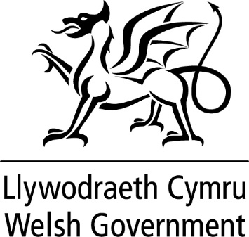

WRITTEN STATEMENT

BY

THE WELSH GOVERNMENT

TITLE | Wylfa Newydd
DATE | 15 January 2019
BY | Ken Skates AM, Minister for Economy and Transport

Last June, I updated Members on the proposed Wylfa Newydd project, welcoming the news that the UK Government was entering into negotiations with Hitachi. I also welcomed the UK Government’s announcement at Trawsfynydd of the UK Nuclear Sector Deal. This week, we have seen heightened media speculation about the future of the Wylfa Newydd project. I am issuing this Statement to outline the Welsh Government’s position on the matter.

Wylfa Newydd is a major project with potentially significant economic benefits to Anglesey, North Wales and the UK. As a government, we recognise the nuclear sector’s huge potential for delivering against our central aim of tackling regional inequalities, exploiting regional strengths and delivering prosperity for all. The nuclear sector’s potential is recognised by our partners in North Wales, including the critical mass of innovative, forward looking and capable nuclear supply chain companies we are proud to have in Wales.

The speculation over recent days is therefore very worrying. Whilst we cannot respond to speculation, we are continuing to maintain our close dialogue and relationship with Ynys Môn County Council, Horizon Nuclear Power and other key stakeholders to track this unfolding situation. We need to remain collectively focused on ensuring this project is secured for Ynys Môn and that a lasting legacy is achieved.

With the above in mind, I am seeking assurance from the UK Government that they are doing everything possible to ensure this project is enabled to continue and that we secure this once in a generation investment for Ynys Môn.

I have this morning spoken with the Minister for Energy and Industry, Richard Harrington MP. I will also be writing to the Secretary of State for Business, Enterprise and Industrial Strategy. I and my officials are also in close dialogue with Horizon Nuclear Power and Ynys Môn County Council and I intend to discuss the matter further with key North Wales stakeholders later this week.

Together, we need to place continued pressure on the UK Government to ensure this project continues, so as to deliver a lasting legacy for Anglesey, North Wales and the UK.

I will continue to keep Members updated as matters progress.

