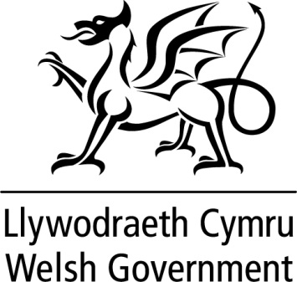

WRITTEN STATEMENT

BY

THE WELSH GOVERNMENT

Title | Visit to North America
Date | 04 March 2020
By | Eluned Morgan AM, Minister for International Affairs and the Welsh Language

Last week, I visited Ottawa, Montréal, San Francisco and Los Angeles. Following the recent publication of the Welsh Government’s International Strategy, the visit was an opportunity to highlight Wales as a nation known for its creativity, its expertise in technology and its commitment to sustainability. The aim was to promote the outstanding work we are already doing in Wales, forge new links with our diaspora networks and attract more business to Wales.

There are strong ties between Wales and North America, spanning business, culture, language and education. As our relationship with the European Union moves to a new phase it is important to maintain close business and trading links with our most important markets. The United States is Wales’ largest inward investor, with around 320 US-owned companies employing almost 50,000 people in Wales, while Wales is also home to 40 Canadian-owned companies.

In Ottawa, I met some of Ottawa’s leading tech experts, including Sir Terry Matthews. This was an opportunity to gain an understanding of the tech ecosystem in Ottawa as well as to demonstrate Wales’ world-class expertise in the tech sector, particularly cyber-security. I was pleased to announce Welsh Government support for new cyber security companies graduating from the Alacrity Foundation in Newport.

I met the Parliamentary Secretary for Economic Development and Official Languages, René Arsenault MP. Discussions focussed on our ambition to reach one million Welsh speakers by 2050, as well as the Canadian perspective on bilingualism. I also met with John McKay, the Chair of the Canada-United Kingdom Inter-Parliamentary Association who was interested to hear of the impact of Brexit on the devolved structure in the UK.

In Montréal, I met my counterpart, the Minister for International Relations and La Francophonie, and signed a declaration of intent with the Québec Government. The relationship between Québec and Wales has grown in recent years, boosted by the establishment of a Welsh Government office in Montréal in 2018. The declaration recognises the importance of the relationship and our mutual determination to increase our activity and foster new collaborations. This will be supported by a collaborative joint call for projects aligned to the themes of the international strategy.

The aerospace industry is an important sector for both Québec and Wales. I met with Aéro Montréal to encourage collaboration in the sector and build on the Memorandum of Understanding signed in 2018 with Aerospace Wales. This momentum will continue with a delegation from Wales travelling out to the Aerospace Innovation Forum in the spring.

From Canada, I travelled to San Francisco, to attend RSA conference, one of the largest annual global gatherings of cyber security experts. I met a number of existing and perspective investors in the margins of the conference, including AT&T and Oracle. I also met Lynwen Brennan, Executive Vice President & General Manager of Lucasfilm, to discuss Wales’s international reputation as a centre of excellence for production and high-end television drama, and I also attended the Royal Welsh College of Music and Drama’s St David’s Day Reception in Los Angeles to promote Wales’ creative strengths.

Our diaspora worldwide are a priceless asset in raising the profile of Wales and promoting our outward looking nation. I hosted receptions in Ottawa and in San Francisco and met with key Welsh business contacts throughout my visit to thank them for the work that they do.

Building on the strong connections with North America is a key part of my International Strategy and my visit aimed to reaffirm the close ties that already exist with Canada and the United States. I am determined that the conversations during the visit will enable us to strengthen the relationships with both countries and provide tangible benefits to Wales.

