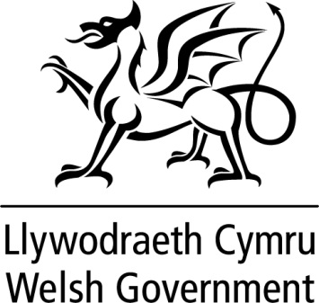

WRITTEN STATEMENT

BY

THE WELSH GOVERNMENT

Title | Visit to Germany
Date | 18 September 2019
By | Eluned Morgan AM, Minister for International Relations and the Welsh Language

On 5–6 September I visited Düsseldorf to undertake a full programme of engagements. This was my first visit to Germany as Minister for International Relations and the Welsh Language.
The purpose of my visit was to inaugurate the new Welsh Government office in Düsseldorf and to promote Wales’ commercial strengths in technology and cyber security. The visit also provided opportunities to position Wales as an outward-facing, forward-thinking nation that is creative and leading the way on sustainability and the well-being of future generations, and to meet with key tourism contacts to promote Wales as a destination.
Germany is our most important economic partner in Europe. It is Wales’s top export destination – with the value of Welsh exports standing at £3.1 billion in 2018. There are an estimated 90 German-owned companies with a presence in Wales, employing just under 12,000 people.
Wales is a proud European nation and my key message for the visit was clear – that we look forward to strengthening our economic, cultural and political relationship with Germany in the years to come and that we refuse to let whatever happens with Brexit harm our strong relationship with Germany.
I met the British Consul General in Düsseldorf to discuss how Welsh Government and Department for International Trade officials can work together more closely to support and encourage more Welsh companies to export to Germany and to increase inward investment by German companies into Wales. We were both pleased that there is a joint willingness and desire to work together to strengthen Welsh trade ties with Germany.
To realise this shared goal, the Consul General and I co-hosted a dinner for business and government leaders from the city of Düsseldorf and the wider State of North Rhine Westphalia. This provided opportunities to promote Wales’ economic offer and ambition to opinion-formers and influencers. The dinner enabled me to gain a deeper understanding of the German perspective on Brexit and how the uncertainty surrounding the UK Government’s ‘no deal’ Brexit policy is affecting investment decisions made by businesses in Germany. It was clear that these key business leaders were interested in the fact that the Welsh Government is urging the UK Prime Minister to change course.
On Friday, 6 September, I hosted a Tech Breakfast Event at which I addressed key tech sector businesses. At the event I shared how Wales is developing particular strengths, especially in the tech sector.
I formally inaugurated the new Welsh Government office in Düsseldorf and underlined the importance that we attach to our links to Germany. Our local partners responded warmly to my message that we are eager to develop relationships across all areas.
I also hosted a Tourism lunch with the German media and travel trade representatives to promote Wales as a destination and to communicate positive messages in relation to tourism in the context of Brexit.
I attended a meeting at the State of North Rhine Westphalia’s Ministry of Economy, Innovation, Digitisation and Energy to highlight how we are using our world leading sustainable development and environmental legislation to set a new pace of change to tackle the climate emergency. This meeting provided scope for identifying commonalities, shared challenges and areas for co-operation with the State of North Rhine Westphalia.
As I returned to Wales it was clear that our business and governmental links in the City of Düsseldorf and in the State of North Rhine Westphalia are stronger than ever, and that there is a strong desire in Germany to work with Wales to limit the damage caused by Brexit uncertainty.

