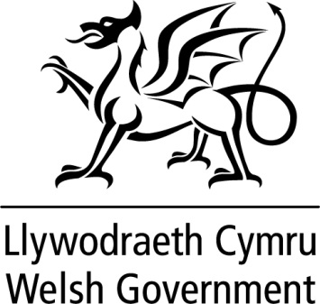

WRITTEN STATEMENT

BY

THE WELSH GOVERNMENT

TITLE | Valuable contribution of EU nationals in Wales
DATE | 24 June 2019
BY | Mark Drakeford AM, First Minister

I was pleased to welcome the Romanian Ambassador Dan Mihalache to Wales today and to explore the work of the Romanian Government during its first Presidency of the EU.
Holding a Presidency is always a challenge but the last six months have been particularly so, coming towards the end of the five-year term of the European Parliament and the European Commission. Romania has done an excellent job, and I extend my congratulations.
The visit of the Romanian Ambassador follows that of ambassadorial visits this year from Italy, Norway, Sweden, Ireland, Japan, Turkey as well as last week’s visit from the Vice Premier of China. Wales remains open to the world and the Welsh Government does everything we can to advance our reputation as a cosmopolitan and welcoming nation.
Yesterday marked the third anniversary of the 2016 Brexit referendum. Three years during which we have deliberated about deal or no deal while thousands of EU citizens who have chosen to make their lives in Wales and the rest of the UK have lived with uncertainty about their futures here.
I want to take this opportunity to try to reassure them that the Welsh Government is doing all we can to support them and that we value the contribution they make to life in Wales.
Wales has a long history of being a welcoming and inclusive nation. We celebrate the fact that citizens from other European nations have come to our country as neighbours, colleagues, friends and family for many years.
There is a mutual embrace of language, culture and history, which has enriched our communities enormously. Citizens from EU countries have held extremely important and valuable roles in our society, in the workplace and in our day-to-day lives.
We recognise that current circumstances and the uncertainty around Brexit must be very unsettling. I want to reassure EU citizens living in Wales that it is important to us that their rights and status are protected and we will use every opportunity to press that point with UK Government.
In particular, we are keen to support EU nationals in applying for settled status to secure their entitlements. The Welsh Government is doing all that it can to provide support and advice to EU citizens during this time. We have recently awarded a contract to Newfields Law, which will be providing immigration advice for EU citizens in Wales, particularly to vulnerable groups, which may find the process of applying for settled status daunting.
There are a number of other organisations in Wales who are offering advice and support, and we will ensure these different services will be joined up in a coherent way and provide a comprehensive support package for EU citizens in Wales.
Let me be clear, Wales will continue to be a welcoming country. We have a long and proud history of Wales being an attractive place to visit, live and work. This Government will do everything we can to make sure this will not change.

