# WRITTEN STATEMENT

# BY

# THE WELSH GOVERNMENT

|  |  |
| --- | --- |
| **TITLE** | **Update on the Procurement for the Wales and Borders Rail Service and South Wales Metro** |
| **DATE** | **4 June 2018** |
| **BY** | **Ken Skates, Cabinet Secretary for Economy and Transport** |

I would like to update Members on the procurement of the Transport for Wales’ Operator and Development Partner (ODP) for the Wales and Borders rail service, which we launched in July 2016.

We are at an historic point for the railway in Wales. For the first time a rail service has been procured and awarded in Wales, for Wales.

This follows over four years of intense work to develop an innovative approach that is bespoke and responds to the lessons learned from rail franchising and infrastructure delivery across the UK in recent years. Through this process we have also considered the issues debated in the Senedd, the ten priorities in the Economy and Skills Committee Report ‘On the Right Track? The Rail Franchise and South Wales Metro’, and the recommendations in the Auditor General for Wales’ report to the Public Accounts Committee ‘Welsh Government investment in rail services and infrastructure’.

We used an outcome-based procurement approach, under the Utilities Contracts Regulations (2016) to develop a high quality, smart and integrated rail contract and South Wales Metro. Our approach, not previously used in UK rail franchising, meant that we could get bidders to focus on quality and innovation.

As an outcome-based approach we required bidders to respond to a minimum set of requirements along with our policy priorities. These requirements far exceed what is provided in the current franchise. To avoid the trap of rewarding the bidder who put forward the most unsustainable offer we also provided a funding envelope for bidders to work within to deliver these priorities, along with a scoring methodology that incentivised bidders to go even further with their investment proposals.

Our approach has been welcomed by the rail industry. We had four credible bidders taking part in our dialogue phase of the procurement, which helped us to refine our requirements taking advantage of the innovation within the industry.

For reasons I have covered in other Written Statements, two bidders left our process, leaving two bidders in competition for award. Both of these bids were of exceptional quality; a testimony to the commitment of both teams to delivering high quality propositions for Wales.

Transport for Wales, our not-for-profit arm’s length company, will partner with the new ODP KeolisAmey to put passengers’ key priorities at the centre, with a focus on alleviating concerns around seat capacity, journey times and service frequency and ensure fair, affordable fares and quality, clean trains. This partnership provides the route to build our capability to develop and deliver the Metro model elsewhere in Wales, accelerating our delivery of the North Wales Metro.

Through Transport for Wales we have secured the continued public sector involvement in the leadership and delivery of rail services. This has given us the means to safeguard what is important to us, integrating the provision of services and infrastructure, and putting broader public transport integration in Wales on a stronger footing.

Let me be absolutely clear: in the coming months and years we will deliver groundbreaking transformation of transport across the country and in the borders region

This is a contract that offers value for money. With £738m in the south Wales Metro, a further £800m in new rolling stock and almost £200m in modernising all 247 stations, the ODP will be driving a nearly £2 billion investment programme that will bring about transformation to communities and people the length and breadth of Wales and its borders. On top of the contractual profit capping and sharing mechanism, the ODP does not expect to pay dividends to its shareholders for the first five years, reinvesting profits to fund this investment.

In addition to improving our financial position over the term of the contract, we will transform the provision of rail services.

The new contract reflects our commitment to carbon reduction. Treherbert, Aberdare, Methyr Tydfil, Coryton and Rhymney lines running north out of Cardiff Queen street will be 100 per cent electric traction, with the electricity sourced from 100 per cent renewable sources (50 per cent from within Wales). There will be a reduction in carbon emissions of 25 per cent across the whole service by the fifth year, as a result of introducing the latest generation of low emission Diesel Multiple Units (DMU).

There will be significant improvements in fares and ticketing, including the expansion of smart ticketing, an improved compensation scheme offering refunds for delays of over 15 minutes (rather than today’s 30 minutes) including an automated process for advance fares. From January 2020 we will act to make fares easier to understand and fairer, with the introduction of many new off-peak fares, reduction in walk-up north Wales fares and flattening of Metro fares at approximately 50 per cent of stations in the Valleys.

Half-price concessionary fares will be extended to 16-18 year olds.

Trains will be more punctual and performance standards will be passenger focused to drive improvements. There will be an improvement in the cleanliness of stations and trains with the introduction of new quality standards backed by considerable investment.

There will be a significant increase in capacity, designed to help more people get a seat during the busiest times, with the number of seats set to grow – an 80% increase in seat miles each week across the whole service. The contract ensures that Transport for Wales’ ODP will be penalised if passengers have to stand for longer than 20 minutes.

This is a long term investment programme, with service improvements starting from the December 2018 timetable change with further changes being introduced through to 2024. The table at Annex A summarises the currently planned service improvements.

To ease overcrowding, we will be introducing additional rolling stock from 2019, which will be on top of the extra trains that we have already announced. These additional trains will be used to relieve crowding, as well as to introduce new services. They will also provide additional cover to enable the rolling programme of upgrades to much of the existing fleet to ensure it meets the new accessibility standards which come into force at the beginning of 2020. The symbol of underinvestment in Wales, the Pacer fleet, will be removed entirely from the network by the end of 2019.

From December 2019 there will be a 22 per cent increase in Sunday mileage, including Sunday services from Maesteg, and additional services to destinations across Wales with increased connectivity to border regions. This will establish a true seven-day service with new Sunday services and earlier starts on most routes.

By 2023 95 per cent of journeys will be made on 148 brand new trains, over half of which will be built in Wales, and the fleet average age will drop from 25 years now to seven by 2024. The new trains will offer an overall improvement to the quality and ambience of passenger facilities compared to the current fleet. We are committed to ensuring that this includes comfortable seats.

The graph at Annex B shows how new rolling stock and capacity will be introduced.

Power supplies will be available at over 95 per cent of seats across all rolling stock types by 2020, with 100 per cent roll out completed by 2022. On-board catering remains a key feature of services on the Wales and Borders network. As a minimum, provision will be of the same level as that currently available. Air conditioning will be rolled out on all rolling-stock in the transformed fleet.

There will be an increase in mobile connectivity and at least 2Mbps per user at all stations, with seamless transition between on-train and station-based communications. To address the ongoing development of the 3G and 4G cellular network across Wales, TfW and the ODP will fill as many of the 132 “not spots” across the rail network as possible. Through this, by 2024 85 per cent of journeys will have end-to-end internet access.

The solution for the South Wales Metro will increase services to four services per hour to each of the heads of the Valleys north of Cardiff Queen Street; from 2022 for Aberdare, Treherbert and Merthyr, and 2023 for Rhymney services. Working across government, we aim to extend the Coryton branch to the proposed new Velindre hospital, and in doing so increase services on that line to 4 per hour.

Increases in service frequency on Maesteg and Ebbw lines remain a priority for South Wales Metro. Infrastructure improvements on the Ebbw Line are currently in progress, and we expect a doubling of services on the line from 2021 – I have instructed Transport for Wales to work with the ODP to deliver this. On the Maesteg line, we will introduce Sunday services from December 2019.

The flexible solution we are buying will allow us to immediately explore infrastructure enhancements to enable further services to be introduced on the Maesteg and Ebbw lines. Our ambition is to grow Ebbw services to four trains per hour by 2024, and we have instructed Transport for Wales to work with the ODP to present to us options for delivering this. There is a different challenge in meeting Metro service levels on the Maesteg line since it has always been a single track railway, but we have similarly asked Transport for Wales to present options for innovative solutions that meet the needs of local people.

The rolling stock used for the South Wales Metro will be a combination of Metro Vehicles and tri-mode trains, all of which will be equipped for level boarding, and which together will offer 45 per cent more seats into Cardiff the AM peak.

The tri-modes trains will bring together three well proven technologies – diesel, batteries and 25kV electric traction (from renewable energy sources) – and builds on well-established bi-mode trains. The tri-mode trains, along with the Metro Vehicles, will enable a 100% diesel free and zero carbon solution for Metro operations to significantly reduce harmful pollution in the most populated area of Wales, supporting our goals of a globally responsible and healthier Wales. The use of batteries will enable a “smart” electrification programme, requiring only limited modification to bridges and other structures – compared to a conventional electrification approach we will avoid disruptive track and civil engineering work at 55 structures; with only 17 sites requiring track works and only one bridge, at Rhondda sports centre (just south of Ystrad Rhondda) needing to be lifted.

Whilst the specific tri-mode solution has been developed to meet the unique requirements for operation on the South Wales Metro, the train is based on an established product platform and uses a modular design from a well-established manufacturer of rolling stock and with a track record of supplying reliable rolling stock elsewhere in Europe.

Similar trains to the tri-modes being introduced in South Wales will be used on services in south east England from the summer of 2019. We will ensure that the ODP and rolling stock manufacturer learn from this to enable a smooth introduction of these trains into Wales.

The Metro Vehicles will use a technology often referred to as Tram-Train. They will operate under Heavy Rail regulations on conventional railway, but will be capable of use in Light Rail (or Tram) mode for extendibility. To ensure all bidders offered a future–proof solution from the outset, the contract requires a short section of on-street running in Cardiff Bay. This is intended as a trial with a view to utilising this increasing flexibility to then expand the network in future.

As I have said previously, on-board toilets will be retained on all new and existing trains. On the new Metro Vehicles which will operate a turn up and go service featuring level boarding on the Taff Vale and City lines (i.e. services to Merthyr, Aberdare and Treherbert), the maximum travel time to a universally accessible toilet will be 14 minutes, with 95% of journeys being within 10 minutes.

Furthermore, the last services each day will include provision for a break in service mid-point for passengers to use the facilities should they wish to do so. This will be advertised and be part of the formal service provision.

On the South Wales Metro we are delivering what we promised.

* 100% electric traction on all trains operating on valleys line services which pass through Cardiff Queen Street.
* A doubling of services to support Better Jobs Closer to Home with four services an hour from Treherbert, Aberdare and Merthyr from 2022 and Rhymney from 2023, with the Sunday service providing 2 services per hour on all of these lines from 2024.
* A doubling of services on the Ebbw Vale from 2021 and on the Vale of Glamorgan line from 2023
* 45 per cent more seats into Cardiff in the AM peak
* A fleet of modern and highly accessible on street capable Metro Vehicles to serve the Taff Vale and City lines and new, innovative tri-mode trains for the Rhymney, Coryton, Penarth, Barry and Vale of Glamorgan lines to allow for through services to the non electrified lines south and west of Cardiff Central.
* New stations will be built in Cardiff at Loudoun Square, Crwys Road, Gabalfa and at the Flourish.

There will be an acceleration of the introduction of the North East Wales Metro. We will be introducing a Chester-Liverpool service from December 2018 and a significant increase in Sunday services on most routes from 2019.

The North East Wales Metro transformation will benefit from the station investment programme, expansion of smart ticketing and the improved compensation scheme offering refunds for delays. We will see a second, limited stop express service every hour on the Wrexham-Bidston line from 2021, and from 2022 see services stopping at Wrexham as part of a new 2 hourly Liverpool to Cardiff service.

Four stations have been identified in the North East Wales Metro area to receive further investment as part of a flagship programme for stations; these include Chester, Shotton, Wrexham General and Blaenau Ffestiniog. Other planned improvements include a new Liverpool to Llandudno service, faster journeys between Cardiff Central and Holyhead and increased trains per hour for four other lines.

Linking up the nation we will build on the fast service between North and South Wales with further improvements in journeys times, and the expansion to three trains per day of the popular locomotive hauled catered service from December 2019 making use of more comfortable Mark 4 carriages

In mid Wales and south west Wales the station flagship programme will invest in upgraded facilities and tourism link at Machynlleth station, improvements to the environment and connectivity at Llanelli station, and routes into Carmarthen station. The Cambrian rolling stock will be replaced during 2022, with a new fleet which will retain local jobs at the Machynlleth depot.

There will be regular hourly services on the Cambrian line between Shrewsbury and Aberystwyth, added trains to the Cardiff-Cheltenham and Heart of Wales routes and an increase in services along the Cambrian coast. By December 2018 there will be seven trains per day between Swansea and Fishguard Harbour, calling at all stations on most journeys. In 2022 the Swansea to Shrewsbury (via Heart of Wales) services will increase to five trains per day.

The new rail services contract introduces a wide range of services across the entire Wales and Borders network, including in England. Service enhancements in England will begin with the introduction of new Chester-Liverpool services from December 2018, while many other improvements will be introduced in parallel to their introduction in Wales. Transport for Wales has worked with the Department for Transport to ensure that the UK government’s requirements for services in England have been met.

Community Rail Partnerships will more than double in number, and the budget they receive will increase by more than 4 times.

I have already described how our approach has sought to avoid the type of disruption that has arisen around the UK in recent years. However, we have included appropriate protections, so that should we see a problem of this nature starting to develop Transport for Wales has a number of options to remedy the situation. Our protections include a parent company guarantee, break clauses allowing us to terminate the contract at year five and year 10 and the ability to appoint an operator of last resort. In the short term we will make use of the UK’s buying power for the operator of last resort, but as Transport for Wales becomes more established, our aim is for Transport for Wales to take on this responsibility as well.

And just as we’ve done with our new Economic Contract, public investment with a social purpose is a cornerstone of our new approach to rail. Working with, and not against, our trade union partners, we are safeguarding the conditions of those people who work on our rail network and we will keep a second member of staff on every train.

The new service will be branded as Transport for Wales – this is a service made in Wales, for Wales.

Finally, I welcomed the publication of the recent report by the Welsh Affairs Committee that restates many of the issues that we have repeatedly raised with the UK Government. It makes important recommendations to the UK Government on the funding and delivery of rail enhancements and the further devolution of rail infrastructure.

Following the curtailed electrification of the Great Western mainline, Cardiff to London journey times will at best be 1 hour and 45 minutes, the same as 30 years ago, and Swansea will still be 2 hours and 45 minutes. Outside of the agreement to transfer the Valley Lines to us, we rely on the UK Government to provide funding for enhancements to the rail network in Wales, and I have already set out my expectations and overarching needs for the network.

Efficient and reliable rail infrastructure is imperative for passengers travelling within Wales, as well as across the border. I continue to raise with the UK Government the need to work with us to develop and deliver the improvements to the rail network that Wales needs, and ensure the report’s recommendations become a reality.

Earlier this year I called on the UK Government to allow the Welsh Government to take on responsibility for the franchising of inter-city services between Wales and the rest of the UK. Given the considerable benefits we have achieved, and the success of the process we have created, I would like to today reiterate that call.

**ANNEX A**

**Service Improvements**

The new Wales and Borders rail service takes the timetable from May 2017 as its baseline. The key changes being introduced under the new service, by year, are summarised in the table below:

| Route  tpd = train per day  tph = train per hour | May 2017 Mon-Fri daytime frequency and calling pattern | Change we will implement |
| --- | --- | --- |
| Changes introduced in Dec 2018 | | |
| Chester – Liverpool Lime St | None | 1tph |
| Merther Tydfil and Aberdare Valley – Cardiff Central | n/a | Additional early morning service to Cardiff Central, Monday to Friday |
| Aberdare – Cardiff | Sunday timetable currently being trialled | Sunday timetable made permanent, and will look at retiming the final service. |
| North Wales Coast | Sunday service currently has a large gap in the morning | Additional Sunday service between Llandudno Junction and Chester to bridge the gap between services in the morning |
| Bidston – Wrexham | n/a | Two additional Sunday morning services between Wrexham and Bidston, and two additional Sunday afternoon services between Bidston and Wrexham. |
| Changes introduced in 2019 | | |
| Most routes | n/a | Earlier first trains and more frequent services on Sundays. We will increase Sunday mileage by 22% |
| Cardiff Central – Bridgend via South Wales mainline (all operators' services) | 3 or 4tph | Consistent 4tph |
| Cardiff Central - Holyhead | 0.5tph | 3tpd Loco-hauled coaching stock (LHCS) included in 0.5tph; faster journeys |
| Aberystwyth – Shrewsbury | n/a | Stop at Bow Street from March 2020 |
| Changes introduced in 2021 | | |
| Cardiff Central/ Newport - Ebbw Vale Town | 1tph Cardiff – Ebbw Vale | Additional 1tph Ebbw Vale – Newport |
| Wrexham – Bidston (N Wales Metro) | 1tph | 2tph, 1tph fast, limited stops |
| Changes introduced in 2022 | | |
| Cardiff – Caerphilly | 4tph to Caerphilly | 6tph to Caerphilly |
| Swansea - Shrewsbury (via Heart of Wales) | 4tpd (+1tpd on parts of the line) | 5tpd |
| Cardiff Central - Cheltenham | 1tph in 2 hours out of 3 | Consistent 1tph all hours |
| Aberystwyth – Shrewsbury | 1tph in most hours | Consistent 1tph all hours |
| Cardiff – Coryton/Caerphilly | n/a | Crwys Road new station opens |
| Cardiff – Aberdare/ Merthyr Tydfil/Treherbert | 2tph each route | 4tph each route with 2tph to Bay and 2tph to Central |
| Cardiff Central – Liverpool via Wrexham General | - | New service 0.5tph Cardiff - Liverpool, 0.5tph Shrewsbury – Cardiff |
| Crewe/ Liverpool Lime St – Holyhead/ Llandudno and Manchester Airport – Chester | 2tph made up of 1tph Manchester Airport – Llandudno; 1tph Crewe – Chester | 3tph made up of 1tph Manchester Airport – Bangor; 1tph Liverpool Lime St – Llandudno; 1tph Crewe – Chester |
| Changes introduced in 2023 | | |
| WCB routes | - | Further increase in Sunday journeys |
| Cardiff – Rhymney | 1tph from Rhymney, 4tph only as far as Bargoed | 4tph Rhymney - Cardiff Central |
| Cardiff Queen Street - Cardiff Bay | 5tph | 6tph. Extension to new station at the Flourish with an additional station at Loudoun Square |
| Cambrian Coast between Tywyn and Pwllheli on summer Sundays | 3 irregular trains per day | 1tph with a new express service. |
| Cardiff – Bridgend via Vale of Glamorgan | 1tph | 2tph |
| Changes introduced in 2024 | | |
| CVL routes | n/a | 2tph on Sundays |

**ANNEX B**

**Rolling Stock Changes**

The following graph illustrates how the fleet will be refreshed over the next few years:

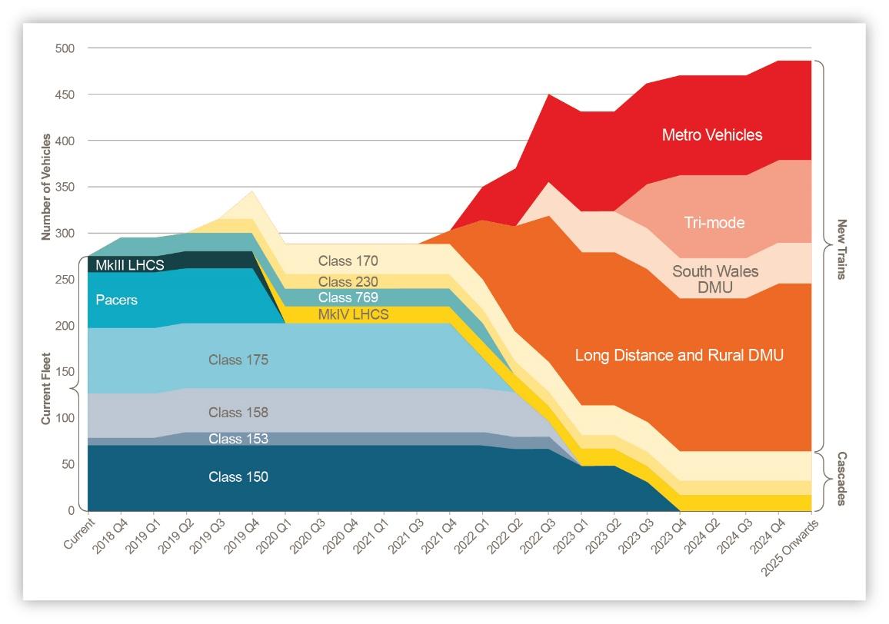

The following graphic shows how capacity will increase over the next few years:

