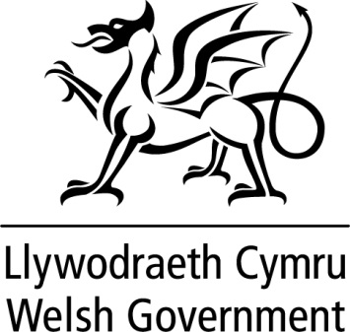

WRITTEN STATEMENT

BY

THE WELSH GOVERNMENT

TITLE | The future relationship between the UK and the EU Ministerial Forum
DATE | 24 May 3018
BY | Mark Drakeford, Cabinet Secretary for Finance

As members are aware, the Welsh Government has been engaging with the UK Government to ensure greater involvement from the devolved administrations in negotiations on the UK’s future relationship with the EU.

Building on initial discussions at the Joint Ministerial Committee Europe (JMC - EU Negotiations), a new Ministerial Forum has been established on the future relationship between the UK and the EU where the devolved administrations will have an opportunity to contribute to the development of a UK negotiating position. We have been making the case for such a forum for sometime and we welcome this development.

The new forum will be jointly chaired by Ministers from the Department for Exiting the European Union (DExEU) and Cabinet Office: the Parliamentary Under-Secretary of State for Exiting the EU Robin Walker and Parliamentary Secretary and Minister for the Constitution Chloe Smith, with other UK Government Ministers attending for specific items.

Ministers from the Welsh Government will attend alongside those from the Scottish Government and officials from the Northern Ireland civil service. The meetings will be informed by technical discussions at official level.

The First Minister has asked Rebecca Evans, Minister for Housing and Regeneration, to act as the lead Minister for the new Ministerial Forum, working with myself as the established Welsh Government representative on JMC (EN). It is envisaged that the relevant Welsh Government Cabinet Secretaries and Ministers will attend where policy discussions on their areas are on the agenda and where counterpart UK Ministers are also attending.

The first meeting of the Ministerial Forum will take place in Edinburgh today 24th May with the Minister for Housing and Regeneration attending. We expect the first meeting to focus on the broad negotiating position rather than departmental specific issues.

We will keep members updated on the development of the Ministerial Forum and the progress of its work.

