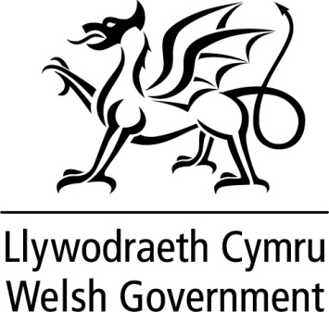

WRITTEN STATEMENT

BY

THE WELSH GOVERNMENT

TITLE | Minister for Education and Skills announces appointment to the Qualifications Wales Board
DATE | 5 April 2016
BY | Huw Lewis AM, Minister for Education and Skills

In January 2016, I announced the appointment of 3 members to the Board of Qualifications Wales, which followed the five appointments I made to the Board in August 2015. The Board has an important role in providing Qualifications Wales with:

- effective leadership,
- a well defined strategic direction; and
- ensuring that it undertakes activities efficiently and effectively and in accordance with its’ aims, objectives and targets.

I have agreed to the appointment of Alun Llwyd to the Board of Qualifications Wales.

Alun Llwyd will bring a wealth of experience and expertise to the Board of Qualifications Wales gained over the last 12 years as the head teacher of Ysgol Dyffryn Ogwen, a Welsh Medium secondary school in Gwynedd; and as the head teacher of Ysgol Y Creuddyn in Conwy in the preceding 3 years.

He is a member of the National Leadership Development Board (NLPB) which focuses on supporting the Welsh Government’s school improvement agenda through creating a co-ordinated national strategy for high quality leadership development.

He is also an Estyn Inspector and was previously seconded to work in Cynnal (the education support service in North West Wales) as a data co-ordinator.
This appointment will begin on 5 September 2016 and will be for a period of 18 months.

I am therefore pleased to announce the appointment of Alun Llwyd as an ordinary member of the Qualification Wales Board. He will bring a valuable schools perspective to the Board.

Notes

The appointment was made in accordance with the Commissioner for Public Appointments Code of Practice.

All appointments are made on merit and political activity plays no part in the selection process. However, in accordance with the original Nolan recommendations, there is a requirement for appointees’ political activity (if any declared) to be made public. The appointee to the Board of Qualifications Wales has not declared any political activity.

