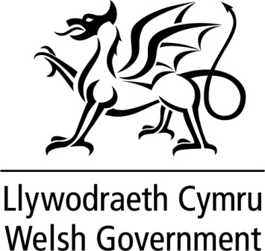

WRITTEN STATEMENT

BY

THE WELSH GOVERNMENT

TITLE | Provisional Police Settlement 2018-19
DATE | 19 December 2017
BY | Alun Davies AM  Cabinet Secretary for Local Government and Public Services

Today, I am publishing proposals for the Welsh Government component of funding to Police and Crime Commissioners in Wales for 2018-19. These include the provisional allocations of core revenue funding for each of the four Police and Crime Commissioners in Wales.

Whilst policing policy is not devolved, funding for the Welsh police forces is delivered through a three-way arrangement involving the Home Office, the Welsh Government and council tax.

A common needs-based formula, operated by the Home Office, is used to distribute funding across English and Welsh police forces, and the approach to setting and distributing the Welsh Government component of police funding provision is based on a principle of ensuring consistency and fairness across England and Wales.

As in recent years, the Home Office has again decided to overlay its needs-based formula with a floor mechanism. This ensures all police forces in England and Wales can expect to receive a cash flat settlement for 2018-19 when compared on a like-for-like basis with 2017-18.

The total support for police forces in Wales will be £349.9 million. Within this, I propose to set the Welsh Government’s contribution to police funding for 2018-19 at £140.9 million. Today’s announcement marks the start of a consultation period which will end on 16 January 2018. Following this, allocations may be revised for the Final Settlement.

This statement is being issued during recess in order to keep members informed. Should members wish me to make a further statement or to answer questions on this when the Assembly returns I would be happy to do so.

Police Revenue Funding
Table 1: Aggregate External Finance (RSG+NNDR, £m)
 |  | 2015-16 |  | 2016-17 |  | 2017-18 |  | 2018-19
Dyfed-Powys |  | 12.788 |  | 12.895 |  | 12.870 |  | 13.101
Gwent |  | 29.696 |  | 30.107 |  | 30.583 |  | 31.083
North Wales |  | 21.308 |  | 21.578 |  | 21.907 |  | 22.122
South Wales |  | 71.218 |  | 72.177 |  | 73.341 |  | 74.594
Total |  | 135.010 |  | 136.757 |  | 138.700 |  | 140.900
Table 2: Police Grant and Floor Funding (£m)¹
 |  | 2015-16 |  | 2016-17 |  | 2017-18 |  | 2018-19
Dyfed-Powys |  | 37.511 |  | 37.117 |  | 36.443 |  | 36.212
Gwent |  | 43.220 |  | 42.393 |  | 40.904 |  | 40.404
North Wales |  | 51.854 |  | 51.167 |  | 49.821 |  | 49.606
South Wales |  | 89.338 |  | 87.463 |  | 84.066 |  | 82.812
Total |  | 221.923 |  | 218.140 |  | 211.234 |  | 209.034
Table 3: Total Central Support (£m)
 |  | 2015-16 |  | 2016-17 |  | 2017-18 |  | 2018-19
Dyfed-Powys |  | 50.299 |  | 50.012 |  | 49.313 |  | 49.313
Gwent |  | 72.917 |  | 72.501 |  | 71.487 |  | 71.487
North Wales |  | 73.162 |  | 72.745 |  | 71.728 |  | 71.728
South Wales |  | 160.555 |  | 159.639 |  | 157.407 |  | 157.407
Total |  | 356.933 |  | 354.897 |  | 349.934 |  | 349.934
Notes:
1 This is the amount of police grant set out in section 3 of the Police Grant Report which includes the allocation under 'Principal Formula' and 'Add Rule 1' (columns a and b) plus the amount 'floor funding' that the Home Office has made available.

