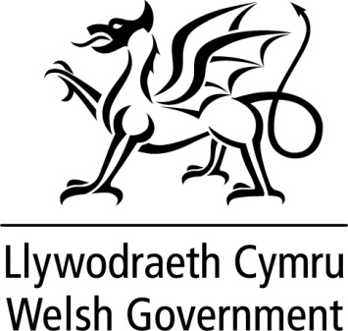

WRITTEN STATEMENT

BY

THE WELSH GOVERNMENT

TITLE | Non-Domestic Rates Relief for Public Lavatories
DATE | 26 June 2019
BY | Rebecca Evans, Minister for Finance and Trefnydd

The Welsh Government recognises that the provision of lavatories for public use can affect the health, dignity and quality of people’s lives. Such facilities are valued by local residents and by visitors to an area. We also recognise that local authority provision of public lavatories has declined in recent years.

Today, I am announcing the introduction of provisions to assist local authorities, and other providers, in keeping standalone public lavatories open without passing on the costs to local taxpayers.

The Non-Domestic Rating (Public Lavatories) Bill was introduced in Parliament on 18 June 2019. We are pleased to have secured provisions for Wales in this Bill so that, from 1 April 2020, standalone public lavatories will have their rates bills reduced to zero. The provisions will apply to all standalone lavatories which are made available for public use, whether they are owned or operated by public, private or charitable bodies.

This will reduce the costs for local authorities and other providers, helping them to maintain public lavatories in their communities. This move illustrates our commitment to maintaining these important local services.

I will be promoting the approval of these provisions in the Assembly on 16 July.

