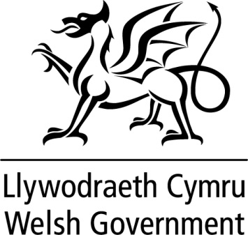

WRITTEN STATEMENT

BY

THE WELSH GOVERNMENT

TITLE | Ministerial Taskforce for the South Wales Valleys
DATE | 16 February 2018
BY | Alun Davies, Cabinet Secretary for Local Government and Public Services

Following the First Minister’s announcement about his new Cabinet on 3 November 2017, the representation on the Ministerial Taskforce for the South Wales Valleys has been reviewed.

I am pleased to announce both Eluned Morgan, Minister for Welsh Language and Lifelong Learning and Rebecca Evans, Minister for Housing and Regeneration will be joining the taskforce.

The Ministers’ involvement demonstrates the Welsh Government’s commitment to the taskforce’s ambitions; focusing the power and resources available to government to act as a catalyst for change.

