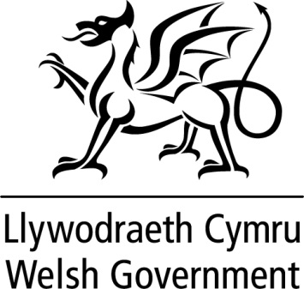

WRITTEN STATEMENT

BY

THE WELSH GOVERNMENT

TITLE | How do we assist Welsh Ministers in measuring a nation’s progress? - Proposals for developing a set of national milestones for Wales
DATE | 17 July 2019
BY | Jane Hutt AM, Deputy Minister and Chief Whip

The Well-being of Future Generations (Wales) Act 2015 received Royal Assent in April 2015, helping place Wales on a more sustainable path towards achieving well-being. The Act put in place seven well-being goals for Wales. These were for a more equal, prosperous, resilient, healthier and globally responsible Wales, with cohesive communities and a vibrant culture and thriving Welsh language.

If we are to collectively achieve our long term ambitions for Wales, we need ways of measuring and understanding at a national level if the nation is moving in the right direction towards achieving our well-being goals. This is why we currently have 46 national indicators in place and also why we are now in the process of developing and setting national milestones.

The milestones will, like the national indicators, aim to reflect the combined contribution that all public bodies, individuals and organisations are making. This doesn’t mean the milestones are aimed at measuring the contribution that individual organisations make, rather it is our hope to set a series of measures against national indicators, which will help us more clearly understand whether our direction of travel as a nation is moving towards achieving our well-being goals.

In January 2019 we published a consultation setting out and asking for views on:
- the criteria for choosing national milestones, and
- the national indicators against which we will set national milestones

In addition the consultation exercise sought to gather views on whether the existing national indicators could be improved in any way.

I would like to take this opportunity to thank the 75 organisations and individuals who responded to the public consultation, as well as those that took the opportunity to feed in their views and engage in the range of consultation events that we held.

Today I am pleased to publish the summary of responses along with the Government’s response to some of the key views received during the consultation period. There are a number of key themes that emerged through the consultation process which we have reflected on and will be incorporated into the next phase of this work.

I was pleased to see there was broad agreement for the proposed set of criteria for selecting a small set of national indicators against which to develop milestones. We will however take on board the points and issues raised through both the consultation and our ongoing discussions with key stakeholders and hone the criteria accordingly.

With regard to the small set of indicators against which we will develop national milestones the two main themes raised for strengthening were the Environment and Housing. We will look closely at this with stakeholders and how we can ensure we best reflect these two key issues.

Similarly we will consider the views put forward on how we can improve the current set of 46 national indicators and make any appropriate amendments, where there is a clear need for change to what were always intended to be indicators for the long-term.

The indicators are already well utilised across the public sector to chart our progress against the well-being objectives. Our national all-Wales milestones will provide a new opportunity to provide an even richer picture of Wales’ economy, society, culture and environment.

Throughout our implementation of the Act, we have sought to embed the requirements in our everyday work – using the opportunity of the Act to better focus our efforts on the differences that we want to make today and for future generations. We have taken this same approach in setting the milestones.

We will now work with our key partners and other public bodies to move this work forward and develop integrated and meaningful national milestones which will shape our combined actions and behaviours to the benefit of Wales.

The national milestones will relate to the period 2021-2050 and, where appropriate, existing targets will be used and the exact nature of each milestone will vary depending on the specific progress we are hoping to measure.

All milestones will of course need to be supported by robust and accurate data that can support regular reporting. The milestones will likely need to be introduced on a phased basis with the potential for most, if not all, to be in place by 2021.

I will provide a further update on our progress in the autumn.

