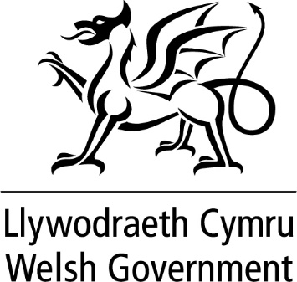

WRITTEN STATEMENT

BY

THE WELSH GOVERNMENT

TITLE | Healthy & Active Fund
DATE | 13 June 2019
BY | Vaughan Gething, Minister for Health and Social Services  Dafydd Elis-Thomas, Deputy Minister Culture, Sport and Tourism
Today we are announcing, in partnership with Sport Wales and Public Health Wales, the 17 projects which will all benefit from our £5.4m Healthy and Active Fund. Each of these projects will contribute to the strengthening of community assets and enabling people adopt healthier lifestyles.

When we launched the Healthy & Active Fund last July it was with the message that the benefits to our mental and physical health of healthy and active lifestyles are clear. These projects show a new, innovative approach to supporting people of all ages and backgrounds.

All successful projects are collaborative in their approach and will be delivered by a range of partners. They provide a diversity of geographical representation across Wales, including within the Valley Task Force area. The projects selected seek to reduce inequalities in outcomes and barriers in a variety of ways. From intergenerational approaches to gardening; encouraging families to get active with their new born babies; to increasing physical and social activities for people living in care homes. There are other projects that look to support people with mental health issues to lead independent and long term active lifestyles, and one that uses sporting memories to help people with dementia.

The 17 successful projects are as follows:-

- ‘Sporting Memories’ – Led by Sporting Memories Network CIC
- ‘Growing Together’ – Led by Keep Wales Tidy
- ‘Balanced Lives for Care Homes’ – Led by Action for Elders Trust
- ‘HAPPy’ – Led by the National Trust
- ‘Super-Agers’ – Led by Bridgend County Borough Council
- ‘West Wales Let’s Walk’ – Led by Pembrokeshire Coast National Park Authority
- ‘Actif Woods Wales’ – Led by Smallwoods Association – Coed Lleol
- ‘Welsh Active Early Years Programme’ – Led by Early Years Wales
- ‘Healthy & Active Newport’ – Led by Newport Live
- ‘Play Ambassadors’ – Led by Play Wales
- ‘Babi Actif’ – Led by Eryri-Bywiol Cyf
- ‘Healthy Body – Healthy Mind Project’ – Led by Women Connect First
- ‘5 Ways to Wellbeing’ – Led by Betsi Cadwaladr University Health Board
- ‘StreetGames’ - Led by Street Games UK Ltd
- ‘Opening Doors to the Outdoors’ – Led by The Outdoor Partnership
- ‘Cyfellion Cerdded Cymru’ – Led by Living Streets Cymru
- ‘BeActive RCT’ – Led Interlink RCT

