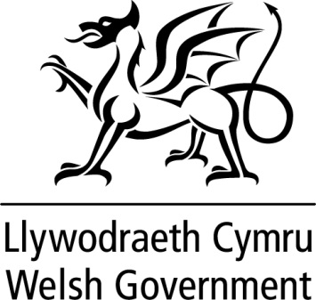

WRITTEN STATEMENT

BY

THE WELSH GOVERNMENT

TITLE | EU (Withdrawal) Bill.
DATE | 25 April 2018
BY | Mark Drakeford AM, Cabinet Secretary for Finance

As members are aware, the Welsh Government has come to an agreement with the UK Government on their on their proposed EU (Withdrawal) Bill.

The inter-governmental agreement and associated documents can be found in the below link:

https://www.gov.uk/government/collections/european-union-withdrawal-bill-agreement-between-the-uk-and-welsh-governments

