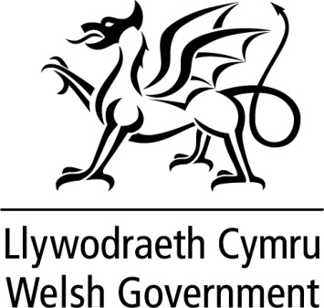

WRITTEN STATEMENT

BY

THE WELSH GOVERNMENT

TITLE | Appointments to the Qualifications Wales Board
DATE | 03 May 2019
BY | Kirsty Williams AM, Minister for Education

Qualifications Wales was established under the Qualifications Wales Act 2015 and became responsible for the regulation of awarding bodies and the quality assurance of non-degree qualifications delivered in Wales.

The Board undertakes an important role in ensuring that Qualifications Wales:

- has effective leadership;
- has a well defined strategic direction; and
- undertakes activities efficiently and effectively and in accordance with its’ aims, objectives and targets.

I am pleased to announce that I have appointed Jayne Woods and Anne Marie Duffy to the Qualification Wales Board. Both paid appointments began on 1 April 2019 and will be for a period of three years. Remuneration is £282 per day for a maximum time commitment of 36 days per year. This is the first Ministerial appointment for both Jayne Woods and Anne Marie Duffy.

Notes

These appointments were made in accordance with the Commissioner for Public Appointments’ Code of Practice for Ministerial Appointments to Public Bodies.

All appointments are made on merit and political activity plays no part in the selection process. However, in accordance with the original Nolan recommendations, there is a requirement for appointees’ political activity (if any declared) to be made public. The appointees to the Board of Qualifications Wales have not declared any political activity.

