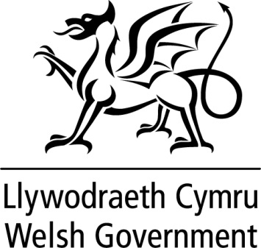

WRITTEN STATEMENT

BY

THE WELSH GOVERNMENT

TITLE | Appointment of Luke Sibieta – Response to CYPE Committee inquiry into school funding
DATE | 24 October 2019
BY | Kirsty Williams AM, Minister for Education

Further to yesterday’s debate on the Children and Young People Education (CYPE) Committee’s Report on School Funding in Wales, I am pleased to provide further details on the Government’s response to Recommendation 1.
The leading education economist Luke Sibieta will take forward an analysis of how total spending, and spending on different categories of inputs, varies across schools in specific circumstances in Wales.
This will include, but not be limited to, how spending varies with levels of deprivation, rurality and growth in Welsh medium education. This empirical analysis would account for the differences in levels and methods of central spending across local authorities, and will help provide for informed decision making on levels of funding for schools and pupils in different circumstances across the country.
I have asked that the work is completed before the 2020 summer recess.
CYPE published their report into school funding on 10th July 2019. I welcomed the report and accepted all 21 recommendations;
http://senedd.assembly.wales/documents/s93706/Welsh%20Government%20Response.pdf

Luke’s experience, knowledge and understanding of the complexities involved in school funding will be paramount in taking this forward. His work on behalf of the Institute for Fiscal Studies will be well known to members.

According to IFS analysis, spending per pupil in Wales is just below £6,000 on average. However this varies considerably between local authorities, reflecting differences in deprivation and sparsity, as well as choices made by local authorities in line with their responsibility for setting school budgets.
Although schools differ significantly in terms of the factors which influence their costs, making it difficult to identify a “minimum cost”, this work will provide an essential analysis for government, local authorities, schools and all with an interest in securing the right investment in Welsh education.

