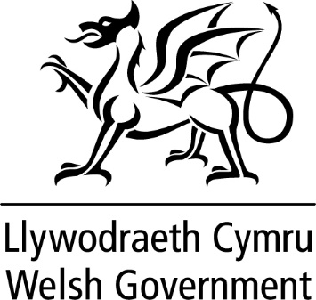

WRITTEN STATEMENT

BY

THE WELSH GOVERNMENT

TITLE | Ministerial Overseas Visit to Dublin, Ireland
DATE | 15 February 2024
BY | Lynne Neagle MS, Deputy Minister for Mental Health and Wellbeing

On the 25th and 26th January 2024, I visited Dublin to attend a British and Irish Council Ministerial Meeting on Drugs & Alcohol.

The British Irish Council was formed as part of the multi-party agreement reached in Belfast on 10 April 1998. Its membership comprises representatives from the Irish Government; UK Government; Scottish Government; Northern Ireland Executive; Welsh Government; Isle of Man Government; Government of Jersey and Government of Guernsey. Its primary aim is to further promote positive, practical relationships amongst its participant nations and to provide a forum for consultation and co-operation.

The purpose of the meeting I attended was to allow Ministers to review recent activity of the British Irish Council’s workstream on Drugs and Alcohol and to discuss a proposed new forward work plan. I also had the opportunity to undertake a Bilateral meeting with Minister Hildegarde Naughton TD of Department of the Taoiseach with special responsibility as Government Chief Whip; and the Department of Health with special responsibility for Public Health, Wellbeing and the National Drugs Strategy.

On arrival in Dublin I attended, with other Ministers, a showcase event with representatives of projects and organisations active in a number of areas including prevention, drug related violence and overdose. This also featured a discussion on ‘Preparing and Responding to the emergence of Synthetic Opioids’ with Professor Eamon Keenan, the Clinical Lead for Addiction in the Irish Health Service.

The second day began with the Bilateral with Minister Naughton where I was able to detail and discuss the Welsh Government experience of the national implementation of injectable buprenorphine (Buvidal) as a treatment for heroin users in Wales.

I then attended the Ministerial meeting alongside the Ministers for Ireland and Guernsey who attended in person, we were also joined virtually by the Scottish, Jersey and Isle of Man Ministers. The meeting was used to review the recent activity of the BIC Drugs and Alcohol Work Sector including Drug Related Deaths, the Covid-19 Impact on substance misuse and work around Financial Mechanisms for Alcohol. We also discussed a proposed new Forward Work Plan. The meeting concluded with a presentation by Paul Reid, Chair of the Irish Citizens’ Assembly on Drugs on Deliberative Democracy.

I found the visit to Dublin to be of huge benefit and we will continue to engage with our partners in the British and Irish Council. The Council gives us the ability to share our learning and look at new approaches that can be undertaken to tackle substance misuse in Wales and across all administrations.

This statement is being issued during recess in order to keep members informed. Should members wish me to make a further statement or to answer questions on this when the Senedd returns I would be happy to do so.

