The inquiry
- In early 2017, the National Assembly for Wales’s Constitutional and Legislative Affairs Committee began to consider how well the National Assembly and the Welsh Government work with the UK Government and the UK Parliament, and the devolved institutions in Scotland and Northern Ireland. The Committee was keen to explore the current nature and effectiveness of these inter-institutional relations, how they can be improved, and what opportunities there are for the people of Wales and the UK to take part in the work of these institutions.
- Our Committee has a wide-ranging remit relating to the scrutiny of new legislative proposals and constitutional matters which directly affect Welsh citizens. As part of our inquiry, we wanted to understand the public’s perceptions and expectations of inter-institutional working and relationships. To do so, we established a Citizen Panel (a National Assembly first).
- The Panel was made up of six citizens who were demographically diverse in terms of age, location, socio-economic background, and gender. The participants had not taken part in a previous National Assembly consultation, and did not necessarily have previous knowledge or understanding of the constitution in Wales.

Meetings of the Citizen Panel
- The Panel’s involvement came during an unprecedented time, against the backdrop of the UK’s decision to leave the European Union and just as the Wales Bill was to receive Royal Assent and become the Wales Act 2017. The Panel first met at the Senedd on 13 February 2017.
- Participants received a presentation from staff on the work of the National Assembly. To give context to the discussions which would follow, the presentation covered the differences between the National Assembly and the Welsh Government, how the National Assembly holds the Welsh Government to account, and the role it plays in ensuring that decisions made are in the best interests of Wales and its people.
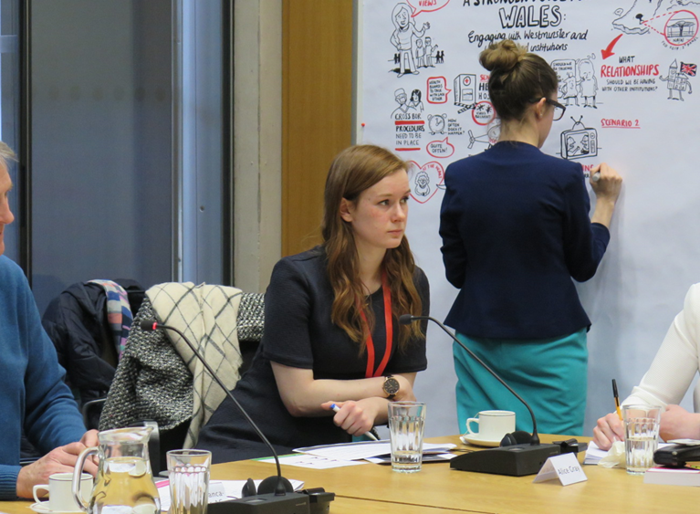
- The Panel members were presented with three hypothetical, health-related scenarios to consider. The purpose of this task was to help the Panel understand how a lack of engagement between politicians and political institutions can negatively affect the way in which services are delivered for citizens. These scenarios were the basis of discussions between the Panel and Committee members. The discussions focused on three key themes: citizens’ perceptions of the matters outlined in the scenarios, their expectation of how these issues should be addressed, and learning from others. The session was recorded visually by a graphic facilitator, whose output helped bring to the fore the main themes from the discussion.
- Holding the first meeting of the Panel at an early stage in the inquiry process meant that the views and ideas of the panel members could be used to inform the formal questioning of stakeholders including the Llywydd, Elin Jones AM; the First Minister of Wales, The Rt Hon Carwyn Jones AM, and the Secretary of State for Wales, The Rt Hon Alun Cairns MP.
- The second meeting of the Citizen Panel took place on 4 December 2017. The purpose of this meeting was to update the Panel members on the work we had undertaken since the first meeting, demonstrate how we as a Committee were seeking to address the issues they had raised, and for us to ask the Panel’s opinion on our proposed recommendations.
- Prior to the second meeting, the Panel members were provided with relevant sections from the draft version of the Committee’s report. During the meeting the Panel members were encouraged to critique, question, challenge and/or support actions we had proposed. Under each section within the draft report, the Panel members listed things they considered to be positives, and areas they would challenge. They also identified areas which needed greater clarity.
- In early January, in order to take account of the rapid pace of events relating to the UK’s decision to leave the EU, we decided to produce a shorter report than originally intended. The report made recommendations on matters that we considered need urgent attention, in order to help shape our constitutional future in the fairest and most effective way possible.
- Below we explain how the Citizen Panel influenced our work and how the recommendations we made are relevant to the views we heard from the Panel.

Effective relationships between Ministers
- What the Panel said at the first meeting:
- Elected representatives are there to represent the people and therefore party politics should not interfere.
“Parties don’t have to agree necessarily, but they have to work together as there is a job to do and things have to move forward.”
- Meetings can take place in any format, formal or informal, as long as they are happening and the lines of communication are open.
- Meetings between Ministers of different governments could happen informally at first, away from the public eye, and this may help pave the way to a successful working relationship.
- The Committee’s conclusion:
- The Committee recognises the importance of effective inter-personal relationships between Ministers in different governments.
- Whilst effective inter-personal relationships between Ministers can aid effective inter-governmental working, this must complement, and not be a substitute for, more formal, transparent and robust inter-governmental structures which can be scrutinised by the public and by parliaments.
- The formal inter-governmental structures must be capable of resolving effectively any breakdown in Ministerial relations.
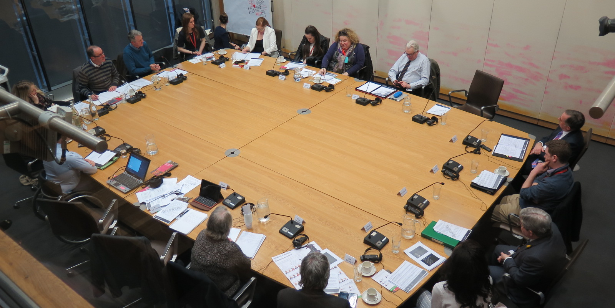
- The Panel’s feedback at the second meeting:
- The public need to be aware of instances where Ministers are working together. This would provide a certain level of reassurance, and show the public that governments are working collaboratively, regardless of party political allegiances.
- However, the Panel expressed some scepticism about whether this collaborative working would be achieved in practice.
“It happens on paper but we still haven’t made that a reality yet.”

Working collaboratively, mutual respect, the current arrangements and improving understanding of devolution in Whitehall
- What the Panel said at the first meeting:
- Working collaboratively between institutions is important when dealing with matters in which there is mutual interest. This collaborative working should take place routinely.
- Wales should be able to have its voice heard and a robust but respectful relationship must be upheld.
- Governments and Ministers should focus on working together in the interests of the public, and should treat each other with respect.
“There is a bigger picture which requires a robust and respectful relationship.”
- Meetings between institutions need a sense of priority and they should not take place for the sake of it. Formal meetings between Ministers from different governments should be recorded and supported by a full complement of officials to ensure the conversation is informed.
- There was also an expectation that meetings between the UK Government and the Welsh Government are held regularly to understand the situation and aspirations in Wales, an issue that is especially important if the Ministers are from different political parties.
- The Committee’s conclusion:
- There is a need to strengthen inter-governmental relations, not just between Wales and England, but as part of a four-nation approach, where each nation is treated with parity.
- The evidence we have heard (including that in relation to the Civil Service) has left us with a firm view that Wales has too often been regarded as less important by the UK Government.
- The need for fundamental reform is clear and pressing, reflecting the considerable internal constitutional change of the last decade or more and the likely changes that will emerge as the UK leaves the EU and redefines its relationships with the rest of the world.
- The best option would be to adopt a completely new approach to inter-governmental relations in order to provide the institutional strength and durability needed to face the challenges ahead.
- The First Minister’s proposal for a UK Council of Ministers to replace the Joint Ministerial Committee (JMC) would be the most coherent long-term solution to resolving concerns about inter-governmental relations. In effect it would be a forum of national governments working collectively in the best interests of the United Kingdom.

- We recommended that in the longer term, post-Brexit, the JMC is subject to fundamental reform so that it becomes a UK Council that:
- is a decision-making body;
- has an independent dispute resolution, arbitration and adjudication mechanism;
- is transparent and accountable in all of its functions and operations, in particular, in its decision-making.
- However, we also recommended that an essential and pragmatic first step before then would be to strengthen the existing JMC structure.
- Many witnesses pointed out the poor knowledge and understanding of devolution that exists in parts of Whitehall, despite some laudable efforts to remedy the situation by successive administrations. Based on the extensive evidence we heard, we believe that it is simply unacceptable that the level of understanding of devolution across Whitehall is often poor, that understanding of Welsh devolution is particularly poor in certain key departments, and that attempts to remedy this have been inadequate.
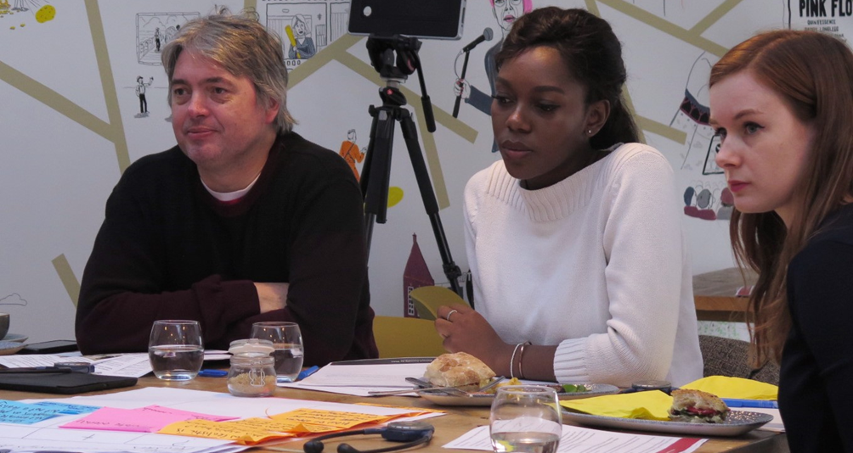
- The Panel’s feedback at the second meeting:
- The results of a more collaborative working relationship should be beneficial to citizens across the UK, though the Panel felt that there is a delicate balance to be met. The Panel felt that a “healthy degree of competition”, where different governments or Ministers are likely to want to be first in introducing ground-breaking legislation (the Panel cited organ donation and the levy on carrier bags) can be of benefit to citizens.
- However, the Panel also felt that the introduction and development of new legislation should be informed by discussions between governments, with discussion and feedback from the public and not by “trying to get there first”.
- There is much to be gained from joint-learning between governments. They felt that the Welsh public should be proud that Wales is able to make laws the other countries are choosing to adopt.
“Institutions should always look outwards. Whilst respect should be shown to the country working to the lead the way, informal information gathering should be allowed to happen.”
- Senior officials in government should be mandated to monitor and explore opportunities for inter-governmental working, and advise relevant Ministers.
“You could argue different institutions like to be the first to do something.”
- The Panel agreed that knowledge of devolution needs to be increased across the board, not just within Whitehall, but amongst Welsh citizens too.
“The average person doesn’t really know very much about it.”
“It’s poorly understood where devolution starts and stops for a lot of people.”
- Specific reference was made to the importance of digital communication, using a variety of platforms and adopting marketing techniques that would encourage Welsh citizens to interact with and understand more about Welsh politics and devolution.
- The Panel were supportive of the Committee’s conclusion. The Panel reiterated previous concerns about how it would be delivered in practice.

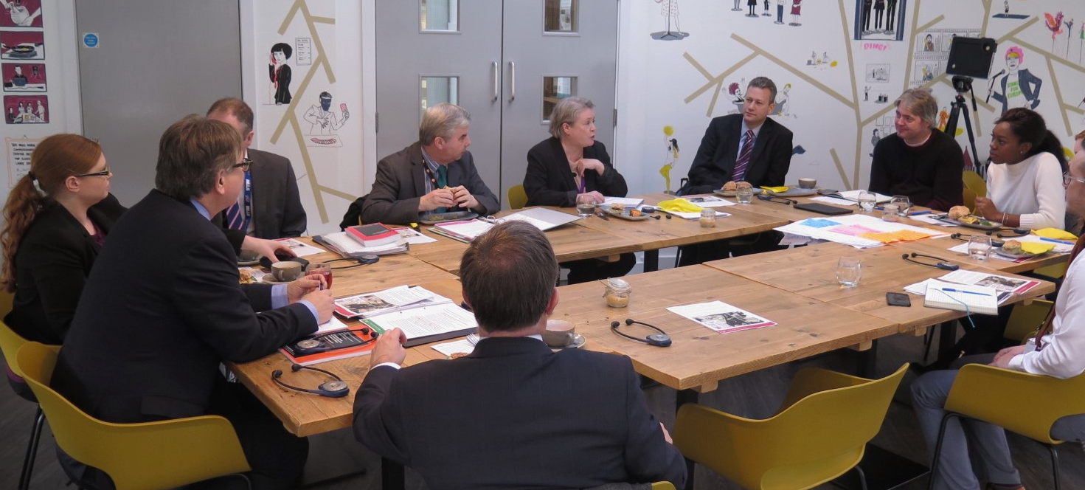

Speakers’ Conference
- The Committee’s conclusion:
- In the House of Commons, a Speaker’s Conference has been used to reach all-party agreement on major constitutional issues. As a result of devolution, we consider there is an opportunity to adapt this model to the Speakers of all UK parliamentary bodies. We believe a Speakers’ Conference could be used as a means of reaching agreement on changes to the UK’s inter-institutional relations, which will inevitably need to adapt, not only to the UK’s withdrawal from the EU but also the changing relationship between the constituent nations of the UK as a result.
- We consider the main role for a Speakers’ Conference to be in relation to developing a framework for inter-parliamentary relations. However, we also see merits in it having a role in relation to inter-governmental relations to assess how they are developing at this crucial period in the evolution of the constitution of the UK.
- The Panel’s feedback at the second meeting:
- The Speakers’ Conference became a much more prominent focus of the report after we met with the Panel to discuss our draft report. Our conclusion in this area of the report was positively received by the Panel, who were eager to see more collaborative working and relationships develop for the benefit of the citizen.

Ministers appearing before committees of the UK’s parliaments and assemblies
- What the Panel said at the first meeting:
- Mutual respect should exist between institutions. This is not only in the context of governments working together on areas of mutual interest, but in the respect demonstrated to other legislatures, for example the readiness of government Ministers to appear before other legislatures’ committees.
- The Committee’s conclusion:
- We would normally expect government Ministers to appear before other legislatures’ committees as required and as is practical. We are not convinced by the argument that this should not be the norm. This is particularly the case when considering legislation that will have a significant constitutional impact for Wales or in an area of devolved policy.
- The Panel’s feedback at the second meeting:
- The Panel were surprised at the lack of interaction between UK Ministers and the Assembly in relation to two of the more substantial constitutional matters in recent history, the Wales Bill and Brexit. The Panels view was that this should happen and that there should be some accountability when this is not happening. Failure do so shows a lack of respect, Greater transparency is required, and having government ministers appear before committees of the UK’s parliaments and assemblies is one way of ensuring greater accountability and transparency.
“If it affects Wales it should be the norm.”

Overall conclusion
- Interactions between institutions should be built on the basis of a robust and mutually respectful relationship.
- We hope that the improvements we suggested—which in essence are a thorough review and overhaul of the existing intergovernmental structures and the development of a Speakers’ Conference—will contribute to improving the effectiveness of collaboration between all institutions for benefit of the citizens they serve.
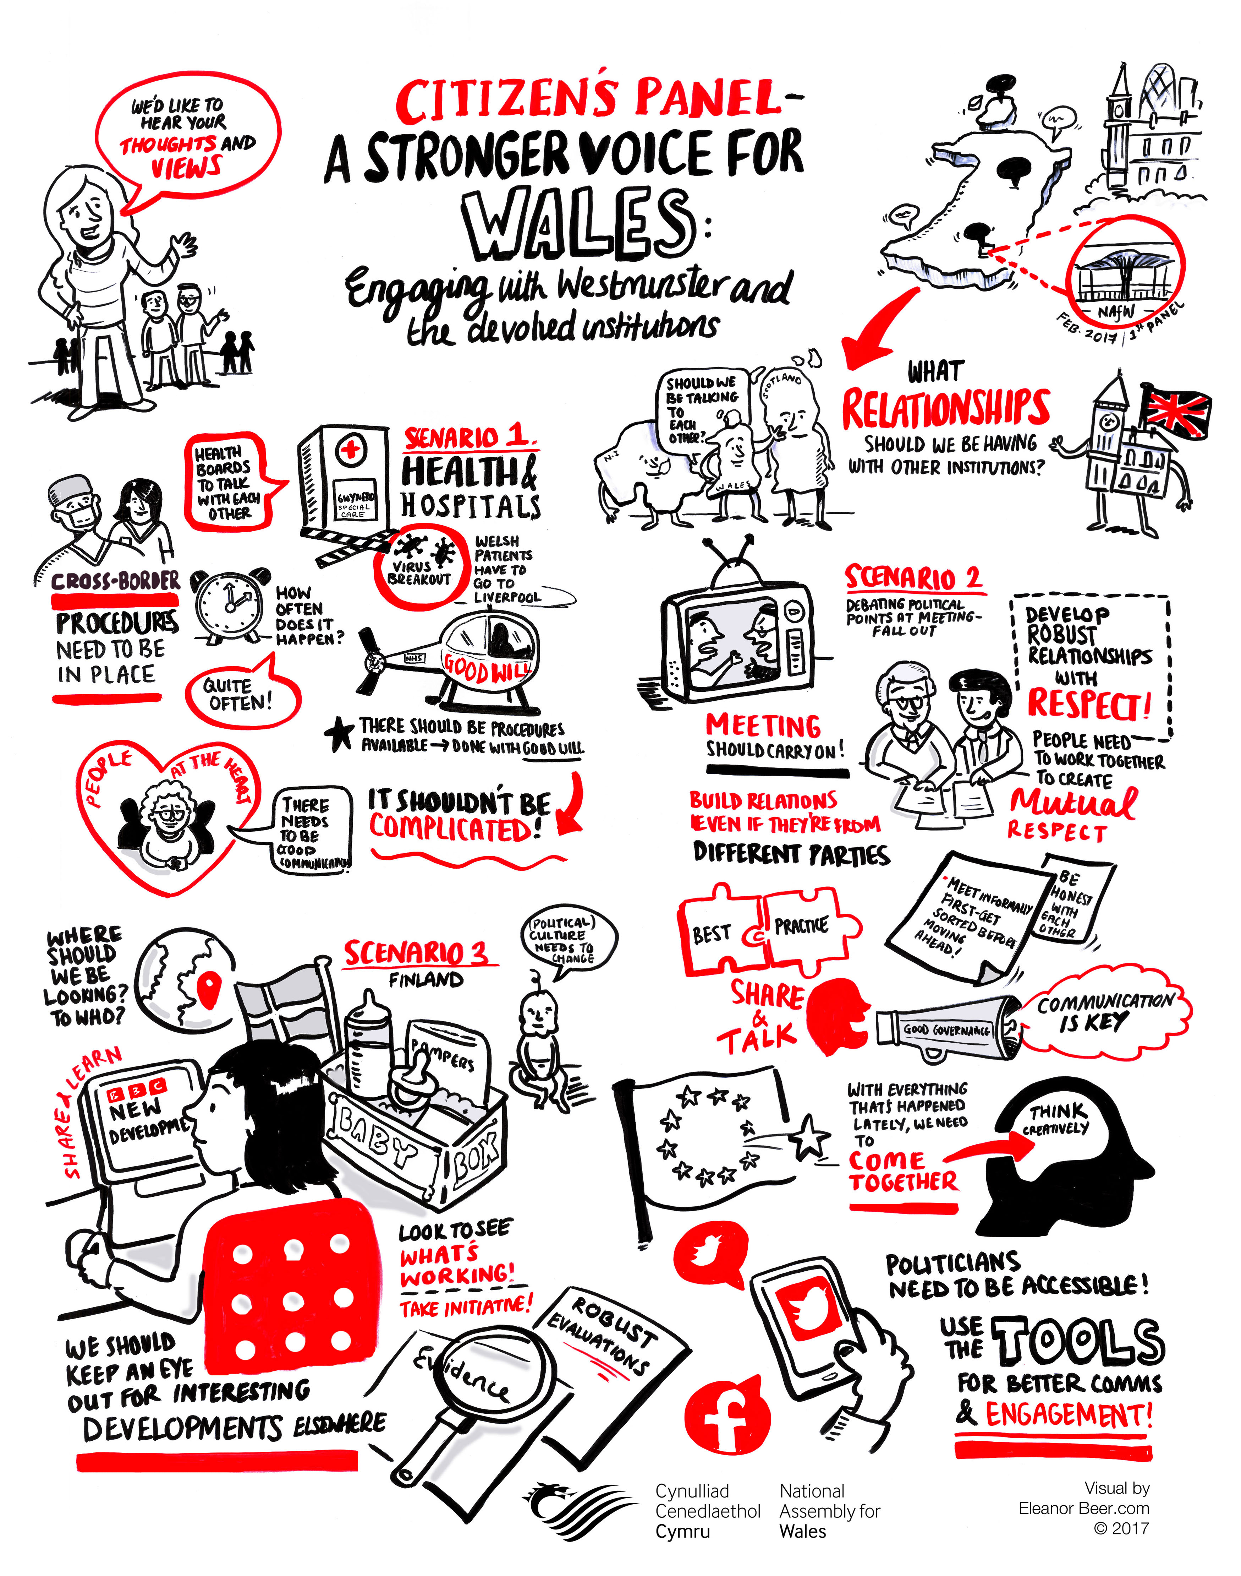
- What participants said about being a member of the Panel:
“Citizens are experts on their own lives – they have the knowledge and experience so use them!”
“It is important to find out what the public actually want.”
“Traditionally there is disillusionment by the public with politicians, but successful engagement will hopefully produce a new generation who feel empowered and involved. Politicians need to be accessible and information needs to be available and easy to understand to encourage participation.”
“Disillusionment can be confused with lack of confidence – citizens who have no political knowledge often feel unable to contribute and more education is required.”
“Citizen engagement should be common practice, and, publicised in the right way, will encourage participation.”
“This Citizen Panel is a good example of engagement with the public and should be mirrored by other committees and institutions. It breaks the mind-set that politicians don’t listen and encourages me to go away and talk about politics.”
- We would like to thank members of our Citizen Panel who took the time to attend our meetings and have their say.

