**Easy Read**

**Draft autism law for Wales:**

**Autism (Wales) Bill**

Response form

I want to know what you think.

Please send this form back by **17 April 2018**.

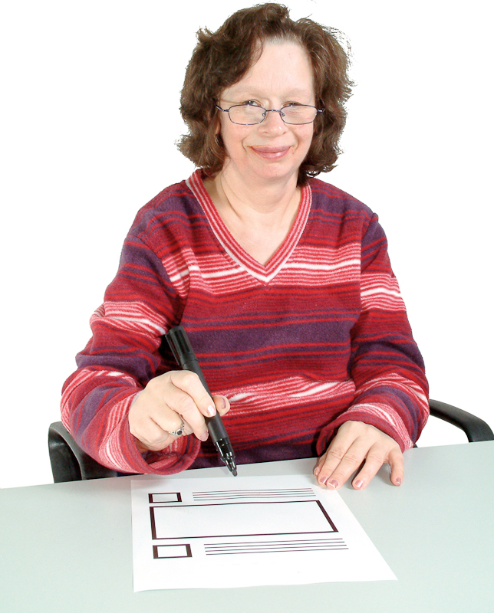

This is an easy read version of **‘The Draft Autism (Wales) Bill consultation document’**

February 2018

**How to use this document**

This is an easy read version. The words and their meaning are easy to read and understand.

You may need support to read and understand this document. Ask someone you know to help you.

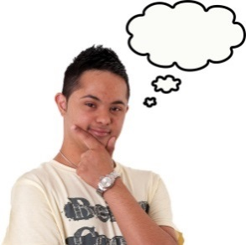Some words may be difficult to understand. These are in **bold blue writing** and have been explained in a box beneath the word.

If you see any words in normal blue writing you can look up what they mean in **Important** **words** on **pages 25** and **26** of the easy read draft **‘Autism (Wales) Bill’**.

Where the document says ‘we’ this means the **National Assembly for Wales**

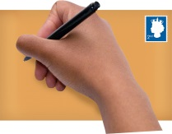To get more copies contact:

Tom Jackson

National Assembly for Wales

Tŷ Hywel, Cardiff Bay, CF99 1NA



Phone: 0300 200 6565



 Email: [Consultation.AutismBill@assembly.wales](mailto:Consultation.AutismBill@assembly.wales)

This document was made into easy read by Easy Read Wales using Photosymbols.

Contents

**Page**

Introduction 4

How your answers will be used 6

Questions about the draft ‘Autism (Wales) Bill’ 7

Definition of autism spectrum disorder 7

Who should have to follow the Bill? 10

Making sure the Bill is being followed 11

How much time should things take? 13

Getting a diagnosis 15

Being treated fairly 20

Information about autism spectrum disorder 21

Raising awareness 24

Will the Bill be good for people? 25

# Introduction

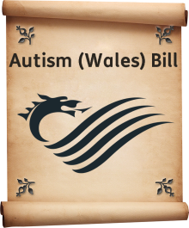My name is Paul Davies. I am an **Assembly Member (AM)** for Preseli Pembrokeshire.

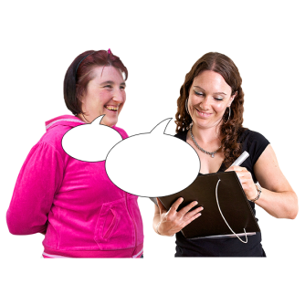The National Assembly for Wales said I could try to get a new autism law for Wales. I will call this law the **Autism (Wales) Bill**.

To help me write the **Autism (Wales) Bill** I asked people for their ideas. I asked what they thought should be in it.

I used what people said to write a **draft Bill**. Now I would like you to read my first draft of the Bill. And tell me what you think about it.

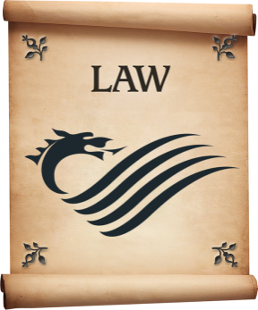A **draft Bill** is the words of a proposed law. It has not yet been introduced at the National Assembly for Wales. This means I can change it if I want to.

It will then be called a Bill when it is being looked at by the National Assembly for Wales.

The National Assembly for Wales can change the Bill.

If the National Assembly for Wales agrees to the Bill, it will then become an Act.

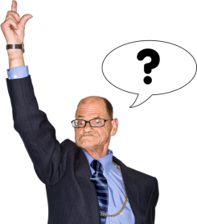

You can tell me what you think about any part of it. But there are some things I would really like your thoughts about. I have written some questions about these things.

First of all, please read the easy read draft **‘Autism (Wales) Bill’**. You can get the document on this webpage about the [Autism (Wales) Bill](http://www.assembly.wales/en/bus-home/bus-legislation/proposed_members_bills/Pages/paul-davies.aspx):



<http://www.assembly.wales/en/bus-home/bus-legislation/proposed_members_bills/Pages/paul-davies.aspx>



Please make sure you have read the easy read draft ‘Autism (Wales) Bill’ before answering the questions.

You will need to have the easy read draft ‘Autism (Wales) Bill’ with you when you answer the questions.

Before each question it tells you what pages to refer to in the easy read draft ‘Autism (Wales) Bill’.

# InternetHow your answers will be used

Your answers will be read by me, other **Assembly Members** and staff at the National Assembly for Wales.



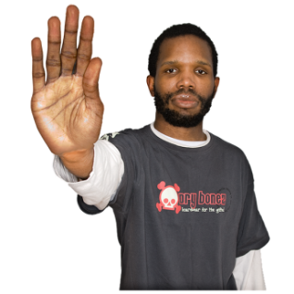I may also show other people what you have written by putting it on the National Assembly for Wales’s website.

If you do not want your name to be shown please let me know.

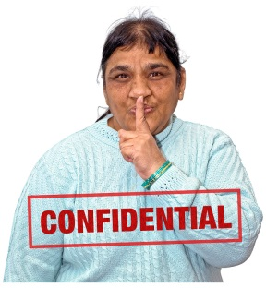

We will look after your personal information. We will follow the law on keeping personal information.

If you have any worries or questions about how we are going to use your information, please contact:

[Consultation.AutismBill@assembly.wales](mailto:Consultation.AutismBill@assembly.wales)

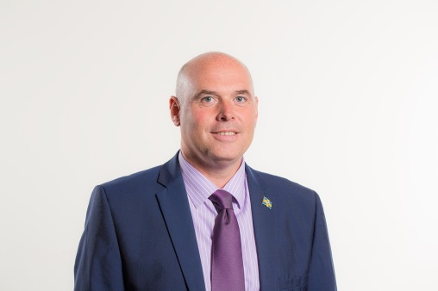You can answer in English or Welsh.

Thank you for your time.

**Paul Davies**

**Assembly Member for Preseli Pembrokeshire.**

# Questions about the draft ‘Autism (Wales) Bill’



**Please read page 5 in the easy read draft ‘Autism (Wales) Bill’**.

## Definition of autism spectrum disorder

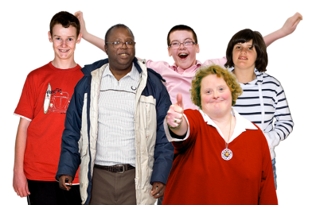

A **definition** is an explanation. The **definition** in this Bill will explain what is meant byautism spectrum disorder.

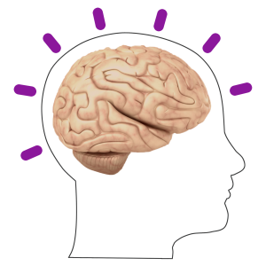People said the **Autism (Wales) Bill** may take support away from other **neurodevelopmental disorders**.

A **neurodevelopmental disorder** is when something goes wrong with how the brain develops.



I want to make sure the Bill does not take support away from other neurodevelopmental disorders.

Because of this, the draft Bill says that autism spectrum disorder means:

* whatever the World Health Organisation says that autism spectrum disorder means; plus
* any other neurodevelopmental disorder that the Welsh Government say should be treated in the same way as autism.

This means that if the Welsh Government believes the Bill should help people with other neurodevelopmental disorders, it can make it do so.



**Do you think a definition of autism spectrum disorder should be in the Bill?** Please tick.

Yes ☐

No ☐

Not sure ☐

The draft Bill uses the World Health Organisation’s definition of autism spectrum disorder.

It also gives powers to Welsh Government to add other neurodevelopmental disorders to this definition.

This is to make sure the Bill does not take support away from people with other neurodevelopmental disorders.



**Do you think this is the best way to do this?** Please tick.

Yes ☐

No ☐

Not sure ☐

## Who should have to follow the Bill?

**Please read page 7 in the easy read draft ‘Autism (Wales) Bill’.**

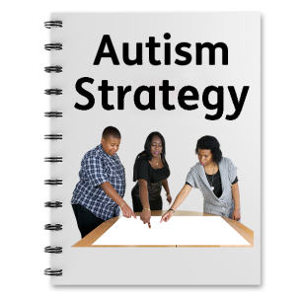

The draft Bill says local authorities and the NHSshould do what the strategy and guidance about the Bill says.

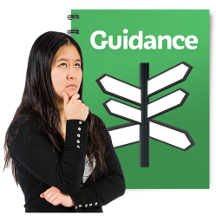

The Welsh Government also has the power to say other organisations should follow the strategy and guidance about the Bill.



1. **Are local authorities and the NHS the right organisations to carry out the aims of the Bill?**

Please tick.

Yes ☐

No ☐

Not Sure ☐

## Making sure the Bill is being followed



**Please read page 7 in the easy read draft ‘Autism (Wales) Bill’.**

The draft Bill says local authorities and the NHS should:



* Think about the autism strategy when doing their work. The strategy will say how to meet the needs of people with autism spectrum disorder.



* Think about the guidance when doing their work. The guidance will explain how to follow the autism strategy.

The Bill could be changed to give the Welsh Government extra power to tell local authorities and the NHS what to do.

It would use this power if it thought the strategy and the guidance about the Bill were not being followed.

However this power is not normally included in legislation unless there is an obvious need for it.



1. **Should the draft Bill be changed so that the Welsh Government has extra power to tell local authorities and the NHS to do something?**

**This will be something that will make sure they follow the strategy and the guidance about the Bill.**Please tick.

Yes ☐

No ☐

Not sure ☐

## How much time should things take?

The draft Bill says:

* The Welsh Government should write an autism strategy. This should be written within 6 months of the Bill becoming law.

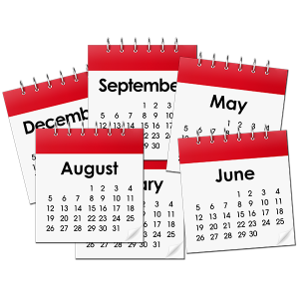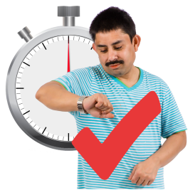

* The Welsh Government should write guidance about following the autism strategy. This should be written within 3 months of the autism strategy being written.
* If the Bill is agreed by the National Assembly then the law will start 3 months afterwards.



**Please read page 8 in the easy read draft ‘Autism (Wales) Bill’.**



1. **Do you have anything to say about the Welsh Government getting 6 months to write an autism strategy?**

|  |
| --- |
|  |



**Please read page 18 in the easy read draft ‘Autism (Wales) Bill’.**



1. **Do you have anything to say about the Welsh Government getting 3 months (after the strategy has been written) to write guidance?**

|  |
| --- |
|  |



**Please read page 7 in the easy read draft ‘Autism (Wales) Bill’.**

1. **Do you have anything to say about this law starting 3 months after it is agreed to?**

|  |
| --- |
|  |

## Getting a diagnosis

**Please read pages 11 to 13 in the easy read draft ‘Autism (Wales) Bill’.**



A **diagnosis** is when a team of people work out if a person has autism spectrum disorder.

The draft Bill says that the Welsh Government must write an autism strategy. The strategy must help people get a diagnosis of autism as soon as possible.



The draft Bill says diagnosis should happen as soon as possible. It should happen within the timescales written in national guidelines.

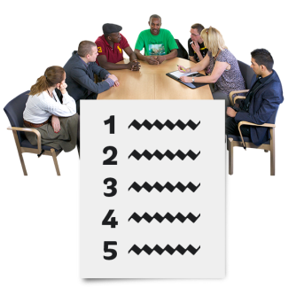

The **National Institute for Health and Care Excellence** writes the guidelines. It is an official group that writes guidelines for health and social care.

This means that any changes to the national guidelines would change the autism strategy’s timescales for diagnosis.

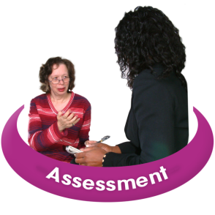The draft Bill also says that when a person gets an autism diagnosis they must have an **assessment**.

An **assessment** is when someone looks at what support a person needs.

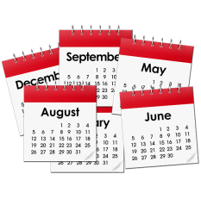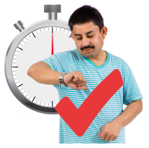

The draft Bill says this should happen as soon as possible. It must happen within 2 months of getting a diagnosis.



1. **Should we use the timescales that are in the national guidelines?**

**They would be used to say the longest time it should take to get a diagnosis.**

**The autism strategy timescales would change if the national guidelines change.** Please tick.

Yes ☐

No ☐

Not sure ☐



1. **Should an assessment happen within 2 months of getting a diagnosis?**Please tick.

Yes ☐

No ☐

Not sure ☐

Assessment teams

**Please read page 19 to 21 in the easy read draft ‘Autism (Wales) Bill’.**



The draft Bill says that a team of people should be involved in diagnosing a person with autism spectrum disorder.

The draft Bill gives examples of the type of people who could be in the team. They are:

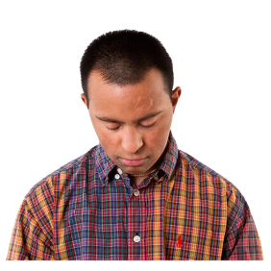

* + - A **psychologist**. Psychologists help people learn how to cope with mental health problems.



* + - A **psychiatrist**. Psychiatrists are doctors for mental health.



* + - A **speech and language therapist**. They treat people who find it hard to talk eat drink or swallow.

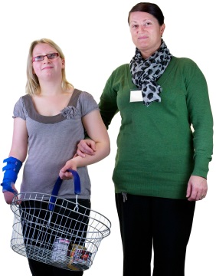

* + - An **occupational therapist**. They help people stay independent. They support them to be able to do every day things.

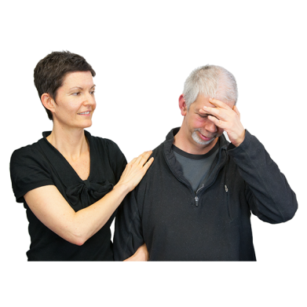

* + - A **behavioural therapist**. They help people overcome problems with the way they behave.

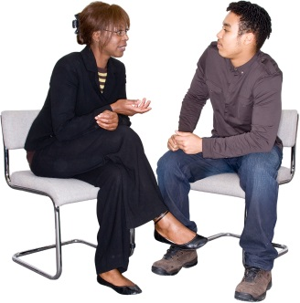

* + - A **social worker**. They support people through hard times. They make sure people are kept safe.



1. **Should the Bill include examples of the type of people who could be in the assessment team?**

Please tick.

Yes ☐

No ☐

Not sure ☐

1. **If yes are there any others that should be in the list?**

|  |
| --- |
|  |

## Being treated fairly

**Please read page 13 in the easy read draft ‘Autism (Wales) Bill’.**

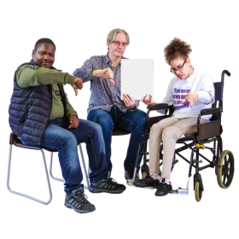

The draft Bill says that people should not be turned away from services because of things like their level of intelligence, known as IQ, or because they have an illness.



1. **Are there any other things that might stop a person with autism spectrum disorder from getting the services they need?**

|  |
| --- |
|  |

## Information about autism spectrum disorder



**Please read page 23 in the easy read draft ‘Autism (Wales) Bill’.**



The draft Bill says Welsh Government must collect information about people with autism spectrum disorder.



1. **Should the Bill say what kind of information should be collected?**Please tick.

Yes ☐

No ☐

Not sure ☐



1. **If yes what kind of information do you think should be collected? This could be things like:**
   * a person’s age
   * if they are male or female
   * the age they were when they got diagnosed
   * how long it took them to get a diagnosis
   * how they were diagnosed
   * the job titles of the people who diagnosed them
   * if other tests were done.

|  |
| --- |
|  |



1. **If the Bill says what kind of information should be collected, where should this be written?**

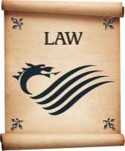**Should it be written on the Bill? This would make it law. It would have to be collected.**

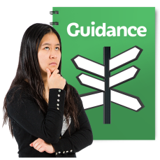**Or should it be written in the guidance? This would mean it was more like advice.** Please tick.

|  |  |
| --- | --- |
| It should be written on the Bill – the information must be collected. | ☐ |
| It should be written in the guidance. It should just be used to help. | ☐ |



1. **Should Welsh Government be able to ask other organisations for information (although this won’t necessarily include the names of people)?**

Please tick.

Yes ☐

No ☐

Not sure ☐

## Raising awareness

**Please read page 24 in the easy read draft ‘Autism (Wales) Bill’.**

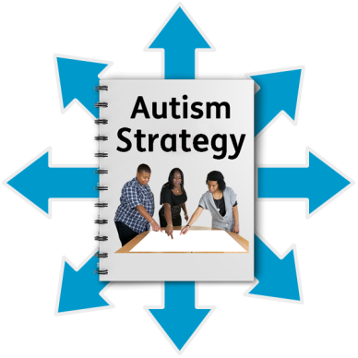

The draft Bill says that when the autism strategy is written the Welsh Government must start raising awareness of the needs of people with autism spectrum disorder. They must keep doing this.

This means the Welsh Government would always be helping people to better understand the needs of people with autism spectrum disorder.

A different way of writing the Bill is that it **could** say the Welsh Government should raise awareness every 3 years at least.



1. **Should raising awareness happen all the time? Or should it be every 3 years?** Please tick.

|  |  |
| --- | --- |
| It should happen all the time. | ☐ |
| It should happen every 3 years. | ☐ |

## Will the Bill be good for people?

**For this question please consider all of the easy read draft ‘Autism (Wales) Bill’.**



1. **Do you think the Bill will be good or bad for people?**   
     
   **In particular, do you think it will be good or bad for:**

* **People wanting to speak English or Welsh.**
* **People wanting things to be fair for everyone.**
* **The justice system in England and Wales.**
* **You - will it cost you anything, or give you any help.**

|  |
| --- |
|  |



1. **Please use this box to tell me any other thoughts or ideas you have about the draft Bill.**

|  |
| --- |
|  |