**Easy Read**

**My plans for a new autism law in Wales**

**By Paul Davies, Assembly Member for Preseli Pembrokeshire**

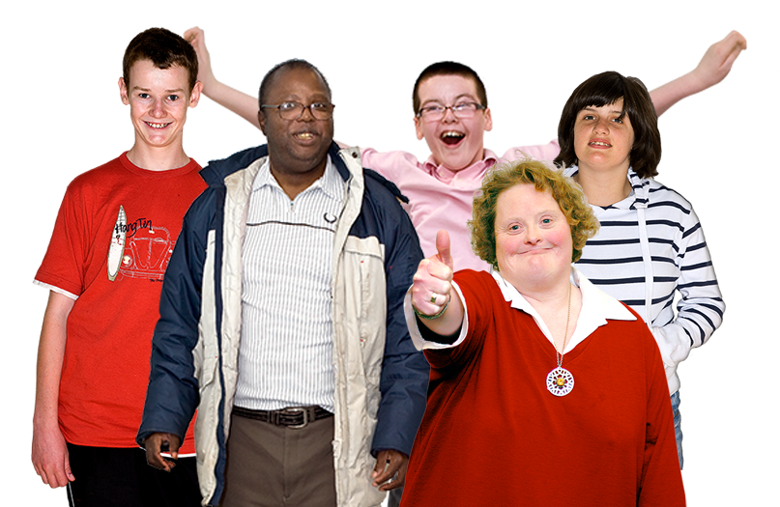I want to know what you think. Please answer the questions by 20 November 2017.

This is an easy read version of **‘Consultation on the proposed Autism (Wales) Bill’**

**August 2017**

**How to use this document**This is an easy read version. The words and their meaning are easy to read and understand.

You may need support to read and understand this document. Ask someone you know to help you.

Some words may be difficult to understand. These are in **bold blue writing** and have been explained in a box beneath the word.

Where the document says ‘me’ or ‘I’, this means Paul Davies

To get more copies contact:

Tom Jackson

National Assembly for Wales

Tŷ Hywel

Cardiff Bay

CF99 1NA

Phone: 0300 200 6565

Email: [Consultation.AutismBill@assembly.wales](mailto:Consultation.AutismBill@assembly.wales)

This document was made into easy read by Easy Read Wales using Photosymbols.

**Contents**

**Page**

About this form 3

Questions about why we need the Autism (Wales) Bill 5

Questions about getting a better way to diagnose Autism 8

Questions about improving the way people get support services 9

Question about autism training for staff 11

Questions about jobs for people with autism 12

Questions about the definition of autism 13

Questions about how much money my Bill may cost 14

Questions about how my Bill might save money 15

Question about other things to think about 16

## About this form

This form includes the questions we want to ask you about our plans for a new autism law in Wales.

Before you answer the questions, please read the easy read consultation called **‘My plans for a new autism law in Wales’**.

Please try to explain your answers. And give your own thoughts and ideas too.

Please tell us your name:

  
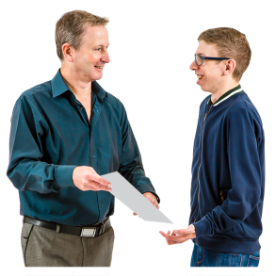Your answers will be read by me and staff at the National Assembly for Wales.

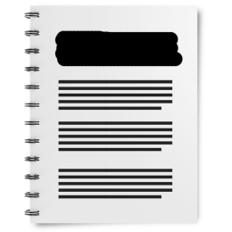I may also show other people what you have written by putting it on the internet - on the National Assembly for Wales website.

If you do not want your name to be shown please tick this box:

## Questions about why we need the Autism (Wales) Bill

1. What do you think about the work that has already happened to improve autism services?

1. Do you think Wales should have a law that says Welsh Government **must** write an autism **strategy**?

Yes  No

A **strategy** is a plan that says what we will do to achieve our aim to get people with autism the support they need.

**2a.** If **yes** do you think it should say Welsh Government **must** write **guidance** about how to follow the plan?

Yes  No

**2b.** If **yes** do you think it should say local authorities and health services **must** follow this **guidance** by law?

Yes  No

**Guidance** is advice and information. It will be written down. It will help to explain what the law is. And it will say how the autism plan is to be followed.

1. Do you think that Welsh Government should have to ask people their views about what to put in a plan for autism?

Yes  No

1. Do you think the law should say how often the plan for autism should be checked and updated?

Yes  No

**4a. If yes** how often do you think it should be checked?

1. Do you have any ideas about how Welsh Government should check how good services are for people with autism?

1. Do you have any ideas about what Welsh Government should do if the services are not very good?

## Questions about getting a better way to diagnose Autism

1. What do you think about how easy it is to get an autism **diagnosis** where you live?

A **diagnosis** is when a doctor looks at a person’s health and behaviour and says whether they have autism or not.

1. What are the most difficult things about getting a diagnosis?

1. Do you think that that local authorities and health services should have to give out information about how to get an autism diagnosis?

Yes  No

## Questions about improving the way people get support services

1. Do you think services at the moment are good enough for people with autism?

Yes  No

1. Do you think the law should say that there must be guidance on how to deliver services for people with autism?

Yes  No

1. I think there should be guidance. I think the guidance should say:
   1. how to organise getting an autism diagnosis
   2. services cannot turn people with autism away because they have a high IQ
   3. there should be plans for people with autism moving from child to adult services
   4. how to plan for autism services
   5. who should be in charge of the organisation of autism services.

Do you agree that the guidance should say something about the things listed above?

Yes  No

Is there anything else you think should be in the guidance?

1. Do you think local authorities and health services should have to collect information about people with autism so they can make better plans for services?

Yes  No

1. Do you have any ideas about the best way to collect information about people with autism?

For example information about how many people have autism. And what their support needs are.

## Question about autism training for staff

1. Do you have any views about the autism training that staff working with people with autism already get?

1. Do you think the law should say:
   1. what the staff who work with people with autism should know and be able to do after their training?

Yes  No

Or

* 1. that key staff should get autism training. The law would not say anything about what they should know.

Yes  No

## Questions about jobs for people with autism

1. Do you have any ideas about what should happen to help more people with autism get jobs?

## Questions about the definition of autism

1. Where do you think the definition should be written? Please tick 1:

a. On the Bill.

b. In the plan for autism.

c. In the **guidance**.

d. I don’t think it should be included.

## Questions about how much money my Bill may cost

1. Can you think of any other ways that this Bill might cost money?

## Questions about how my Bill might save money

1. Do you have any ideas about how the Bill might save money?

## Question about other things to think about

1. Can you think of any ways this Bill might have a bad effect on people or organisations?

Yes  No

1. If **yes** what do you think we should do to deal with it?

1. Can you think of anything else that I should think about or know about when writing the Bill?