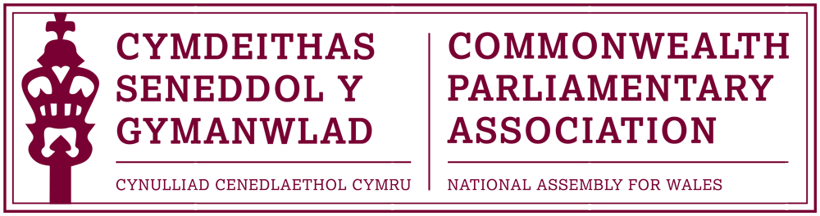

Inaugural Conference for Parliamentarians with Disabilities

Halifax, Nova Scotia,
Canada
29-31 August 2017

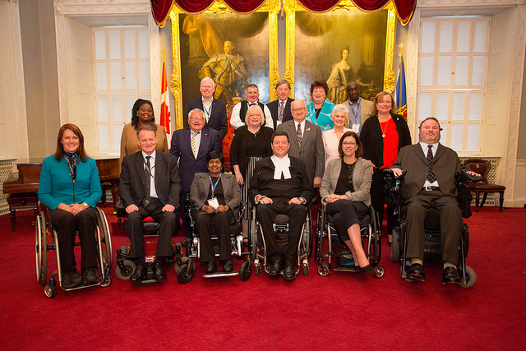

Delegation
Ann Jones AM, Deputy Presiding Officer of the National Assembly for Wales
Enfys Roberts, Private Office Manager - International and Communications

Contents

- About CPA CPwD
- Conference Overview
- Attendees
- Programme

- About CPA CPwD

  - The Commonwealth Parliamentary Association (CPA) Inaugural Conference for Parliamentarians with Disabilities (CPwD) was held to agree on a case to put forward to the Commonwealth Parliamentarian Association International Executive Committee (EXCO) to establish a new branch of the CPA with the suggested title of CPwD
  - This was the first conference of its kind and focused on the bigger picture of establishing the group rather than the finer details of its running
  - The main outcomes of the inaugural Conference included:
- a proposal to the EXCO for the establishment of a network for Commonwealth Parliamentarians with disabilities; and
- a Report of the recommendations and discussions that could be shared with the wider Commonwealth Parliamentarian Association membership to ensure information sharing on good practice is disseminated across all one hundred and eighty Commonwealth Parliaments and Legislatures.
  - The main objectives that were agreed CPwD would hold, if it were successful at EXCO would include:
- Support in seeking elected office
- outreach activities / programs, including educational and promotional videos, be developed and distributed
- all Parliamentarians be encouraged to be “leaders” and “ambassadors” that “inspire”, “empower”, “encourage” and “support” persons with disabilities to seek elected office;
- political parties be encouraged to pro-actively recruit and support persons with disabilities to become party candidates
- the voting process, including physical polling stations, be accessible to persons with disabilities; and
- data collection / survey / research to be conducted by an independent agency to understand more fully the reasons for which persons with disabilities run for public office or chose not to run for public office.

- Accessibility and inclusiveness
- parliament buildings be fully accessible;
- barriers, both physical and mental, created by stigma, stereotyping, assumptions and attitudes associated with and towards persons with disabilities be identified and strategies developed and put in place to overcome the barriers;
- all persons recognize that low income and poverty levels are additional barriers compromising the ability of persons with disabilities from seeking elected office

- Funding
- funding be provided by the Commonwealth Parliamentary Association International to the Commonwealth Parliamentarians with Disabilities (CPwD), once created;
- funding be made available to assist candidates with disabilities to run for public office;
- funding commitments by Parliaments be made to make their buildings and legislative processes accessible and inclusive; and
- funding be provided by governments for government programs to support persons with disabilities.

- Collaboration
- The CPwD should work collaboratively with Parliaments, the CPA and CWP, other levels of government and other organizations whose mandate is to work with and assist persons with disabilities;
- To share best practice and personal experiences to improve accessibility and inclusiveness

- Important roles for persons with disabilities
- Parliamentarians with disabilities be encouraged to educate their fellow Parliamentarians, the Press, the Parliamentary staff and Table Officers on disability related issues;
- Parliamentarians with disabilities become advocates for the recognition and acceptance by Parliaments and Governments that their permanent care givers, sign language interpreters and other attendants, needed to allow them to carry out their daily routine
- Governments be lobbied to appoint qualified candidates with disabilities to appointed positions such as agencies, boards and commissions and to provide training to civil servants
- political parties be lobbied to hire qualified persons with disabilities as members of their political staff;
- qualified persons with disabilities be considered for positions within the civil service (bureaucracy) that are directly involved in policy implementation affecting persons with disabilities;

- Conference Overview

The Commonwealth Parliamentary Association International Executive Committee approved the proposal for an inaugural meeting for Parliamentarians with disabilities in 2016. The idea for a network for Commonwealth Parliamentarians with Disabilities (CPwD) was proposed by the Speaker from the Nova Scotia Parliament, Hon. Kevin Murphy. The inaugural meeting was held in Halifax, Nova Scotia on 31 August and 1 September 2017. Twenty-nine parliamentarians from twelve Commonwealth countries attended the conference.
The World Health Organization reports that in most countries about 15% of the population report having some form of disability. Preliminary research indicates that significantly less than 1% of currently serving parliamentarians at the state and federal level of Commonwealth governments are persons with disabilities. Despite constituting approximately 15% of the world’s population, persons with disabilities continue to be disproportionately represented in governance and at all levels of decision-making.
The conference provided an opportunity for participants to share their personal experiences with others from all over the Commonwealth, and to share best practice. Delegates discussed how parliamentarians with disabilities can play a full and equal role within the parliamentary environment, and how physical and mental barriers must be overcome to entice greater numbers of people with a disability into politics. Many examples were shared in relation to discrimination, stigma and unfair treatment due to a disability. Delegates were unanimous in agreeing that breaking through these barriers is an essential focal point in moving forward.
Recognising the need to increase representation of persons with disabilities in political institutions, the proposal is to create CPwD to be founded by current Commonwealth parliamentarians with disabilities so that at future conferences, delegates could discuss ways to increase persons with disabilities representation in Parliament and work towards the mainstreaming of disability considerations in all CPA activities and programs. CPwD would be formally recognised in the CPA Constitution and its elected Chairperson became part of the CPA Executive Committee. The CPwD will work towards better representation of persons with disabilities in state and federal legislatures across the Commonwealth.
The CPwD would be composed of self-identified persons with disabilities who are current state or federally elected representatives in Commonwealth countries. Its aims and objectives would be:
- To increase representation of persons with disabilities in our Parliaments;
- To provide opportunities for strategic discussion and development for future and present Parliamentarians with disabilities;
- Identify barriers preventing persons with disabilities from seeking elected office
- Develop outreach program and materials encouraging persons with disabilities to seek elected office
- To foster closer relationships between Commonwealth parliamentarians with disabilities;
- To discuss, strategize and act on issues relating to persons with disabilities internationally.

CPwD would pursue these aims and objectives by means of annual Commonwealth parliamentary conferences, regional conferences, outreach programs, and campaign schools, with a mission statement of:
‘The CPwD, as an integral part of the CPA, works for the better representation of persons with disabilities in legislatures and for the furtherance of disability related issues across the Commonwealth’
Delegates agree that the aims of the CPwD include:

1) To increase persons with disabilities representation in Parliaments and Legislatures across the Commonwealth;
2) To bring disability issues to the fore in parliamentary debates

In addition to ensuring that persons with disabilities are represented, it was noted that gender balance was also an issue to be addressed as part of this. It was stated that women from all around the world should be involved, not just those from Europe. For example, less women are involved in politics in regions such as the Caribbean. Ann Jones AM stated that as a disabled woman in politics, women should be supporting each other. Members discussed ways in which their parliaments have attempted to tackle this, and also of innovative ways on how to help others understand the everyday lives of people with disabilities. Examples included Jersey and Barbados giving three parliamentarians a disability for the day to help them see everyday tasks in a difference perspective. Training was also discussed, with Ontario being the first in the world to require staff to be trained on accessibility. Jamaica also passed the Disabilities Act in 2014 and held a Disabilities Convention in 2007. Wales has had the advantage of building the Senedd in recent years (2006), resulting in a fully accessible building. This is not the case in many other legislatures meaning that adjustments must be made.
Following the conference, as a way of promoting the CPwD, delegates were encouraged to write a piece for ‘The Parliamentarian’. Deputy Presiding Officer, Ann Jones AM was happy to contribute to this and would like to extend great thanks to Hon. Kevin Murphy for taking the initiative to create this network, and also to the CPA Secretariat for their support. Ann Jones AM stated that she hopes parliamentarians across the CPA, disabled or not, join the participants that were present in Nova Scotia, to support the formal creation of Commonwealth Parliamentarians with Disabilities (CPwD).

- Attendees
Name | Official Role | Jurisdiction
Hon. Kevin Murphy | Conference Host  Speaker of the House of Assembly  Member of the Legislative Assembly for Eastern Shore | Nova Scotia, Canada
Miss. Kerryann F. Ifill | President of the Senate of Barbados  Senator | Barbados
Hon. Linda Reid | Member of the Legislative Assembly for Richmond East | British Columbia, Canada
Ms. Stephanie Cadieux | Member of the Legislative Assembly for Surrey - South | British Columbia, Canada
Hon. Carla Qualtrough | Minister of Sport and Persons with Disabilities  Member of Parliament for Delta | Canada
Hon. Motiram Chandravanshi | Parliamentary Secretary  Member of the Legislative Assembly for Pandariya | Chhattisgarh, India
Dr. Floyd Morris | Senator | Jamaica
Mr. Paul Routier, MBE | Senator | Jersey
Mr. Frederuc | Member of the Provincial Assembly | Khyber Pakhtunkhwa, Pakistan
Hon. Dr. Clement T Chiwaya | Deputy Speaker of the Malawi Assembly  Member of Parliament for Mangochi Central | Malawi
Hon. Bathmavathi Krishan | Senator | Malaysia
Hon. Steven Fletcher | Member of the Legislative Assembly for Assiniboia | Manitoba, Canada
Dr. Edward Doherty | Minister of Service New Brunswick  Minister responsible for Aboriginal Affairs  Minister responsible for Poverty Reduction and the Economic and Social Inclusion Corporation  Member of the Legislative Assembly for Saint John Harbour | New Brunswick, Canada

Mr. Gareth Ward | Member of the Legislative Assembly for Kiama | New South Wales, Australia
Ms. Lisel Tesch | Member of the Legislative Assembly for Gosford | New South Wales, Australia
Hon. Jackson Lafferty | Speaker of the Legislative Assembly for the Northwest Territories  Member of the Legislative Assembly for Monfwi  Canada Executive Committee Member | Northwest Territories, Canada
Hon. Tracy MacCharles | Minister of Government and Consumer Services  Minister Responsible for Accessibility  Member of the Provincial Parliament for Pickering - Scarborough East | Ontario, Canada
Hon. Francis (Buck) Watts | Speaker of the Legislative Assembly | Prince Edward Island, Canada
Mr. Jeremy Balfour | Member of the Scottish Parliament for Lothian | Scotland
Mr. H.R Ian Roach | Senator | Trinidad & Tobago
Rt. Hon. Baron Blencathra | House of Lords | United Kingdom
Mrs. Ann Jones AM | Deputy Presiding Officer | Wales
Hon. Nickson Chilangwa | Member of Parliament for Kawambwa | Zambia
Mr. Sebastian Kopulande | Member of Parliament for Chembe | Zambia
Hon. Mwantatu Mbarak | Member of the House of Representatives | Zanzibar

- Programme

WEDNESDAY 30 AUGUST 2017
18:30 – 20:30 | Tour of Legislature and Reception hosted by the Speaker of the Nova Scotia House of Assembly.
THURSDAY 31ST AUGUST 2017
09:00 – 09:30 | Welcome Remarks: Hon. Kevin Murphy, MLA  Speaker, Nova Scotia Legislative Assembly  CPA Representative: Hon. Jackson Lafferty, MLA Speaker, Northwest Territories Legislative Assembly
09:30 – 10:15 | Session 1 – The Development of the Commonwealth and the Commonwealth Parliamentary Association?  Presenter: Hon. Jackson Lafferty, MLA  Ms Meenakshi Dhar  Director of Programmes, CPA HQ Secretariat
10:15 – 11:15 | Session 2: The proposal for the Commonwealth Parliamentarians with Disabilities Network (CPwD)  (Overview of the Proposal; Brainstorm Session: why is the CPwD necessary; How would CPwD add value to the Association; How would CPwD strengthen the relationship between Parliamentarians and persons with disabilities throughout the Commonwealth))  Chair: Hon. Carla Qualtrough  Minister of Sport and Persons with Disabilities, Canada  Presenter: Hon. Kevin Murphy  Floor opens to all participants for discussion
11:45 – 13:00 | Session 3: Commonwealth Women Parliamentarians (CWP)  Genesis, history of the CWP and the CWP Canada Region  Chair: Hon. Ann Jones, AM, Wales  Presenter: Hon. Linda Reid, MLA  Floor opens to all participants for discussion
14:00 – 15:30 | Session 4: General Status of Persons with Disabilities in CPA Member Countries/Parliaments.  Factual/Statistical review of status and Disabilities legislation in Commonwealth countries including Commonwealth jurisdictions with defined seats for persons with disabilities in Parliament  Chair: Senator Kerryan F Ifill, Barbados  Presenters:  - Senator Paul Routier, Jersey  - Hon. Dr Clement Chiwaya, Deputy Speaker, Malawi  Floor opens to all participants for discussion
FRIDAY 1ST SEPTEMBER 2017
09:30 – 10:30 | Session 5: Session: Election and Beyond (Access to elected Office and the Member of Parliament)  (Roundtable discussion where delegates share their own experiences with getting elected – as a person with a disability; how they manage daily responsibilities; Parliamentary perspective – legislation, enforcement and challenges)  Chair: Hon Francis Watts  Speaker, Prince Edward Island  Presenters:  - Hon Jeremy Balfour, MSP, Scotland  - Hon Sebastian Kopulande, MP, Zambia  Floor opens to all participants for discussion
11:00 – 13:00 | Session 6: Accessibility of Parliament for Disabled Members  (Sharing of good practice/examples of innovations that make Parliament more accessible and responsive to the needs of disabled Members of Parliament)  Chair: Dr Clement Chiwaya  Presenters:  - Hon Nickson Chilangwa, MP, Zambia  - Hon Steven Fletcher, Manitoba  Floor opens to all participants for discussion
13:00 – 15:00 | Session 7: Conclusion and Recommendations for the Report to Establish CPwD  Panel: Hon. Kevin Murphy  Hon. Jackson Lafferty  Hon. Linda Reid  Ms Meenakshi Dhar  Floor opens to all participants for discussion

