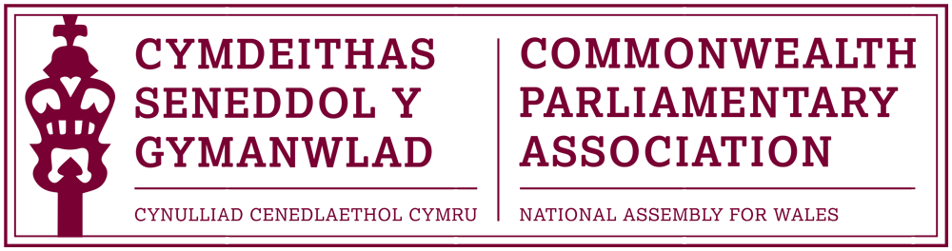

14th CANADIAN PARLIAMENTARY SEMINAR
Ottawa, 16-20 October 2017

STRENGTHENING DEMOCRACY AND THE ROLE OF PARLIAMENTARIANS: CHALLENGES AND SOLUTIONS

Report from National Assembly for Wales CPA Branch representative
Lee Waters AM

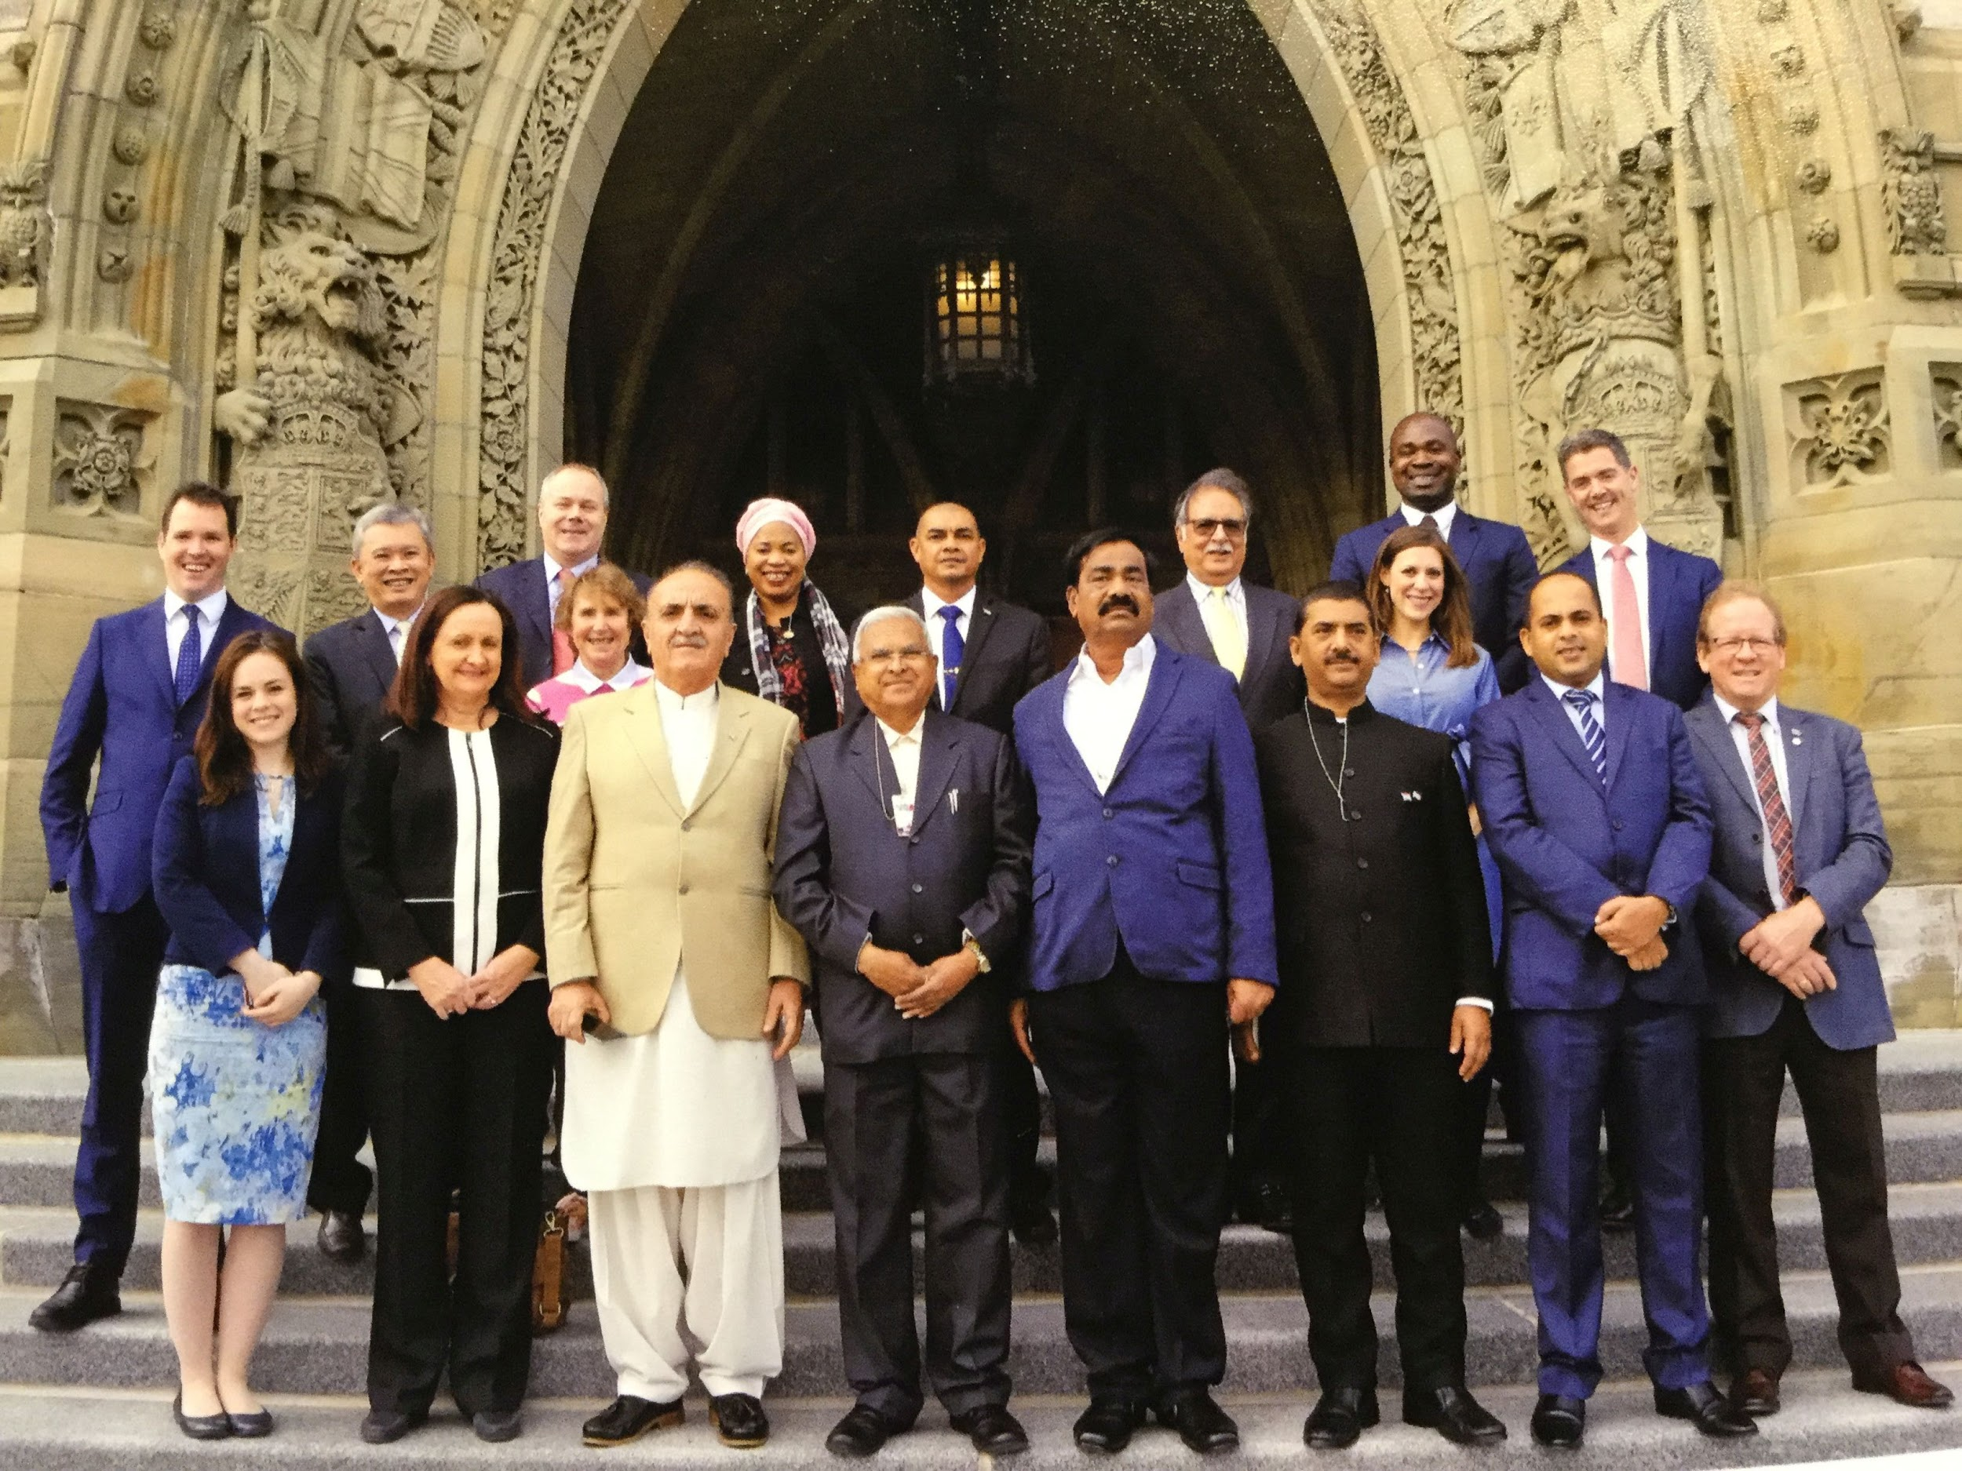

Introduction
Arriving in Canada towards the end of its celebrations of 150 years of confederation provided a valuable opportunity to reflect on the challenges of Government and representation in complex societies.
It is striking that even a Century and a half on Canada's institutions and constitution are still adapting and adjusting. During a week of detailed briefings and discussions with politicians and officials a picture emerged of a country still evolving its confederation. The election of a disruptive political force in its dominant neighbour the year before, and the review of its trading relations, has clearly unsettled the governing class. Similarly the upsurge in nationalist feeling in Catalonia, and the determined response of the Spanish Government, has implications for the political situation in Québéc and the stability of the Canadian confederacy. And the role of the second chamber in the Canadian constitution has reemerged as a source of debate following the decision of the new Canadian Government to end partisan appointments to the Upper House in favour of non-party nominations from an independent Commission.
Even in a prosperous and stable democracy such as Canada the task of governing a diverse society in a global economy is an ongoing challenge. It was within that context that the eleven countries represented spent five days exchanging experiences of the challenges each faced in strengthening their democracies.
Programme
This was the 14th year that the Canadian branch of the Commonwealth Parliamentary Association hosted its seminar aimed primarily at recently elected members of Parliament. The programme is very well organised and the format is tried and tested, albeit a little tired.
Over the course of five days 16 delegates from a diverse range of commonwealth parliaments were briefed on the Canadian political situation and the way in which its system operates. A series of Members of Parliament and Senators joined us in our sessions to explain their roles and the issues they face. The seminar covered the Canadian political scene, the role and operation of the Canadian Parliament, its committees and the way its parties caucused. We discussed how MPs engaged their voters, how their elections were financed and how lobbying was regulated.
Whilst the formal programme was mostly interesting the most valuable part of the programme was the opportunity to get to know, and discuss issues, with our fellow delegates. Getting to understand the pressures and political cultures experienced by colleagues in countries as varied as Singapore, Sri Lanka, Australia, Jamaica, Zambia and Pakistan was invaluable professional development. My chief disappointment was the inability to fully interact with representatives from India because of language barriers.
The most productive formal sessions were those that focused on comparative discussions. The most stimulating topics were the role of women in politics in the different countries, and the tensions in managing political groups. These topics intersected each of the countries and almost all delegates had interesting contributions to make. Similarly on the final morning each of us had an opportunity to introduce a subject of our choice to bring to the attention of the other delegates and to have a brief discussion. This proved another opportunity to understand the diversity of the commonwealth and the plurality of the issues political repressive system are grappling with: from the cultural challenge presented by the pressure to allow same-sex marriages in Jamaica, to the interference of the military in Pakistan, political violence and intolerance of dissent in Zambia, to the homogenising cultural influence of Netflix raised by an Australian regional Senator and my own paper and discussion on the need to adapt in the face of automation and robotics.
I was pleased that some delegates indicated a willingness to develop the issues around automation in their own Parliaments, and that the discussion around the need to pressure Netflix to commission more local content has led to a joint initiative between myself and the delegates from New South Wales, Singapore and Scotland.
Conclusion
The diversity of the Commonwealth is its strength. There is little that binds the member countries together save our common past. However that heritage does create the platform for a rich network of contacts to share problems and discuss solutions.
From a personal point of view I found the chance to better understand the issues faced by countries that I otherwise would have no interaction with to be very valuable. Likewise I appreciated the opportunity to spend a week discussing common issues with a group of people who instinctively understand many of the dynamics I am dealing with. The varied discussions provided a chance to reflect on the challenges my own Parliament faces, and the way I personally handle them.

