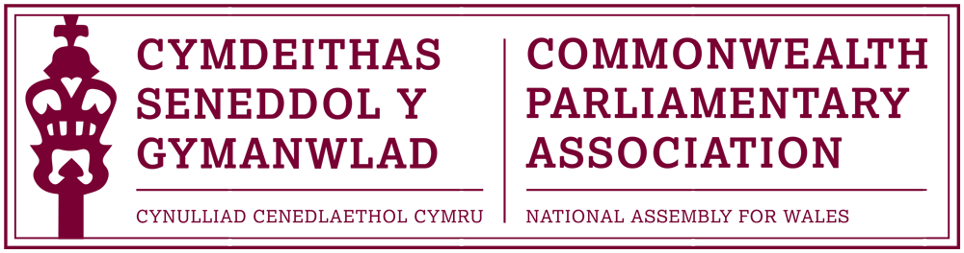

63RD COMMONWEALTH PARLIAMENTARY CONFERENCE, DHAKA, BANGLADESH

1-8 November 2017

THEME: “Continuing to enhance high standards of performance of Parliamentarians.”

CPA Wales Delegation
Mohammad Asghar AM (Oscar)
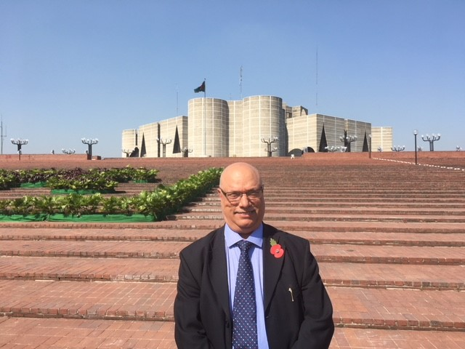
Photo: Mohammad Asghar AM outside the Bangladeshi Parliament Building, Dhaka

63rd CPC, Bangladesh – Report Notes by Mohammad Asghar AM
Sunday 5 November 2017
- Attended Official Opening of the 63rd CPC
- Spoke during the ensuing discussion on the Rohingya Refugee Crisis
- Delegates agreed to take steps to try to sort out this issue
- Interviewed by Bangladesh Media and interview shown on mainstream television.

Monday 6 November 2017
- Attended Workshop B on the role of Parliamentarians in building stronger ties within the Commonwealth
- Spoke on the work being done in Wales to strengthen such links
- Stressed the need to improve trade and cultural links especially with those countries new to democracy
- Contribution well received
- Attended Workshop E on Critical Mass: Small jurisdictions and big problems-Logistics and infrastructure challenges
- Spoke on the devolved areas and competence of the Assembly
- Stressed that the National Assembly is still evolving following the Government of Wales Act
- Countries raised points regarding difficulty their Parliamentarians have in getting UK visas
- Fast track programme for Visas to be considered
Tuesday 7 November 2017
- Attended General Assembly and Election of Chairperson of the Executive Committee
- Supported UK backed candidate from Pacific Region who was unsuccessful
- Felt the UK appears to have lost influence in the Commonwealth and links need to be improved

I wish to record my thanks to Al Davies for all the help and support provided before and during this visit.

Mohammad Asghar AM
29 November 2017

