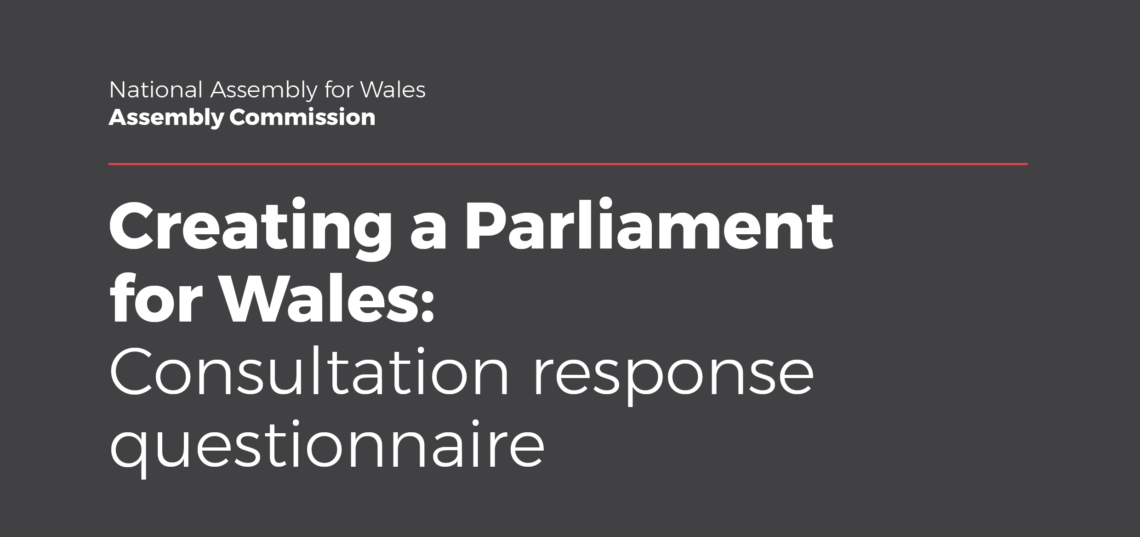
We would like to know your views on the proposals in our consultation document: Creating a Parliament for Wales.
The Assembly Commission is keen to hear your views. We would like to hear from members of the public, academics, organisations and other stakeholders, from those who frequently engage with the Assembly and politics in Wales, and from those who would not normally do so.
How to respond
You are welcome to respond to any or all aspects of the proposals. We also welcome the submission of additional supporting written evidence where relevant.
To respond to the consultation, please complete this response questionnaire and return it by Friday 6 April 2018 to:
- AssemblyCommission.Consultations@assembly.wales
- Freepost, National Assembly for Wales
If you have any queries about this consultation, please contact:
- Email: AssemblyCommission.Consultations@assembly.wales
- Telephone: 0300 200 6565

How we will use the information you provide
Who we are
The Assembly Commission is the data controller of the information you provide, and will ensure it is protected and used in line with data protection legislation.
Why we are collecting this information
Your submission will be used to inform the Assembly Commission’s work on reforming the National Assembly for Wales, for example in relation to its size and its electoral, operational and internal arrangements.
What we will do with your information
Submissions will be seen in full by the Assembly Commission staff involved in the consultation. Submissions may also be seen by Assembly Commissioners and other Assembly Members. All responses to the consultation questions (including those submitted in hard copy) will be stored in Survey Monkey. Survey Monkey may store your information outside of the European Economic Area. See their website for details about how they will use your information:
https://www.surveymonkey.com/mp/policy/privacy-policy/
Publication of submissions
The Assembly Commission may publish some or all of your submission to this consultation on the Assembly’s website. We may also publish extracts from your submission within documents produced following the consultation and published on the Assembly’s website. Any submissions that are published on the Assembly’s website will remain in the public domain.
Please let us know if you would prefer that your submission or extracts from it are not published.
If we publish a submission you have provided on behalf of an organisation, we will include your name, job title and the name of your organisation with your submission. If we publish a submission you have provided on your own behalf, we will only publish your name if you have asked us to do so.

How long your information will be retained
Responses will be stored on our own secure IT system until the Assembly Commission has completed the consultation and any subsequent work in the areas outlined in this document.
Contacting you
We may use the contact details you provide to contact you in relation to this consultation and your submission. We may also like to contact you in the future in relation to this consultation, your submission, and the Commission’s Assembly reform work. Please inform us as you respond to the consultation if you would like us retain your contact details and contact you for these purposes. If you decide to opt into further contact, you may opt out of further contact at any point by letting us know.
Requests for information made to the Assembly Commission
In the event of a request for information being made under access to information legislation, it may be necessary to disclose all or part of the information that you provide. This may include information which has previously been removed by the Assembly Commission for publication purposes. We will only do this if we are required to do so by law.
Your rights
Your personal data will be processed for the performance of a task carried out in the public interest by the Assembly Commission i.e. a consultation on Assembly reform. If you would like to: engage any of the rights that you have under the legislation (such as the right of access); ask a question; or make a complaint about how your information is used; please contact the Assembly’s Information Governance Manager: alison.bond@assembly.wales
You can also make a complaint to the Information Commissioner’s Office (ICO) if you believe we have not used your information in line with the law. ICO Contact details on their website: https://ico.org.uk/concerns/

Your details
It would be helpful if you could provide the following information, although you are not required to do so. Please see the previous section for details on how the information you provide will be used.
Name: | Your name here
Organisation: | If you are replying on behalf of an organisation, please state the name of the organisation
Address: | Your address here
Email address: | Your email address here
Telephone number: | Your phone number here
Are you aged 18 or over?
If you would prefer that your submission or extracts from it are not published, please indicate here by ticking the box. ☐
If you are responding on your own behalf (rather than on behalf of an organisation) and would like to us publish your name with your submission, please indicate here by ticking the box. ☐
If you would like us to retain your contact details and contact you in relation to your submission should we need to, please indicate here by ticking the box. ☐
If you would like us to retain your contact details and contact you in future in relation to the Commission’s Assembly reform work, please indicate here by ticking the box. ☐
If you decide to opt into further contact, you may opt out of further contact at any point by letting us know.
If you are under 16 please tick this box to confirm your parent or guardian is happy for you to respond to this consultation. ☐

Consultation response
How many Assembly Members does the Assembly need?
Q1. The Expert Panel has concluded that the Assembly needs to have between 80 and 90 Members to carry out its role effectively. Do you agree? Please give reasons for your answer.
Click here to enter text.

Q2. Would changes to the number of Assembly Members result in i) costs, or ii) benefits, for you or your organisation? If so, what would the costs or benefits be?
Q2.(i) Costs for you or your organisation.
Click here to enter text.
Q2.(ii) Benefits for you or your organisation.
Click here to enter text.

How should Assembly Members be elected?
Q3. The Expert Panel has outlined three possible electoral systems which could operate effectively in Wales to elect an Assembly of at least 80 Members. Which of these systems would be most appropriate for electing Assembly Members and why?
Please pick one.
Please give reasons for your answer.
Click here to enter text.

Q4. Do you agree with the Expert Panel’s recommendation that a change to the electoral system should be used to encourage the election of an Assembly that more accurately reflects the diverse nature of society in Wales?

Q5. If you answered yes to question 4, do you believe that this should be achieved through legislation such as formal gender quotas, or by less formal means such as voluntary measures put in place by political parties? Please give reasons for your answer.
Click here to enter text.

Q6. Should people be able to stand for election to the Assembly on the basis of job sharing?

Q7. What, if any, benefits or risks do you see resulting from allowing people to stand for election on the basis of job sharing arrangements?
Click here to enter text.

Q8. If the Assembly adopted either the Single Transferable Vote or Flexible List Proportional Representation for the election of Assembly Members, should Assembly Members be elected on the basis of:
Please pick one.
Q.9. Would changes to the Assembly’s electoral system result in i) costs or ii) benefits for your or your organisation? If so, what would the costs or benefits be?
Q9.(i) Costs for you or your organisation.
Click here to enter text.
Q9.(ii) Benefits for you or your organisation.
Click here to enter text.

Who should be allowed to vote in Assembly elections?
Q10. To what extent do you agree or disagree or disagree with the following statement:
The same people should be allowed to vote in National Assembly for Wales elections and in local government elections in Wales.

Q11. What implications would there be if there were differences between who could vote in Assembly elections and who could vote in local government elections in Wales?
Click here to enter text.

What should be the minimum voting age for Assembly elections?
Q12. What should be the minimum voting age for Assembly elections?
Please tick one.

Q13. Would reducing the minimum voting age for Assembly elections result in i) costs or ii) benefits for you or your organisation? If so, what would the costs or benefits be?
Q13.(i) Costs for you or your organisation.
Click here to enter text.
Q13.(ii) Benefits for you or your organisation.
Click here to enter text.

Q14. Are there any other issues, benefits or risks you would like us to consider in relation to changing the minimum voting age for Assembly elections? Please give reasons for your answer.
Click here to enter text.

Should residents in Wales who are not UK nationals be allowed to vote in Assembly elections?
Q15. To what extent do you agree or disagree or disagree with the following statement:
All legal residents in Wales should be allowed to vote in Assembly elections, irrespective of their nationality or citizenship.

Q16. Are there any other issues, risks or benefits you would like us to consider in relation to changing the rights of non-UK nationals legally resident in Wales to vote in Assembly elections? Please give reasons for your answer.
Click here to enter text.

Should prisoners be allowed to vote in Assembly elections?
Q17.(i) To what extent do you agree or disagree or disagree with the following statement:
Prisoners released on temporary licence or on home detention curfew should be allowed to vote in Assembly elections, in line with the UK Government’s intention for UK elections.

Q17.(ii) To what extent do you agree or disagree or disagree with the following statement:
Prisoners whose due release date falls before the end of the term of the Assembly for which they are voting should be allowed to vote in Assembly elections, in line with the Welsh Government’s intention for local government elections in Wales.

Q18. Are there any other issues, risks or benefits you would like us to consider in relation to changing the rights of prisoners to vote in Assembly elections? Please give reasons for your answer.
Click here to enter text.

Who should be able to be an Assembly Member?
Q19. Should legislation to reform the Assembly’s electoral arrangements include provision to implement the recommendations of the Fourth Assembly’s Constitutional and Legislative Affairs Committee in relation to disqualification from being an Assembly Member?
Are there any other changes which should be made to the disqualification arrangements?
Please give reasons for your answer.
Click here to enter text.

Should the law relating to electoral administration be rationalised?
Q20. Should legislation to reform the Assembly’s electoral arrangements include provision to implement the following?
Please give reasons for your answers.
Q20.(i) The Electoral Commission’s recommendations that costs relating to translation between Welsh and English should not count towards expenditure limits for political parties and candidates in relation to Assembly elections as they already are for non-party campaigners.
Click here to enter text.
Q20.(ii) The Electoral Commission’s recommendations that costs relating to an individual’s disability should not count towards expenditure limits for political parties and candidates in relation to Assembly elections as they already are for non-party campaigners.
Click here to enter text.
Q20.(iii) The Law Commissions’ recommendations in relation to the conduct and administration of elections.
Click here to enter text.

Should the Assembly have flexibility to decide on its internal arrangements?
Q21. Should the Government of Wales Act 2006 be amended as set out in this consultation document, in order to give the Assembly greater flexibility to determine its own working practices and arrangements through its internal procedures rather than in legislation?
Click here to enter text.

What impact might these proposals have?
Q22. Are there any issues, benefits or risks which could result from the proposals in this document in relation to the following, that are not considered in this consultation, or that you would like to comment on?
- The Assembly’s official languages (Welsh and English)
- Equality, diversity and inclusion
- The justice system in England and Wales
Could any of the proposals be reformulated so as to increase the positive effects or reduce the possible adverse effects? Please give reasons for your answer.
Click here to enter text.

Q23. Would any of the proposals in this paper result in i) costs or ii) benefits for you or your organisation which you have not already outlined in your response to this consultation? If so, what would the costs or benefits be?
Q23.(i) Costs for you or your organisation
Click here to enter text.
Q23(ii) Benefits for you or your organisation.
Click here to enter text.

