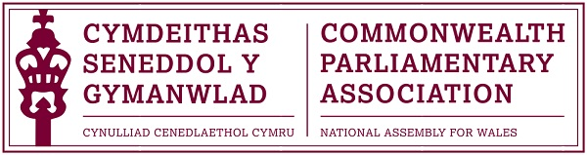

2016 Commonwealth Day Report
by
CPA Wales Branch Representative,
Nobee Moyo.
On 14 March 2016 I was selected to attend the Official Commonwealth Day Celebrations in London, the theme of which was “An Inclusive Commonwealth”. I represented the National Assembly for Wales, other attendees came from countries as varied as Jersey, New Zealand, and South Africa.
This year’s theme celebrated the diversity of the commonwealth. The day commemorated how even though the commonwealth has more than two billion people, their differences and uniqueness help reinforce the charter, ‘everyone is equal and deserves to be treated fairly.. without regard to their race, age, gender, belief’. This theme of inclusivity and this promotion of diversity, especially with today’s political unrest, I feel is a very important message.
The day began with a talk from the 7th CPA Secretary-General Mr Akbar Khan. Mr Khan introduced the theme and explained how inclusivity directly co-exists with the commonwealth. Mr Khan spoke of his own background, born in Guyana but moved to the United Kingdom in his later life. Educated in the United Kingdom with a Master’s in Public International Law (LLM) Mr Khan began to illustrate that he embodied the theme of an ‘inclusive commonwealth’. The Secretary General then proceeded to ask us what we in turn understood an inclusive Commonwealth to be; many of us gave varied accounts, however, we all fundamentally agreed that inclusivity meant recognising and embracing individual identity.
His Excellency Mr Guy Hewitt and Acting High Commissioner Ms. Peggy Mclennan illustrated to us their careers, Mclennan and Hewitt spoke of their transition from undergraduate degrees with Mclennan accomplishing a Bachelor of Arts degree in English and History, to then progressing to a Post Graduate Diploma in International Studies, to then joining the CPA. Mclennan and his excellency Mr Guy Hewitt, explained how a political career, doesn’t have just one route, they were then both joined by Roberta Blackman-Woods, MP for the city of Durham and Mr Ian Richard Liddell-Grainger MP who also reiterated this message by discussing their careers at length.
The day then proceeded with a ceremony in Westminster Abbey, where we were greeted with the presence of Her Majesty The Queen, and the Royal family. This ceremony was open to the general public, and the diversity in the room was apparent. The ceremony in Westminster Abbey I feel, was (although on a smaller scale) a strong depiction of what it means to have an inclusive commonwealth.
As a young BME female, originally from Zimbabwe, representing Wales during the Commonwealth day I felt I was the embodiment of what it means to have an inclusive commonwealth; as my race, age or gender, did not predict or takeaway this opportunity.

