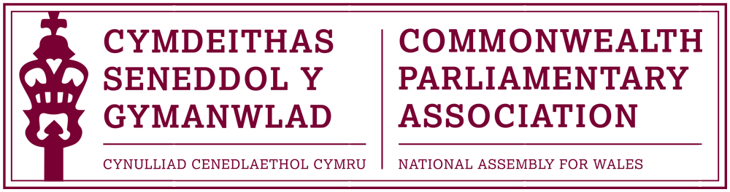

BRANCH EXECUTIVE MEETING

Meeting Date: Tuesday 8 March 2016

MINUTES

Present:
Joyce Watson AM, Chair
Mohammad Asghar AM
William Powell AM

Al Davies, Acting Branch Secretary

- APOLOGIES FOR ABSENCE

Apologies had been received by Simon Thomas AM.

- MINUTES OF THE LAST MEETING – Paper CPA 04-15M

Attendees present concurred with the minutes of the previous meeting

- MATTERS ARISING FROM MINUTES

- Branch arrangements for transition into 5th Assembly

Members considered and agreed the document outlining the proposed arrangements for the Branch’s transition into the 5th Assembly, as requested at the previous meeting. These included:
- That no Branch AGM be held before Dissolution, with the existing Branch
Executive Members remaining until 5 April 2016.
- That a draft Annual Report to cover the period from the last report up until
March 2016 be drafted and distributed to coincide with Commonwealth Day
2016.
- That an AGM be arranged, as soon as practical, in May/June 2016 following
the Assembly Elections.
- That the CPA Wales Branch be represented at the 2016 BIMR by any existing
BEC Members who are re-elected in May 2016, and who - subject to Assembly
business - are able to attend.

- REVIEW OF RECENT ACTIVITIES

Feedback and follow-up of recent Meetings, Visits,
Events and Conferences

- 3rd BIMR CWP Conference
Guernsey
12-14 February 2016

The Chair reported that the Regional CWP conference had been very well organised with strong speakers (two of whom were from Wales). The conference had raised many interesting matters, including the challenges faced by Guernsey and other small island legislatures. The Chair noted how pleased she had been that Janet Howarth AM, as a newly elected Member, had attended and was encouraged by how positive she had found the experience.

- Presiding Officer’s Visit to South Africa & Lesotho
12-17 February

The Chair noted the recent visit the Presiding Officer had undertaken to Africa during February’s Recess, and asked the Acting Branch Secretary, who had accompanied her to give an overview of the visit programme.
The Visit Programme had included visits and meetings with:
- The British Council in South Africa
- The Gauteng Provincial Parliament in South Africa
- The Speakers of both the Lesotho Senate and National Assembly
- The Welsh Schoolteachers currently teaching in Lesotho
- South Africa’s Federal Parliament and Members of the Welsh community living in South Africa.

5. FORWARD PLANNING

Forthcoming Meetings, Visits, Events and Conferences

- Commonwealth Day Seminar & Observance
Westminster
14 March 2016

The Chair confirmed that the Branch would again this year be represented by a young person at the Official Observations as part of the programme organised by the CPA. Selected to attend, in consultation with the Assembly’s Education service, was Signobile Mayo – a young woman studying at Cardiff University.

- Commonwealth Day Reception
Senedd Oriel
Lunchtime, Tuesday 15 March 2016

The Chair reminded Members that a reception, jointly hosted with the
British Council Wales, would be held the following week in the Senedd
Oriel to celebrate both Commonwealth Day and the Assembly’s
International relations.

- Event with Baroness Scotland
– Secretary General of the Commonwealth
Temple of Peace, Cardiff
Tuesday 22 March

The Chair confirmed that she would be attending and representing the Branch at this event which would welcome The Rt Hon Patricia Scotland QC, as the newly appointed Secretary General of the Commonwealth Secretariat, to Wales.

- 13th CPA Canadian Parliamentary Seminar
Ottawa
29 May – 4 June 2016
It was confirmed that the Branch had, once again this year, been invited to apply for places at the annual Canadian Parliamentary Seminar which was aimed at new or recently elected parliamentarians.
The Acting Branch Secretary had notified the Canadian Branch of the difficulty we may have in nominating Members this time, in view of the election dates.

- 27th Australian Commonwealth Parliamentary Seminar
Queensland
5-11 June 2016

The above seminar - to which the Branch had also been invited to apply for places - was noted. It was unlikely that the Branch would be able to attend and also noted was that the seminar dates would coincide with the Royal Opening of the Fifth Assembly.

- 46th BIMR Conference
St Helia, Jersey
15-18 May 2016

The Chair noted that the confirmed conference theme of this year’s Regional Conference would be: “Parliaments and public engagement.”
Al Davies had explained to the Jersey Branch secretariat the difficulty that the conference dates posed this year and that we could unfortunately not provide names and numbers of our delegation by the end of this month as requested.
It had therefore been agreed that three places be reserved for our Branch (with the option of more possibly available if required) and that these - as detailed in the 5th Assembly Paper -would be taken by Members of the current Branch Executive Committee who were re-elected and (subject to Assembly business) able to attend.

- 62nd Commonwealth Parliamentary Conference
Dhaka, Bangladesh
1-10 September
Confirmation had now been received of the dates and location of this year’s CPC. Invitations were expected in May and places would be advertised following the AGM with selection of the Branch delegation to take place before the summer recess.

  - FUTURE MEETING DATES:

Annual General Meeting – May/June 2016 (tbc)

Notification of the date of this year’s AGM would be notified following
the Assembly election.

  - NEW ITEMS / ANY OTHER BUSINESS

The Chair closed the meeting by thanking Members of the Branch Executive Committee as well as Al Davies, as Acting Branch Secretary, for their work and commitment during the Fourth Assembly.

END OF BUSINESS

March 2016

